**Temps Plus JKM**

**User Guide**

**By Bridgeware Systems, Inc.**

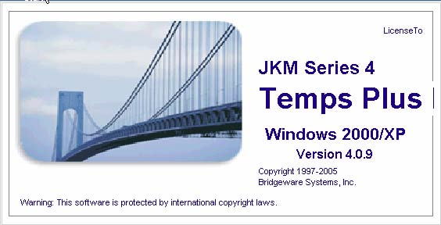

Last updated 8/10/2009 2:25 PM

Copyright 2004, Bridgeware Systems, Inc.

Table of Contents

**Temps Plus JKM----------------------------------------------------------------------------------------------8**

**Welcome................................................................................................................................................8**

**Where to Find the Information You Need.........................................................................................9**

***Help While Running the Program................................................................................................................................9***

Automating Software Updates..................................................................................................................................9

Using AUTOINFO option of tpAutoFTP.................................................................................................................9

***Your Temps Plus Dealer..............................................................................................................................................13***

***Bridgeware Websites....................................................................................................................................................13***

**Updating Your Temps Plus Software..............................................................................................14**

***A note about versions...................................................................................................................................................14***

**Protecting Your Data.........................................................................................................................14**

**Security...............................................................................................................................................14**

**Installing Temps Plus on your computer.........................................................................................14**

***The NPATH.................................................................................................................................................................15***

***Changing your NPATH...............................................................................................................................................15***

**Company Setup..................................................................................................................................16**

***Company Control Information....................................................................................................................................16***

**Overview and Features......................................................................................................................17**

***Temps Plus JKM Overview..........................................................................................................................................17***

Keyword Search.....................................................................................................................................................17

Job Orders..............................................................................................................................................................17

Payroll/Billing........................................................................................................................................................17

In Process At a Glance...........................................................................................................................................18

Backing Up Your Data...........................................................................................................................................18

Backing Up to Tape-----------------------------------------------------------------------------------------18

Backup Type-------------------------------------------------------------------------------------------------19

Tape Rotation------------------------------------------------------------------------------------------------19

Backup Frequency------------------------------------------------------------------------------------------19

Data Files-----------------------------------------------------------------------------------------------------19

Npath Files---------------------------------------------------------------------------------------------------19

Backup Schedule--------------------------------------------------------------------------------------------20

Restore Tests-------------------------------------------------------------------------------------------------20

In Summary--------------------------------------------------------------------------------------------------20

Sample Backup Schedule----------------------------------------------------------------------------------20

Running "Compact"-----------------------------------------------------------------------------------------21

How to use this Manual------------------------------------------------------------------------------------21

General Accounting Integration---------------------------------------------------------------------------21

***Temps Plus JKM Features..........................................................................................................................................23***

System Features......................................................................................................................................................23

Applicant Maintenance...........................................................................................................................................23

Job Order Maintenance...........................................................................................................................................24

Time Card Entry.....................................................................................................................................................24

**Temps Plus Basics..............................................................................................................................25**

***Terms and Concepts.....................................................................................................................................................25***

Applicants...............................................................................................................................................................25

Employees..............................................................................................................................................................25

Customers...............................................................................................................................................................25

Accounts Receivable Module.................................................................................................................................25

Job Orders..............................................................................................................................................................25

Placements..............................................................................................................................................................25

Keywords...............................................................................................................................................................25

Skill Profile.............................................................................................................................................................25

Company Code.......................................................................................................................................................25

Search.....................................................................................................................................................................25

Browsing................................................................................................................................................................26

Work Codes............................................................................................................................................................26

Recordset................................................................................................................................................................26

***Color Bars....................................................................................................................................................................26***

Color Bar Meanings During a Browse of Applicants.............................................................................................26

Color Bar Meanings While Viewing Job Orders....................................................................................................26

Color Bar Meanings for Placements.......................................................................................................................26

Color Bar Meanings for Time Card Entry..............................................................................................................27

Color Meanings when Editing the Period Batch....................................................................................................27

***Browsing......................................................................................................................................................................28***

Browsing Applicants..............................................................................................................................................28

The Find Function-------------------------------------------------------------------------------------------29

The Set Function--------------------------------------------------------------------------------------------29

More Notes on Browsing-----------------------------------------------------------------------------------30

Browsing Job Orders..............................................................................................................................................30

Browsing Customers..............................................................................................................................................30

Summary for Browsing..........................................................................................................................................30

***Printing Master Record Screens.................................................................................................................................31***

Shortcut Keys.........................................................................................................................................................31

Menu Bar Shortcuts-----------------------------------------------------------------------------------------31

Other Keyboard Shortcuts----------------------------------------------------------------------------------31

Hidden Shortcuts--------------------------------------------------------------------------------------------31

Data Entry Shortcuts----------------------------------------------------------------------------------------31

Shortcuts using the default functions in the Applicant and Orders screens--------------------------32

***The Temps Plus Menu Bar..........................................................................................................................................32***

***Data Grids....................................................................................................................................................................32***

***Custom Information Screens.......................................................................................................................................34***

Designing Custom Screens.....................................................................................................................................35

Resizing Custom Information Fields---------------------------------------------------------------------36

***Emailing in Temps Plus...............................................................................................................................................37***

***Emailing Resume(s).....................................................................................................................................................38***

***Emailing Invoices........................................................................................................................................................42***

***Locations......................................................................................................................................................................43***

***Check Queues..............................................................................................................................................................47***

***Special Pay Numbers...................................................................................................................................................48***

Prior Period Pay Numbers......................................................................................................................................50

Drag and Drop........................................................................................................................................................51

Attachment Templates............................................................................................................................................51

**Master Screens...................................................................................................................................54**

***Applicant Screen..........................................................................................................................................................54***

Applicant Assignment Section...............................................................................................................................56

Demographic and W4 information.........................................................................................................................56

Numeric and Date Fields........................................................................................................................................56

[Keywords F3]........................................................................................................................................................56

Performing a Search...............................................................................................................................................57

Printing Your Search Results------------------------------------------------------------------------------58

Find Jobs................................................................................................................................................................58

***Job Order Screen.........................................................................................................................................................60***

Job Order General Information...............................................................................................................................61

The Billing section------------------------------------------------------------------------------------------61

1 Invoicing Tab......................................................................................................................................................62

2 Req/Placed - Job Requirements Tab....................................................................................................................63

3 Pricing Tab..........................................................................................................................................................64

4 Dispatching Tab..................................................................................................................................................65

5 Skills/Other Tab..................................................................................................................................................65

Job Order “Quick-Action” Buttons........................................................................................................................66

The MU (My Unfilled) or the AU (All Unfilled) job orders buttons---------------------------------67

The MO (My Open) or the AO (All Open) job orders buttons----------------------------------------67

Managing your Job Orders---------------------------------------------------------------------------------67

What makes an order “MY” order?-----------------------------------------------------------------------67

The Notes section - [Notes F4]...............................................................................................................................68

Placements - [Place F6]..........................................................................................................................................68

Inserting A New Placement--------------------------------------------------------------------------------69

Place and Print [Print F3] or [Print Shift-F3].........................................................................................................71

[DNR] – DO NOT RETURN.................................................................................................................................71

Security Options for DNRs--------------------------------------------------------------------------------71

Job Order Information Screen - [Other F8]............................................................................................................72

Billing History - [History]......................................................................................................................................72

Rates [Rates]...........................................................................................................................................................73

Close Job Order - [Close F10]................................................................................................................................73

Closing Job Orders.................................................................................................................................................74

Closing an Entire Job Order-------------------------------------------------------------------------------74

Closing Individual Placements----------------------------------------------------------------------------74

***Time Card Entry Screen..............................................................................................................................................75***

The Group Time Card (Grid) Entry Screen............................................................................................................75

Selecting Multiple Placements----------------------------------------------------------------------------75

Emphasis-----------------------------------------------------------------------------------------------------75

Selecting Multiple Placements – Batch Entry Mode---------------------------------------------------76

Find - [Find F7] – Group Time Card Screen-------------------------------------------------------------76

Other - [Other F8] (Employee Group Time Card)------------------------------------------------------76

Select Screen Views (All, Time, No Time)--------------------------------------------------------------76

Find - [Find F7] – Edit Time Card Screen---------------------------------------------------------------76

Other - [Other F8] (Employee)----------------------------------------------------------------------------77

Refresh - [Refresh F9]--------------------------------------------------------------------------------------77

Hold Bill------------------------------------------------------------------------------------------------------77

Checks - [Checks F6]---------------------------------------------------------------------------------------77

Detailed Time Card Entry Screen - [Edit F3]------------------------------------------------------------77

Color Coded Transactions----------------------------------------------------------------------------------78

***Alternate Time Card Entry Screen..............................................................................................................................79***

***Customer Screen..........................................................................................................................................................80***

[Contacts F3]..........................................................................................................................................................83

[Notes F4]...............................................................................................................................................................83

[Customer Info F8].................................................................................................................................................83

[Skill Profiles F9]...................................................................................................................................................83

Creating and Maintaining Skill Profiles------------------------------------------------------------------83

Selecting and placing matching applicants---------------------------------------------------------------87

Linking and Unlinking Skill Profiles---------------------------------------------------------------------87

[Suspend Service]...................................................................................................................................................88

[Customer Rates]....................................................................................................................................................88

Entering Customer Rates-----------------------------------------------------------------------------------88

Enforcement of Customer Rates---------------------------------------------------------------------------89

Security Option for Customer Rates----------------------------------------------------------------------89

Bill Rate Calculator-----------------------------------------------------------------------------------------89

[Change Number]...................................................................................................................................................90

Share Across Locations..........................................................................................................................................90

Customer Code Prefix............................................................................................................................................90

***Employee Screen..........................................................................................................................................................91***

Employee Master Screen........................................................................................................................................91

[Notes F4]----------------------------------------------------------------------------------------------------92

[Info F8]------------------------------------------------------------------------------------------------------92

[DNR] – Do Not Return------------------------------------------------------------------------------------93

[Mark As Unreviewed]-------------------------------------------------------------------------------------93

[Garnishments]----------------------------------------------------------------------------------------------93

[E-Time checkbox]------------------------------------------------------------------------------------------93

[Private checkbox]------------------------------------------------------------------------------------------93

***Work Codes..................................................................................................................................................................94***

***Keywords......................................................................................................................................................................95***

[Map F4]-----------------------------------------------------------------------------------------------------95

[Add F5]------------------------------------------------------------------------------------------------------95

[Delete F8]---------------------------------------------------------------------------------------------------96

[Change F9]--------------------------------------------------------------------------------------------------96

***Appointments...............................................................................................................................................................96***

Features..................................................................................................................................................................96

Activating The Appointments Screen.....................................................................................................................96

Appointments Overview.........................................................................................................................................98

The Calendar-------------------------------------------------------------------------------------------------98

Options-------------------------------------------------------------------------------------------------------99

The Appointments Grid------------------------------------------------------------------------------------99

The Command Bars---------------------------------------------------------------------------------------100

Grid Notes--------------------------------------------------------------------------------------------------101

Appointment Tutorials..........................................................................................................................................101

Applicant Interviews--------------------------------------------------------------------------------------101

Quality Assurance Calls----------------------------------------------------------------------------------101

***Maintain Customer Rates..........................................................................................................................................102***

***Maintain Equipment List...........................................................................................................................................102***

***Maintain Warboard...................................................................................................................................................103***

**Process Menu....................................................................................................................................103**

***Queue All Unpaid Entries.........................................................................................................................................103***

***The Check Queue (Print Checks)..............................................................................................................................104***

Selecting the Check and Advice Printers..............................................................................................................106

Ordering Options..................................................................................................................................................107

TPCHECKS.EXE.................................................................................................................................................107

Maximum Quick Check Option...........................................................................................................................107

Using Unique Check Numbers.............................................................................................................................107

Printing Checks On-The-Fly................................................................................................................................107

Multiple Check Queues........................................................................................................................................107

Defining Additional Queues-----------------------------------------------------------------------------107

Using Multiple Queues-----------------------------------------------------------------------------------108

Remote Branches------------------------------------------------------------------------------------------109

***Void a Current Check................................................................................................................................................109***

***Update Current Payroll.............................................................................................................................................110***

***Select Check Queue...................................................................................................................................................110***

***End Of Quarter Payroll Tasks...................................................................................................................................111***

Quarter Info Tab...................................................................................................................................................111

Reports To Run Tab.............................................................................................................................................112

Quarterly Selection Criteria - [Selection F7]----------------------------------------------------------112

Rates and Options Tab..........................................................................................................................................113

Magnetic Media Reporting-------------------------------------------------------------------------------114

SSA Annual Magnetic Media Program-----------------------------------------------------------------114

Clear Year-to-date Check Totals..........................................................................................................................114

***Move Current Billings to Period Batch.....................................................................................................................115***

Period Batch/Current Batch..................................................................................................................................115

Period Batch/Current Batch Overview-----------------------------------------------------------------115

Why are there a current batch and a period batch?----------------------------------------------------115

***Printing Invoices........................................................................................................................................................115***

Examples:.............................................................................................................................................................117

***Close Printed Invoices To History.............................................................................................................................118***

***Archiving Invoices.....................................................................................................................................................119***

***Temps Plus Online.....................................................................................................................................................121***

***Jobstreams..................................................................................................................................................................121***

***Transfer Data To Corporate......................................................................................................................................121***

Transfer Mode......................................................................................................................................................121

Gather Mode.........................................................................................................................................................123

When to transfer...................................................................................................................................................123

Miscellaneous Transfer/Gather Information.........................................................................................................124

***Posting to Accounting – Configuration....................................................................................................................124***

Configuration for CYMA IV Accounting (Windows).........................................................................................124

Configuration for CYMA PAS5 Accounting (DOS)............................................................................................126

***Post To General Ledger.............................................................................................................................................128***

Fixing invalid posting entries...............................................................................................................................128

How entries are organized when posted to General Ledger.................................................................................128

**Temps Plus Concepts.......................................................................................................................130**

***Job Orders..................................................................................................................................................................130***

Front Office..........................................................................................................................................................130

Back Office...........................................................................................................................................................130

Invoicing Issues....................................................................................................................................................130

One Job Order/One Invoice..................................................................................................................................130

Multiple Job Orders/One Invoice.........................................................................................................................131

Job Order History.................................................................................................................................................131

***Entering Hours and Printing Checks.......................................................................................................................131***

Printing Checks Immediately...............................................................................................................................131

Printing Checks Later – Batch Printing................................................................................................................132

Printing Checks from more than one Workstation...............................................................................................132

Multiple Checks and Pay Numbers......................................................................................................................132

***Invoicing Issues.........................................................................................................................................................132***

***Current Period vs. Previous Payroll Periods............................................................................................................133***

***Payroll Journals and Reports....................................................................................................................................133***

***General Ledger Considerations.................................................................................................................................133***

***Applicant Payroll Check History...............................................................................................................................133***

***Check History and Workers Comp issues.................................................................................................................133***

***Printing Reports for Previous Periods......................................................................................................................133***

***Company Specific Check Formats............................................................................................................................134***

***"Wav" File Alerts/Sounds.........................................................................................................................................134***

***Invoicing....................................................................................................................................................................134***

***Period Batch Billing Editor.......................................................................................................................................135***

Changing Views...................................................................................................................................................135

Select and Options Buttons..................................................................................................................................135

Select All---------------------------------------------------------------------------------------------------136

Select Time-------------------------------------------------------------------------------------------------136

Select No Time--------------------------------------------------------------------------------------------136

Options All-------------------------------------------------------------------------------------------------136

Options Unbilled------------------------------------------------------------------------------------------136

Options Billed---------------------------------------------------------------------------------------------136

Options Hold Bill-----------------------------------------------------------------------------------------136

Options Ot Except-----------------------------------------------------------------------------------------136

Order By...............................................................................................................................................................136

Find.......................................................................................................................................................................136

Command Bars.....................................................................................................................................................137

Full View – [F3]-------------------------------------------------------------------------------------------137

Job Notes – [F4]-------------------------------------------------------------------------------------------137

Other – [F8]------------------------------------------------------------------------------------------------137

Refresh – [F9]---------------------------------------------------------------------------------------------137

HoldOnOff – [F6]-----------------------------------------------------------------------------------------137

Delete - [F10]----------------------------------------------------------------------------------------------137

Find – [F7]-------------------------------------------------------------------------------------------------137

Inv Id Filter------------------------------------------------------------------------------------------------137

[History ReBill]-------------------------------------------------------------------------------------------138

***Invoicing Items With No Time Cards........................................................................................................................139***

***Designing Invoices.....................................................................................................................................................139***

***Daily Pay Considerations..........................................................................................................................................139***

***Reports........................................................................................................................................................................141***

The Reports Library.............................................................................................................................................141

Payroll/Billing Analysis Reports..........................................................................................................................141

Workers Comp Reports........................................................................................................................................141

Other Included Reports.........................................................................................................................................142

TPREPORT Database..........................................................................................................................................142

ID------------------------------------------------------------------------------------------------------------142

Report Type------------------------------------------------------------------------------------------------142

Report Name-----------------------------------------------------------------------------------------------145

Report Description----------------------------------------------------------------------------------------145

Filename----------------------------------------------------------------------------------------------------145

Required Variables...............................................................................................................................................145

Special Report Names..........................................................................................................................................147

Designing Reports................................................................................................................................................149

Report Installer/Packager.....................................................................................................................................149

Building a Package----------------------------------------------------------------------------------------151

Using the Report Installer--------------------------------------------------------------------------------151

Using the Report Packager-------------------------------------------------------------------------------151

Report Queries and SQL......................................................................................................................................151

**Appendix...........................................................................................................................................153**

***Checklists...................................................................................................................................................................153***

Weekly Checklist.................................................................................................................................................153

Monthly Checklist................................................................................................................................................154

Quarterly Checklist...............................................................................................................................................154

Yearly Checklist...................................................................................................................................................154

***Automatic Garnishments (JKM v3.0.x method).......................................................................................................155***

***Garnishments (Temps Plus JKM v3.1.x method).....................................................................................................159***

***Prioritizing Garnishments.........................................................................................................................................166***

***401K Deduction Example..........................................................................................................................................168***

***Time Card Entry Adjustments...................................................................................................................................171***

***Reprinting a check.....................................................................................................................................................171***

***Special Check and Invoice Formats..........................................................................................................................172***

***Printing Checks as Reports.......................................................................................................................................172***

***Local Taxes................................................................................................................................................................175***

***Shift Differentials......................................................................................................................................................177***

***Doing Staff Payroll with Temps Plus........................................................................................................................179***

***Posting to General Ledger Configuration.................................................................................................................180***

***Email TimeCard Spreadsheets..................................................................................................................................182***

***Document Based Time Card Entry...........................................................................................................................186***

***Printing Checks as Reports.......................................................................................................................................190***

# **Temps Plus JKM**

## **Welcome**



Welcome to the Temps Plus JKM series for Windows

The information here is intended to introduce you to Temps Plus and familiarize you with many of the forms and features. While it is a good source of reference for learning about the basics of the Temps Plus JKM product, it should not be the only source for your continuing education of the Temps Plus family of products.

When you’re ready to learn more, review the section “Where to Find the Information You Need”.

*Documentation for Temps Plus JKM version 4.0.x*

*Documentation Version date: 8/18/2009*





Questions or suggestions about the documentation? Contact Bridgeware West/ISS at [**www.bridgeware.net**](http://www.bridgeware.net/)

## **Where to Find the Information You Need**

### **Help While Running the Program**

Selecting the [**Help**] item on the Temps Plus JKM menu bar will provide you with several options.

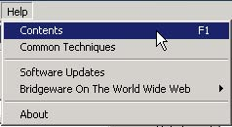

[**Contents F1**] - takes you to the computer based help system. This is the actual user’s manual for the Temps Plus JKM system, and is updated automatically when you perform a software update. There is a Contents, Index, Favorites and Search tab to help you zero in on what you’re looking for. The “Search” option is a particularly useful way of finding the exact information you’re looking for.

*Pressing [F1] while in the Temps Plus JKM application brings up context sensitive help for the form you were on when you pressed the [F1] key.*

[**Common Techniques**] – presents an additional help file with useful information on many subjects, including SQL query examples, frequently asked questions, etc.

[**Software Updates**] – this option will (assuming you have an internet connection) automatically update the software on your system. Details on how to use this option can be found at [www.bridgewaregold.com/webhelp/Tips/SoftwareUpdatesHelp.htm](http://www.bridgewaregold.com/webhelp/Tips/SoftwareUpdatesHelp.htm).

#### ***Automating Software Updates***

The tpAutoFtp program can be run in fully automatic mode by adding "Auto" to the command line. For example,

c:\program files\temps plus jkm\tpAutoFtp Auto

When run this way, the program will automatically log on to the Bridgeware site, download any updates and copy them to the npath. It creates a log that it puts in the npath, named "AUpdates.txt" which contains the date and time the update was performed and a list of the files that were updated.

When workstations log in, the program automatically checks for AUpdates.txt in the npath and, if found, reads the date and time of the last update. If then compares this date/time value to a registry setting of the last update it installed. If the values are not equal it automatically runs the workstation update program (updates.exe) and installs the updates. If there is a problem installing the updates (like a file it is trying to replace being in use), it makes a registry setting to automatically perform the updates the next time the system is restarted.

With these new features, a client could use the Windows Task Scheduler (available from the control panel) to have one machine on the network execute tpAutoFtp on a regularly scheduled basis (weekly, monthly, etc) and all the workstations on the network would take care of themselves.

#### ***Using AUTOINFO option of tpAutoFTP***

You can use the same program that downloads software updates and installs them on a workstation to simply check for available updates and email the information to a specified user or users. You do this by using the AUTOINFO option when calling tpAutoFTP. Here is a step by step example.

1) Create a new desktop shortcut and browse to tpAutoFTP.exe in the \Program Files\Bridgeware Systems\Temps Plus JKM 4 directory.

2) Right-click on the new desktop shortcut you created and choose “Properties” from the dropdown menu.

3) In the “Target” textbox of the “Shortcut” tab add a space and the text AUTOINFO at the end of the line (after the .exe and closing quote).

4) Click Ok to save the changes.

5) Dbl-Click the desktop shortcut to launch tpAutoFTP in the AUTOINFO mode.

6) If you get a message “Connection Failed” verify that a valid user ID and password have been entered in the appropriate fields of the main form. You must have the “Save Password” box checked to use the AUTOINFO feature.

7) When the program has finished checking for updates it will prompt you for information about where to send the email and how to send it (your smtp server, etc.) This only happens automatically the first time you use the AUTOINFO option. On subsequent runs you can force the configuration screen to appear by pressing CTRL-E (for “E-Mail configuration”) while the program is checking the updates. If you press CTRL-E the form will appear AFTER the program gathers the information about available updates.

It is important to note that the email notification is not controlled at a workstation level but at the network level (the settings are stored in the control database in the npath.) The feature is designed for a system administrator to be notified about available updates. Indeed, the latest version of tpAutoFTP allows administrators to be notified when a user updates his/her workstation via tpAutoFTP. There is a new setting on the Email configuration screen to control this.

Below are sample screen shots of the Windows Task Scheduler Wizard showing a typical setup for automating the available updates notification process to occur on a regularly scheduled basis.

**Windows Task Scheduler sample**

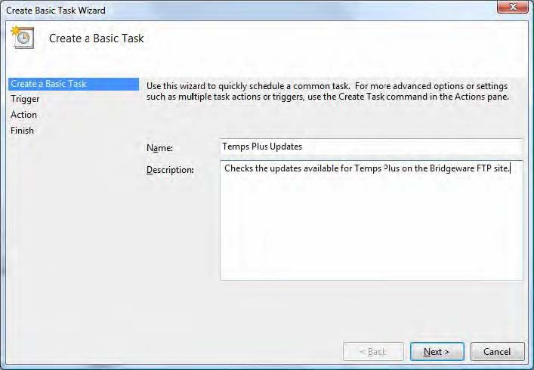

**Describe the task**

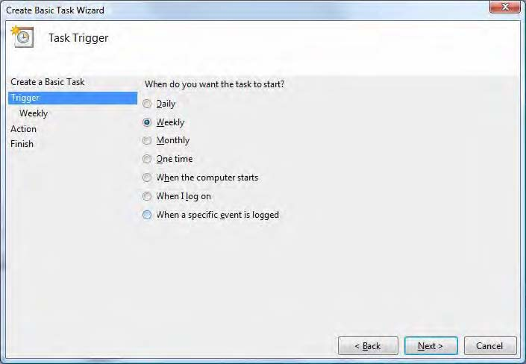

**Set when/how often the task will occur.**

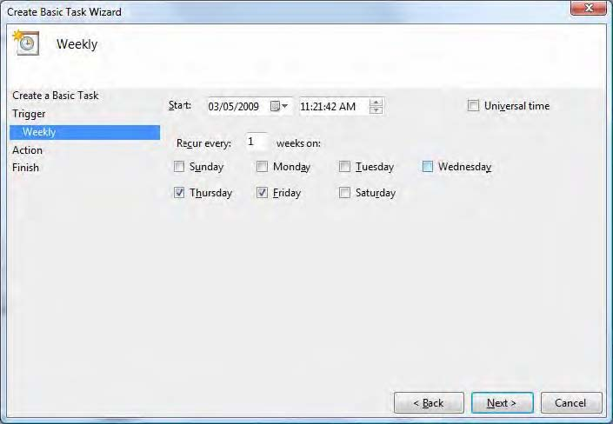

**Specify a start time**

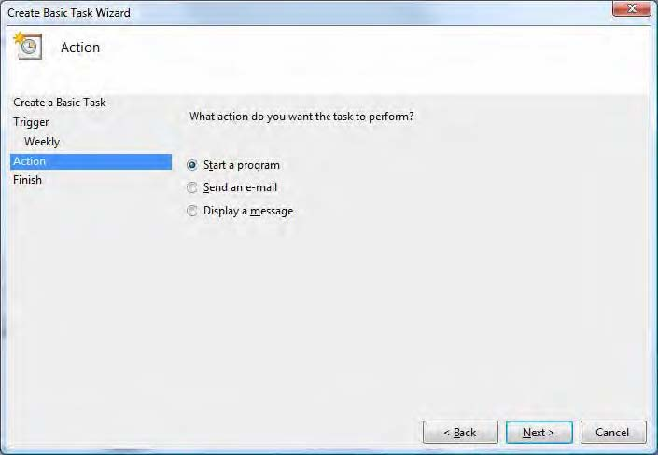

**You’re going to start a program - tpAutoFTP**

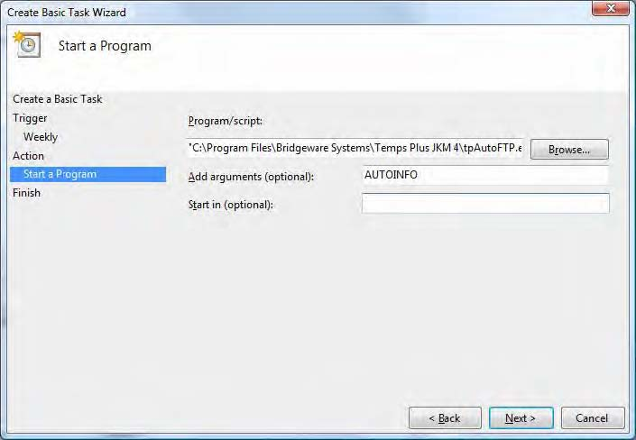

**You can browse to where the program is located on your disk - add "AUTOINFO" to the “Add arguments box”.**

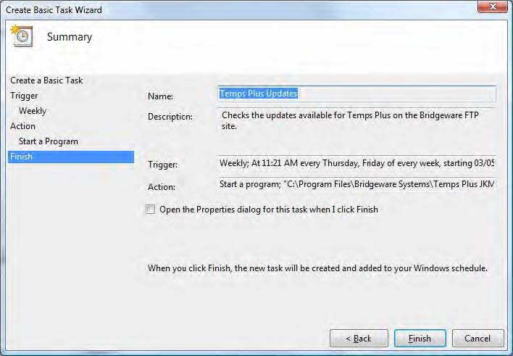

**[Bridgeware On the World Wide Web]** – provides an easy to navigate to one of our several web sites.

**[About]** – displays the current version of Temps Plus you have installed, as well as license information. Pressing the “?” key at the About screen will run the security reporting option by pressing the “?” key at the “About” screen. This will write a file (named mdiMain) to the default directory containing the main form's name and the name and caption of all menu controls contained within that form. This information can be used with the Temps Plus Security Editor.

### **Your Temps Plus Dealer**

Your Temps Plus dealer can answer any questions about the capabilities or operation of the system. A yearly support agreement provides unlimited updates, W2 updates, and phone support at a fixed price.

### **Bridgeware Websites**

With an Internet connection, you can access the Bridgeware Websites to get updates or utilities, or leave a message for the technical staff and authors of Temps Plus.

**Main Website**

<http://www.bridgeware.net/>

This site is our marketing site, with information about all our products, etc.

**Technical Support Website**

<http://www.bridgewaregold.com/webhelp/>

This site is for the use of our customers, and contains a wealth of information, including report updates, tax updates, tips, training videos, documentation, etc.

## **Updating Your Temps Plus Software**

Updates to the software may be downloaded directly from the menu item Help, Software Updates (see above).

Files with a “txt” extension that match each application files (for instance, TPJKM.txt matches the TPJKM program) contains the “version history” for that application. These files are stored in your Temps Plus program folder, and can be viewed using a text editor (like notepad) or any word processing application.

This will let you view the programming changes that have been made to the program. Each change shows the version number followed by the date and a description of the change.

### **A note about versions**

In order to determine which version you have (and therefore, whether you would benefit from updating your software), you may press the "Shift-F1" key sequence from the program screen - or choose “Help, About” from the menu bar.

Please note that the main Temps Plus application (TPJKM.EXE), as well as the Check Queue application (TPChecks.EXE), Invoice Printing application (TPInvoices.EXE), Supervisor Utilities (SuperJKM.EXE), and Accounts Receivable (AR.EXE) each have their own versions which must be checked while that application is active on your screen. These files may be found in the program folder containing the Temps Plus application files (normally “C:\Program Files\Temps Plus JKM”).

Each workstation that runs Temps Plus must be updated with the appropriate modules needed on that workstation. Details on how to use this option can be found at [www.bridgewaregold.com/webhelp/Tips/SoftwareUpdatesHelp.htm](http://www.bridgewaregold.com/webhelp/Tips/SoftwareUpdatesHelp.htm)

## **Protecting Your Data**

It is your responsibility to protect your data by performing regular (meaning at least "daily") backups (Backing Up Your Data), as well as the data integrity and performance utility provided in the SuperJKM program (See the documentation for SuperJKM)”.

## **Security**

You may setup security on a user-by-user basis within the Temps Plus JKM program from the SuperJKM program by using the User exclusions table of the User Maintenance Screen.

You can use the Temps Plus security editor to add menu options which will then appear in the User Exclusions table of the User Maintenance Screen (see the section <http://www.bridgewaregold.com/webhelp/Tips/TipSept72001.htm>

and the “[About]” option for more information on adding options using the security editor.

## **Installing Temps Plus on your computer**

It’s easy to setup Temps Plus.

Updated instructions for installing Temps Plus may be found at [www.bridgewaregold.com/webhelp/tpsetup.htm](http://www.bridgewaregold.com/webhelp/tpsetup.htm).

You will be prompted to input the path to the common network files (which we call the NPATH folder). This is the computer data path where various control information for your computer system is located (see box below). If you are on a network, you may need to contact the system administrator of your system to determine what your "NPATH” is.

After the program is installed, and registered, choosing the Temps Plus JKM selection from your list of programs will bring up the Login Screen. You must have a valid User Name and Password to login to the application. The SuperJKM application is used to setup user names and passwords.

After entering your User Name and Password, the Applicant Maintenance Screen appears. The screen that appears immediately upon login can be controlled by changing the setting in the Security Configuration under the System Wide, Security Configuration screen in the company setup.

### **The NPATH**



The NPATH location is where the TPCtrl database is located, which stores program information about the Temps Plus JKM application, including user information and company code database locations.

The default directory for your NPATH on a stand-alone computer system is "C:\Program Files\Temps Plus JKM\Npath".

On a "peer to peer" network, entering the full computer name (like \\Computer1\Program Files\Temps Plus JKM\Npath\ is a good way to enter the location.

While you may wish to enter a "mapped" drive and directory as the location (like "F:\TPJKM") as in a Novell Netware environment, the preferred method would be to use a URL such as “\\server\npath”.

### **Changing your NPATH**

You may use the REGEDIT program that comes with your Windows software to find and change the NPATH location on your computer.

• Choose the "Start" button from your Windows desktop task bar and choose Run.

• Type "regedit" in the Open dialog box, then press OK.

• From the Registry Editor screen, choose Edit, Find

• In the "Find what" dialog box field, type "npath", the press Find Next.

You should now be presented with a screen that shows where your NPATH location is set on this computer. Double click on the item to change the location

If you wish, you may navigate directly to the screen where your location is stored (instead of using the find method above) by moving through the folder tree in regedit as follows:

If the following key exists, then the location is as follows:

*My Computer\HKEY_LOCAL_MACHINE\Software\Bridgeware Systems\Temps Plus JKM\Startup*

Otherwise the location will be found at:

*My Computer\HKEY_CURRENT_USER\Software\VB and VBA Program Settings\TPJKM\Startup*

## **Company Setup**

### **Company Control Information**

To fully utilize the many features of Temps Plus, you may wish to change some of the default settings in the Company Setup.

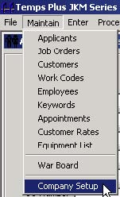

 Choosing the Company Setup selection performs the same function as starting the SuperJKM.exe application.

Refer to the help or documentation on the SuperJKM module for available options and features.

## **Overview and Features**

The Temps Plus JKM system is designed to automate much of the routine work of a Staffing Service. This work is usually divided into two parts - Keyword Search/Retrieval and Payroll/Billing. Sometimes these parts are referred to respectively as "Front Office" and "Back Office".

### **Temps Plus JKM Overview**

#### ***Keyword Search***

Generally considered a “front office” feature, the Keyword Search portion of the application allows you to rapidly match the requirements of an employer against the qualifications of a large number of applicants. The result is a list of all the applicants who satisfy the requirements, with the best-qualified candidates appearing on the list.

The Keyword Search program eliminates the need to look through applicant files by hand, giving you the freedom to maintain a large file of active applicants. The names, addresses, and phone numbers of every qualified candidate in your file will be provided to you in a matter of moments, and none will have been overlooked. Once you have the list of candidates, you will still have to consider their resumes and interviews in deciding whether a particular candidate should be submitted for a particular opening. Keyword Search cannot replace your professional judgment.

When an applicant becomes an employee, the information applicable is automatically available to the Payroll Billing files without re-keying the data.

The “Skill Profiles” feature of the software allows you to “store” searches with customers and job orders for easy use as needed. You can find more information on this feature on the 5 Skills/Other Tab section of job orders.

#### ***Job Orders***

Job Orders “fill” the gap between the back and front office. The front office uses it to track orders and place applicants to work – the back office uses it to determine who needs to be paid and billed. Find out more in the Job Order Screen section.

There are generally accepted roles for the front and back office when using job orders, which would be defined by you after a better understanding of (and training on) the product. There is no hard and fast rule where the line is drawn between who enters which information on the job order, but as always, the more accurately the information is keyed in, the more useful it will be when needed.

#### ***Payroll/Billing***

The Payroll/Billing portion automates the process of time card entry (Time Card Entry Screen), payrolling (The Check Queue; “Print Checks”) and invoicing (Printing Invoices). Various management reports are also provided which allow you to quickly analyze your business performance. With the optional addition of General Ledger and Accounts Payable modules, a completely integrated accounting solution with a seamless interface is achieved.

#### ***In Process At a Glance***

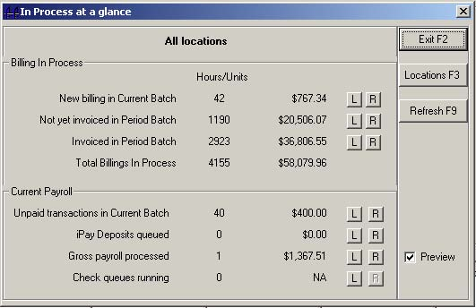

This feature shows key information about current payroll and billing activity, and will will appear automatically when entering a new company code, if configured to do so. This is now the default form for Temps Plus if you are a supervisor. From this form you can quickly get location breakouts for activity and/or launch reports.

A security item (Maintain, Company Setup, Maintain SystemWide, ‘In Process At a Glance’ Default for Supervisors) exists to exclude users from the new form -- but only users with Supervisor equivalence will have access to the form regardless.

You can also bring up the screen manually by choosing, “Report, In Process at a Glance”.

A set of default reports to use with the new form is available at

<http://www.bridgeware.net/ipaagReports.zip> or on the [BridgwareGold Website](http://www.bridgewaregold.com/). The reports are delivered in "tpr" packages, ready for installation by simply opening each file and clicking the "Install" button. See the section on Special Report Names for specific file names.

#### ***Backing Up Your Data***

Most people learn the hard way - by losing irreplaceable data - whether through equipment failure or operator error, all it takes is one incident. Be assured, someday it will happen to you! Be prepared, not sorry.

##### **Backing Up to Tape**

Anyone who uses computers should set up a daily routine for backing up critical data. All data should be backed up periodically. Backing up to tape is one of the most reliable and cost efficient way to backup your entire system. It is a good idea to alternate backup tapes using some variation that includes, daily, weekly and monthly backups. Most tape backup devices have detailed instructions on tape rotation techniques.

This section contains recommendations on using your existing tape drive and backup software to manage the process of backing up and restoring Temps Plus programs and data. It does not include instructions for performing the actual backup and restore procedures. If you need more detailed instructions, refer to the instructions for the software you use to perform backups or contact your network system administrator.

NOTE: If you are familiar with tape backup procedures in general, you may want to skip directly to the "In Summary" section

##### **Backup Type**

The phrase "backup type" refers to the use of various options that are available while you are backing up your files. For example, backing up all the files in one or more locations is called a "full" backup.

In particular, Bridgeware recommends that you always use the "compare" or "verify" option while you are doing a backup. (The terminology used depends on your particular backup software.) This type of backup has two phases. First, the data is copied to the tape. Then, the backup software compares each backed up file to the copy on the tape, to make sure that they are identical. While this process takes more time, it assures that you will be able to reliably restore data from the tape. Using the “differential” type of backup generally does not provide a reliable way to restore your data.

##### **Tape Rotation**

The phrase "tape rotation" refers to the practice of backing up files to different tapes on different days. This is done so that you won’t accidentally overwrite a "good" backup with a "bad" backup.

For example, suppose you back up your data files every Wednesday, starting January 3. On January 10, you back up the files again. Now suppose that on January 12, you discover that there is a problem that dates back to January 7.

If you used different tapes for the backups on January 3 and January 10, you can restore your files from the January 3 backup and then re-enter any data that you entered after January 3. However, if you used the same tape for both the January 3 and January 10 backups, you have overwritten the January 3 backup with the January 10 backup. Therefore, you no longer have a "good" backup, and you will not be able to restore your files.

A similar problem can occur when you store multiple backups on a tape by appending instead of overwriting. If there are multiple backups on a tape and the tape is damaged, you can lose all your backup data.

##### **Backup Frequency**

###### **Yearly**

Always make a backup at the end of each year of your data and npath folders on a new tape. Put this tape away for archival purposes.

###### **Monthly**

Always make a backup at the end of each month of your data and npath folders on a new tape. Keep these tapes separate from the tapes that are rotated through the weekly schedule. This tape should be created monthly and may be called upon for use in restoring information that cannot be retrieved from your daily backups, which are overwritten weekly. At the end of the year, you may overwrite your monthly from the previous year.

##### **Data Files**

Back up your data files every day. These are files that change every time you access your data, and whose location depends on the configuration of your system. They will be files with an “.mdb” file extension (TempsXXX.mdb, TpARXXX.mdb, TpAppt.XXX where ‘XXX’ is the company code).

##### **Npath Files**

Back up your common network files at least once a week (including subfolders). These are files that may not change every time you access your data, but include tax calculations, report formats (including invoices and checks), etc. So if the need arises, be sure you have backed up this information at least as often as these types of information are changed.

##### **Backup Schedule**

It is best to schedule backups to run automatically during the night, when no one will be using the software. This is because all users must be logged off during a backup, and also because backing up can slow down system response time. Also, scheduling automatic backups assures that you won’t forget to run the backups on a regular basis.

After the backup, remove and store the tape, after verifying that the backup completed successfully (most backup software can be configured to print a completion report or log to the screen).

Make sure all network users are logged off the system at the end of the day before a scheduled backup.

##### **Restore Tests**

To confirm that you can actually restore files that you have backed up, it is a good idea to perform a partial restore procedure now and then. For example, once a month you can restore a history file to a different directory than the one in which the current file is stored. Confirm that the Restore process completed without errors, and compare the file sizes of the current and the restored files. If you suspect that there is a problem with the backup or restore process, contact your system administrator immediately.

##### **In Summary**

• Make sure all network users are logged off the system at the end of the day of a scheduled backup.

• Insert the tape cartridge the day of the scheduled backup and remove it the following morning.

• Use the Overwrite (not Append) option when you do backups. Also use the Compare or Verify option. Do not use “differential” type of backup.

• Schedule backups to run automatically when no one is using the software.

• Rotate the backup tapes, using a different tape for each day of the week.

• **Test the Restore process periodically** – many users who have ignored this step have been disappointed to find they didn’t know how to restore, or worse, couldn’t restore because the data was not backing up properly.

##### **Sample Backup Schedule**

In this scenario, data files are backed up every night, the data files and the Npath information once a week, monthly, and yearly.

Monday – Sunday tapes are reused weekly.

Monthly tapes are reused yearly.

Yearly tapes are stored indefinitely.

|  |  |  |  |  |  |  |  |  |  |  |  |  |  |
| --- | --- | --- | --- | --- | --- | --- | --- | --- | --- | --- | --- | --- | --- |
| Monday - Thursday | | | | Friday | | | | Saturday | | | | | Sunday |
| Insert tape labeled with the correct day of the week. Run automatic backup to backup daily files. | | | | Insert Friday tape and run automatic backup to backup weekly files | | | | If you work on Saturday, run another daily backup. | | | | | If you work on Sunday, run another daily backup. |
| Monthly | | | | Yearly | | | |  | | | | |  |
| Insert tape labeled with correct month. Run backup to backup weekly files. Archive these tapes till next year. | | | | Insert tape labeled with correct year. Run backup to backup weekly files. Archive this tape permanently. | | | |  | | | | |  |

##### **Running "Compact"**

The "Compact" utility in the supervisor utilities maybe run on a regular basis - and in coordination with your tape backup routine/schedule because it creates a new database with the data and tables in contiguous and sorted order. It also refreshes the statistics in the database and causes all stored queries to recompile. Ultimately, this reduces the size of the database and can significantly increase performance.

More significantly, though, is the benefit of knowing (before it's too late to use a current backup tape from which to restore) that your data has problems. These problems could go undetected for long enough that there would simply not be an option to restore from tape. Running "compact" will bring any severe problems with your database to your attention immediately, as well as providing the other benefits described above.

##### **How to use this Manual**

There is a good chance that you will be able to do quite a bit with the TEMPS PLUS program without ever looking at this manual. The program usually displays everything you can do right on the screen, and computer-based help is just a keystroke away. Furthermore, the program has been carefully organized to fit the workflow of a staffing service; so much of it should come naturally.

WE ENCOURAGE YOU TO READ THE MANUAL at least once. There are many excellent features built into the program, which you might not discover on your own. By reading the manual, you will be able to make use of the full range of the program's capabilities in a fairly short period of time.

Please bear in mind that no manual can cover all the possible situations that a sophisticated program will allow. Should any questions arise, it is best to adopt the attitude of an explorer. Test the program with demo files, and see what it will do. You can't break the program - the worst that can happen is that you may damage some data in the demo files.

##### **General Accounting Integration**

Temps Plus JKM can work seamlessly with general accounting software applications, which provides the "back office" general accounting features not specific to Temps Plus.

Working with a separate general accounting software application lets us concentrate on the core features of Temps Plus, while providing you with the sophisticated features of a mature general accounting application

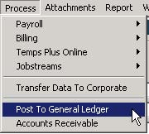

Temps Plus "posts" directly to the appropriate general accounting modules from the "Process, Post to General Ledger" item on the menu bar whenever you're ready to do so.

See "Posting to Accounting Configuration" in the Appendix chapter for specifics on configuring Temps Plus to work with a specific accounting package.

### **Temps Plus JKM Features**

Temps Plus has been designed to maximize convenience and flexibility and includes the following features.

#### ***System Features***

• Maintains screen and function key compatibility with Temps Plus RJM (PASIII)

• True MDI (Multiple Document Interface) allows multiple views of your data

• Crystal Reports by Seagate. All reports were designed, are readily accessible, and can be modified/created with Crystal Reports. Every report can be:

 *displayed on the screen for quick viewing*

 *printed out for a hard-copy record of your data*

 *stored on a disk file for further editing or for use with the "Mail merge" capabilities of a word processing program*

 *modified to user specifications*

 *added as a new report to the Report Library*

 *emailed to someone*

• Keystroke entries have been minimized:

 *full-length titles and descriptions are set up once and automatically inserted in the reports; abbreviated titles and descriptions are used thereafter for routine data entry. This saves time and reduces the chances of making typographical errors*

 *"Quick Cities" allows rapid data entry of City, State, and Zip from a single user defined code*

• Color-Coded Applicants, Job Orders and Placements provide instant on-screen record status identification

• “Smart” Scanning

• "Recordset" scrollbars speeds movement through multiple records without leaving the data entry screens

• Configure all data entry screen parameters at the user level

• Data entry fields may be set as “Required”, and as such, will prevent the creation of a new record, or saving a changed record if there is not valid data entered into required fields

#### ***Applicant Maintenance***

• Quick Entry/Quick Lookup - add a new record by just typing in the information, no thinking of what ID to assign. The system auto assigns the ID and builds all indices to find it later.

• No need to know ID Numbers, finding the right person is fast and easy. Just key in any portion of their name or find them by social security number, or any thing else about them.

• Keywords are added from categorized tabs that are user defined. Key words can be tailored to mirror the check boxes on your application, and can be added with mouse clicks or keyboard entries.

• Resumes and Notes can be attached from virtually any source; scanned as images or as text and dragged and dropped in from other files (like word processing documents). Text can be typed in (unlimited in length), or utilizing full OLE support (Object linking and embedding). OLE support allows full documentation, attaching pictures, sound files or related document files to provide a complete presentation for all your staffing professionals.

• Any files placed in the resume folder (determined by choosing Company Setup, Features, [Set] Resume Folder) folder with the correct naming convention will automatically be attached to the appropriate applicant’s resume button. The naming convention is XXX_1234.doc (or .pdf, etc.) where XXX is the company code, and 1234 is the applicant id.

• Applicant records (including resume attachements) may be gathered using the “Temps Plus Online” from your website.

• Complete online assignment histories are available and color-coded to indicate the status of the assignment. Details on each assignment are also a click away to see both historical pay and bill information.

• Check histories are available instantly, in order to expedite unemployment claims, workers comp claims, social service income reports, or to verify payment.

• User-defined fields and print formats make Temps Plus JKM the most powerful applicant tracking system on the market today, with the flexibility to last for years to come.

#### ***Job Order Maintenance***

• New jobs, like applicants are designed to be entered quickly. Much of the information defaults from customer profile information that seldom gets changed. If an order is closer to a previous order for that customer you can use the clone feature to further expedite the order taking process.

• Orders, like applicant and placements, are color-coded. The colors will allow you to instantly determine the status of the order (Unfilled, Partially Filled, Filled, Closed and To Be Deleted). On browsing orders, they are listed for you in the order that they need attention.

• Pricing info is available on orders to handle the exception to the rule type orders. The pricing screen tracks and handles the fixed markup jobs, special billing formats, shift differentials, automatic discounts based on volume and more.

• History on the job is two-fold. A complete invoice history is available, summarized by invoice just for that job. Expand your view to all invoices for that customer on all jobs, or drill down on the details of each invoice. History is also available for each person assigned to the job showing color-coded status as to why they were removed, performance reviews, notes, start and end dates, and a summary of their hours.

• Quick-batch editing features are provided to keep your data current, and you are able to close assignments while indicating the final time card is missing.

• Additional custom fields are available, along with user-defined reports to give you the edge in tracking jobs and job performance.

• Customer “Rates” feature insure the integrity of work codes and rates entered.

#### ***Time Card Entry***

• The time card entry screen displays every assignment the system expects a time card for based on the status. As time cards are entered this screen serves as your discovery of what time cards are missing.

• The auto apply feature has the ability to give all people assigned to a job, multiple jobs or just selected records the same hours with a single entry and have the choice of instantly printing checks.

• Time card entry makes all the entries necessary for both payroll and billing, while accumulating a wealth of history in all key areas to fulfill all your reporting and tracking requirements.

• Alternate “Warboard” interface speeds assignment of employees, and allows list of “available” applicants.

## **Temps Plus Basics**

### **Terms and Concepts**

There are a few basic terms and concepts with which you should become familiar. These items are introduced here, and are explained fully when they come up in the screen sequences.

#### ***Applicants***

Applicants are persons whom you wish to track in the system. They may, or may not, become employees.

#### ***Employees***

Employees are persons who were initially an applicant, but for which an additional employee screen has been created. Creating an employee screen can be performed directly from the applicant screen, or by placing an applicant not previously an employee on a job order.

#### ***Customers***

Customers are those companies or individuals whom you bill for services. A customer record is necessary for any job order and may contain “[customer rates]” specific for each customer. There is a corresponding customer record in the Accounts Receivable module for each customer record in the Temps Plus module, allowing your collections (or back office) to store different information than your front office personnel for the same customer.

#### ***Accounts Receivable Module***

When you close printed invoices to history, the invoices (and any changes to customer screen information) is automatically transferred to the Accounts Receivable module, if it is enabled. See the separate [documentation for the Accounts Receivable module in the Bridgeware University Library](http://www.bridgewaregold.com/BSIU/BsiLibrary.htm) on the Webhelp web site.

#### ***Job Orders***

Job orders are the connection in the system between your customers and the employees working there. At the very least, job orders must be kept current as to pay and billing information. Job orders that are properly maintained can help you schedule your day and help you manage your customer's needs.

#### ***Placements***

When employees are assigned to work, they are "placed' on a job order, and have a placement record.

#### ***Keywords***

Essentially, a keyword is a job skill for an applicant, or any other item you wish to track applicants by. Typical examples of keywords might include "Secretary" and "Technical Writer". Keywords need not be limited to skills, however. You may create and use a keyword for anything you wish to view or search by on an applicant screen.

#### ***Skill Profile***

A skill profile is a saved search that can be saved and attached to customers and job orders.

#### ***Company Code***

A Company Code is a three-letter code used by the program to identify related files. It is not used for security purposes. You may have as many company codes as you wish, each having it own unique database and parameters.

#### ***Search***

A search is the process of matching a client's requirements with the qualifications of an applicant.

#### ***Browsing***

Several operations allow you to browse for information if you don't know exactly what to enter. Browsing allows you to view all the possible entries and then select the one that applies.

#### ***Work Codes***

Work codes are classifications for various work situations, which are set up in the Temps Plus module. They control various parameters on Job Orders such as Worker's Compensation Rates, Pay and Bill Rates, account numbers for posting to general ledger, etc. You must have appropriate work codes set up for your employees in order to perform Payroll/Billing features.

#### ***Recordset***

A Recordset is a group of “selected” records. The number of records in the recordset is display at the lower left hand corner of the form.



You may “scroll” through the records by using the arrow keys on the recordset bar.

### **Color Bars**

Another unique feature in the Temps Plus JKM system is the Color Bar. When browsing records, the color is used to indicate the status of a record. The Color Bar helps you to instantly identify information in your system.

Colors are available for applicant, job order, and placement records, as well as during time card entry and editing invoices.

#### ***Color Bar Meanings During a Browse of Applicants***

If an Employee has been marked as Terminated, Inactive, or Deleted (BLUE), this Employee may not be paid until their employee record is changed back to Active.

• If an Applicant is in the system as (RED), there is no employee record and/or assignment for this applicant.

• Applicants marked as (YELLOW) have employee records that have been entered “on-the-fly” during a placement, and as such are unreviewed, and should be reviewed prior to their initial payroll

• (GREEN) Applicants/Employees are on active assignment

• (MAGENTA) is an Applicant/Employee with no assignments

• (BLUE) designates a status of Inactive, Terminated, or Deleted

#### ***Color Bar Meanings While Viewing Job Orders***

• (RED) is a job order without any assignments

• Not as many assignments as were required on the order is (YELLOW)

• As many or more assignments as required is (GREEN)

• A closed job order is (MAGENTA)

• A (BLUE) job order is not only closed, but also marked for deletion later.

#### ***Color Bar Meanings for Placements***

• (RED) indicates an active placement

• (GREEN) is a closed placement, without anything adverse.

• Optionally, you may use the other three colors are normally used at your discretion to show an ended placement that was terminated unsatisfactorily. You may, however, use your own imagination when using these colors, for any tracking purpose you desire. When editing placement records, you may change the status number to the number of the color referenced above to track the records as you wish.

#### ***Color Bar Meanings for Time Card Entry***

During Time Card Entry (using the EDIT F3 screen):

• (CYAN) indicates items that are not yet paid, but have been moved to the period batch.

• (YELLOW) items are paid items, and takes precedence over any other color.

#### ***Color Meanings when Editing the Period Batch***

While using the Period Batch Invoice Editor:

• (CYAN) indicates items that have already been invoiced.

• (YELLOW) indicates items that have been placed on a "hold" status.

### **Browsing**

One of the most powerful features of the Temps Plus system is browsing. Browsing is available for applicants, employees, job orders, work codes, customers and placements.

Browsing applicants, job orders, or placements differs from browsing in other areas because of thecolor-coding feature. Color Bars signify different status for items in the browse list.

#### ***Browsing Applicants***

To browse a list of applicants, press [F7] from the ID field on the applicant screen

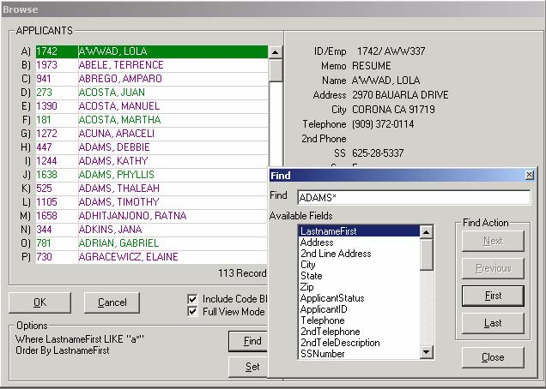

 Note that the detail for each highlighted record shows on the rightmost part of the screen, and changes dynamically to reflect the currently highlighted record. To move through the browse, use the [**Up Arrow**], [**Down Arrow**], [**Home**] or [**End**] keys, or use your mouse with the scroll bar. To select an item, move your cursor to highlight that item and press [**Enter**] or press the letter shown on the left side of the browse window.

The Bridgeware browse operates in a special way when you have something on the input line before pressing [F7] or [ENTER] to call the browse. If you enter a partial identifier like "A", when you call the browse, the browse is limited to just the A's. We don't show you everything. If you press [Home] you go to the first "A" and [End] takes you to the last "A". If you key in an entire identifier then we show you everything but we highlight and start you at the matching identifier.

You can use the directional keys to scroll the records. [PageUp]/[PageDn] moves through the orders one page at a time, and the [Up Arrow] and [Down Arrow] keys one record at a time. [Home] goes to the first record and [End] will take you to the last record.

With applicants, entering a valid applicant id will retrieve the applicant without invoking the browser. Any numeric input that is not a valid applicant id will be seen as a social security number or range of social security numbers and the records will be ordered by SSNumber. If the input might be an employee number or range of employee numbers the ordering will be by employee number. If the input could not be construed to be a valid employee number or range of employee numbers, or SSNumber or range of SSNumbers the system creates a select statement based on the applicant name and orders the records by applicant name.

You may also search by using an SQL phrase – for example to search for the first name of “John”, you could enter "*John”, which would display any applicant with the string “John” contained in the name.

##### **The Find Function**

When you depress the [Find] action bar, you are presented with a screen in which you can further narrow your browsing parameters.

By choosing which field to search on, you can "find" records from within your already browsed records.

For example, in the screen above, to find the first applicant in the state of CA, you would select State in the Available Fields window, and press the [First] action bar. If such a record existed, the first one found would be highlighted. You could then press [Next], or [Last] to find more records matching your request.

You can use "SQL" wildcard characters to locate text. For instance, "ADAMS*" would find every applicant whose last name started with the letters "ADAMS".

##### **The Set Function**

Pressing the [Set] action bar allows you to further limit the records showing in your browse. In the example below, the letter "A" was entered in the ID field before browsing. The between statement of LIKE "a*" reflects that process. Here you can add, delete or change the parameters of the browse.

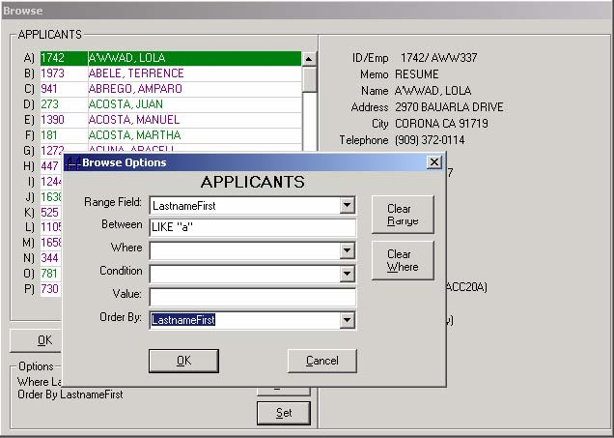

Use the Where, Condition, and Value fields together to form specific requests. Use the “Order By” field to change the sort order of the browse.

Experimentation with this screen will show you the powerful scope of this feature in utilizing your browsing screen.

##### **More Notes on Browsing**

The way the browser works is based on what you enter into the text box prior to browsing. If you leave the text box blank, records are typically ordered by their primary key. For example, applicants would be displayed by applicant number, customers by customer number, workcodes by workcode.

***Also, you may browse for applicants by entering a social security number employee number, or reference number.*** You may also search by using an SQL phrase – for example to search for the first name of “John”; you could enter "John”, which would display any applicant with the string “John” contained in the name. See the “Summary for Browsing” section for more information.

### **Printing Master Record Screens**

While you have a master record on the screen (applicant, job order, customer, etc.), you may print a paper record of the record on the screen (by simultaneously pressing the [Ctrl-P] keys. This is a function that would be somewhat like a "screen print" that some DOS users may be familiar with. It provides a quick and convenient way to get a paper record of an applicant, job order, customer, etc. currently on the screen.

Each master record screen "looks" for a special print format (see Special Report Names section) in the NPATH folder.

• PRAPP.rpt – Applicants

• PRCUS.rpt – Customers

• PREMP.rpt – Employees

• PRWOR.rpt - Work Codes

• PRJOB.rpt - Job Orders

• PRKEY.rpt – Keywords

• PRARC.rpt – AR Customers

#### ***Shortcut Keys***

As an alternative to using just the mouse, you may use the keyboard to quickly access many items and features of Temps Plus.

##### **Menu Bar Shortcuts**

Then the menu bar is visible, you may simultaneously press the [Alt] and underlined letter of the desired option to pull down the drop down sub-menu for that option. For instance, [Alt] - [F] key combination would access the File sub-menu.

##### **Other Keyboard Shortcuts**

Whenever a sub-menu option is visible, and there is an underlined letter of an item visible, you may press that letter to access that item (no need for the [Alt] key here).

##### **Hidden Shortcuts**

• **[F1]** - Displays help for the currently running application

• **[Shift-F1]** - If the program does not have a "Help >> About" menu option, this key sequence will display the "about screen" (which includes the software version)

• **[Ctrl-Q]** (during time card entry) - Displays the status of the Check Queue (running, paused, etc.)

• **[Ctrl-A]** - Launches the appointments module, and makes an association with any currently displayed applicant, order, placement or customer. This differs from choosing the menu option "Maintain >> Appointments" in that no association is automatically made when calling appointments through the menu.

• **Dates** - In all text boxes expecting date input you have a few short cuts available. If the date you are entering is for the current year you do not need to enter the year. For example, if the year is 2001 and you enter "10/12" in a date field the system will come back with 10/12/2001. On a blank date field you can enter a plus sign and the number of days from today you want to add. For example, if today were October 12, 2001 and you entered "+21" in a date text box, the system would return 11/2/2001. You can also precede a date with a number of days to add or subtract or you can follow a date with a number of days to add or subtract and the system will perform the appropriate date math. For example, "10+10/27/2001" would return 11/6/2001. Likewise, "Oct 16 +21" would return 11/6/2001 (assuming the current year is 2001).

##### **Shortcuts using the default functions in the Applicant and Orders screens**

Some keys in the applicants and orders screens have special functionality when pressed at a blank screen. For example, in the applicants screen, when a record has been selected, pressing F10 will take you to the employee screen for that applicant. When the F10 key is pressed from a blank applicant screen, all "un-reviewed" employees are selected and you are taken to the employee screen so that they may be reviewed. Here's a recap of these special, 'blank screen' functions.

**Applicants**

• **[F6]** - retrieves and displays all employees with active placements then moves to placement history for editing.

• **[F9]** - retrieves and displays all employees with current checks.

• **[F10]** - retrieves and displays all "unreviewed" employee records then moves to employee maintenance for review process.

**Orders**

• **[F3]** - Retrieves and displays all orders, regardless of dispatcher with a next dispatch date greater than or equal to "Today" and displays them in next dispatch date order.

• **[F6]** - retrieves and displays all orders with expired placements then moves to the placement screen for editing.

• **[F10]** - retrieves and displays all open orders scheduled to close on or before today.

• **[History]** - retrieves all orders that have had billings in the past 30 days and moves to the billing history grid for review.

### **The Temps Plus Menu Bar**

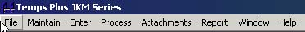

The Temps Plus menu bar is consistent in operation to many “Windows” applications, and provides access to the many features of the Temps Plus application. Placing your mouse over the desired selection will display a drop-down menu of items available for the menu operation.

### **Data Grids**

Data grids are a special type of screen form that is used throughout Temps Plus. While the data and use of the grids vary, the grid form itself has several features which may be common to any of the grids, where applicable.

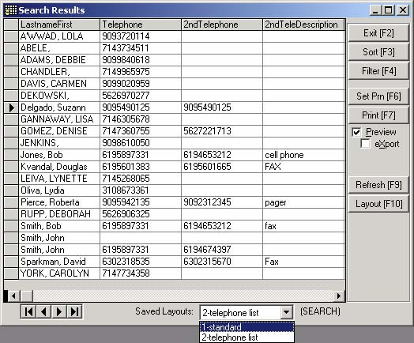

Data populating the grid is divided into several columns, each representing a field name in the table(s) being used by the function that generates the grid. You may move and resize the grids by using your mouse to create a different “look” for the grid form. We call these different looks “layouts”. You may save and recall these layouts later. Normally, there will be many more fields than the grid can display at one time, and you may use your window scroll bars to move through the fields and records.=

[**Sort F3**] – By highlighting a column (by clicking the column heading with your mouse), then pressing the [Sort F3] button, you can sort the data in the grid by any column heading.

[**Filter F4**] – You may enter an SQL expression to filter the data appearing in the grid.

[**Set Prn F6**] – You may set the printer used when pressing the [Print F7] button to print the report.

[**Print F7**] – Prints (or previews the report if the “Preview” box is checked. You may still print the report if you preview it first, just as you can with any report in Temps Plus.

**eXport Box** – Strips the heading line from the report. In this way, if you were exporting the data to another application, you could get just the data without the report title and date included.

[**Refresh F9**] – Probably not applicable in most situations, but it is used to “reload” matching data in the form in case the data has changed since the grid was displayed.

[**Layout F10**] – You may resize, delete, or move column heading to match your requirements for viewing, printing, or exporting. Pressing the [Layout F10] button allows you to save new layouts with your changes, and will appear in the “Saved Layouts:” drop-down list for later recall.

 If you delete columns and move them for different layouts, be sure to save one layout (possibly named “standard”) as a standard grid layout you can always return to for use when making new layouts.

 Layouts are NOT shared between users on different workstations. The layout files are stored in each workstation’s program folder with an extension of “.grx”. You may copy these layout files to another workstation to make them available on that workstation, without going to the trouble of designing them again at the new workstation.

### **Custom Information Screens**

Additional information for most “master screens” (customers, employees, applicants, etc.) may be stored in additional screen forms called custom screens. These screens, when they exist, are displayed by pressing the [Other F8] button on the appropriate screen (the button names may vary from screen to screen, but are usually associated with the F8 key designation.

These custom screens must be setup and designed one time before they can be used. This function is accomplished by choosing the appropriate screen name in the Company Setup, [Screen Defs] section. For instance, the custom screen for applicants would be named “OtherApplicants”. You may setup as many fields for use on each screen as you wish, naming them appropriately as you wish them to appear when displayed (you may change the field names later directly from the custom screen by double-clicking with your mouse on the field name).

When creating the Screen Definition for the custom screen, just type in the field name in the DataElementTitle column, and make sure that each row has a unique ScreenIndex number, starting with “0” (see example below).

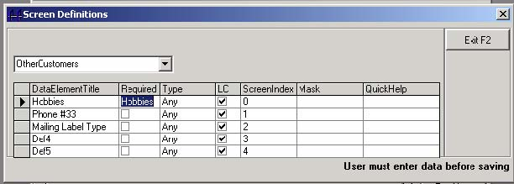

By default, the data type is set to “Any”, and will be stored as text. The “type” field specifies how Temps Plus verifies the data entry for each field. For instance, you could set the Type to “Date”, but the data would still be stored as text unless you change the actual data types in the underlying database itself. You can use MS Access or Visdata to change the data types.

CAUTION: Using MS Access or Visdata to modify settings in your database can have adverse effects if you are not sure what you are doing. Call tech support before making such changes if you are not qualified to make changes directly to the database. See the section titled “Screen Definitions” for more information.

#### ***Designing Custom Screens***

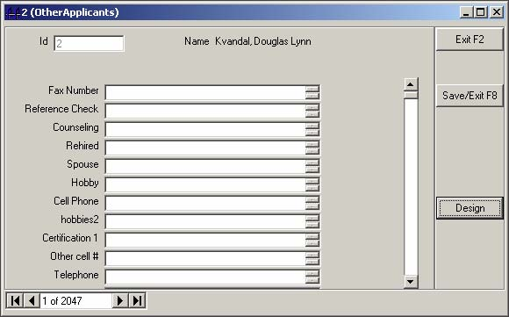

After you have created a custom information screen for a master screen (applicants, employees, customers, etc.) you can easily change the way the screen looks, including the field name, label justification, field size and location for each field.

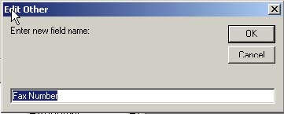

Changing the label name for any field is as easy as double-clicking on the field name and changing the label name. Please note that changing the name of the label does not change any data that may already be stored in the field.

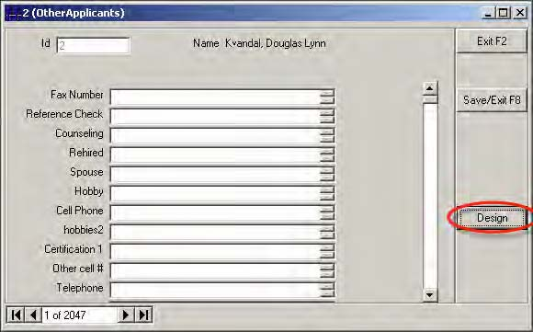

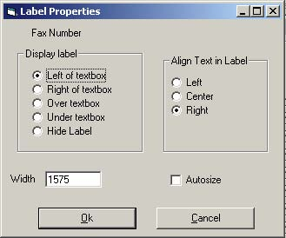

Choosing the Design button and then double clicking on any field will bring up the Label Properties window, where you can change how the label is displayed (or not displayed) on the screen.

##### **Resizing Custom Information Fields**

Additionally, you can move and resize the fields themselves by double clicking on any field, then using your up, down, left and right arrow keys to resize the field boxes. Using the arrow keys in conjuction with the shift key will move the box itself on the screen.

For instance you could design a screen with multiple columns (like a table view) by moving and resizing the labels and fields.

### **Emailing in Temps Plus**

Emailing in Temps Plus JKM is available anywhere the

 or

 button appears on your screen.

You can always email the individual contact on the screen where the

 button appears and the individual has an email address.

Starting with Temps Plus JKM version 3.0.37, additional “bulk mail” features were added to support emailing a group of contacts.

The

 button appears on the customer, applicant, job order, Warboard, AR Customer and all “grid” screens. When you click this button and there is more than 1 record in the recordset (the recordset navigator in the lower left corner of the form shows how many records are loaded), you will be presented with additional dialog boxes that support the “bulk mail” feature.

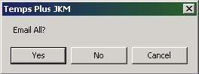

Answering [Yes] to the “Email All?” prompt will take you to the “Email Recordset” dialog window. The email feature will attempt to send emails for every unique email address in the recordset that was selected at the time you pressed the

 button and for which there is an email address. It will skip those records where there is no email address entered or where the email address is the same as a previous record.

For instance, if you press the

 button from the customer screen where you have a recordset of 309 records, the email feature will attempt to email to all 309 customers. It will skip the customers who do not have an email address entered. If more than 1 customer record has the same email address, only the first customer with that address will be sent an email.

Pressing the

 button on the Email Recordset window will search all the customers in the recordset to determine which members of the recordset have something typed in the “Email To” field. The number of records selected (filtered) will be reflected at the bottom left hand corner of the window. If the same email address occurs more than once, only one occurrence of it will be used.

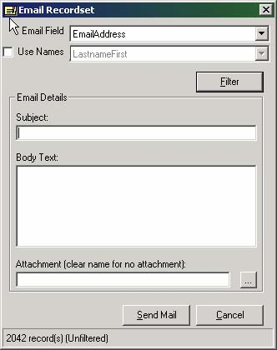

**Email Field** – This box determines which field should be used to find the email address.

**Use Names** – Selecting this option, and choosing an available field from the drop down box will use the selected field as the “To:” description in your email(s).

**Email Details box**

**Subject** – Enter the subject line for your email

**Body Text** – Enter the text of your email

**Attachment** – You may attach a file to your email(s) by entering the full name and path of the file you wish to include with the email.

Pressing the

 button will pass the email information to the email client installed on your workstation. Your email client must be setup as the “default MAPI” email client (consult your operating system support person if you have difficulties with this).

**Some Ideas:**

1. Perform a search of applicants and email all of them about something (such as job availability or tasks they need to perform in order to stay eligible for work)

2. Email all your customers (press [F7] at the “Customer Number” field on a blank customer screen to get all customers). A more useful scenario might be to email only certain customers about promotions or new services you offer to certain types of clients). This can be done by performing a search of customers on a field on the main or info screen (see ????? for information on performing a search on records other than applicants).

3. You can also email to a recordset returned from any query you have created.

### **Emailing Resume(s)**

In Temps Plus you can choose from one of two ways to email resume information to interested customers. With the default method, Temps Plus builds the information to send from the contents of the applicants Resume screen and keywords assigned to the applicant’s record. Features are available in the Keyword Maintenance Screen to designate which keyword categories to include in the build -- and optionally, which keywords within a category to exclude.

The second method requires you to create a Crystal report, which contains the information you want to send and the format you want to present it in. The Email Resumes feature will look for a Resume.rpt file in the Npath. If found, it will create the resumes to be emailed using the crystal report format method instead of the default format method. Additionally, you may also add a ResumXXX.rpt file in the Npath, which will be used by the company code (represented by the ‘XXX’ in the file name) instead of the Resume.rpt file. Regardless, the Resume.rpt must exist to invoke the alternate (Crystal Report) method.

**Note:** The Webhelp website at:

<http://www.bridgewaregold.com/webhelp/reports/VersionHistory/ReportsLibrary_version_history_results.asp> contains default Resume.rpt formats you may use.

Regardless of the method used, a single file is created containing the information for 1 or more applicants. If the default method is used this file can be edited and/or printed prior to emailing and does not affect the applicants' individual records. If the Crystal report format is used, the file is generated and mailed in a single step so it cannot be viewed/edited prior to mailing.

Either method begins the same

After selecting the [Resume] button from the applicant screen, the

 button appears on the command bar at the right side of the window. Also note the number of records selected in the recordset bar.

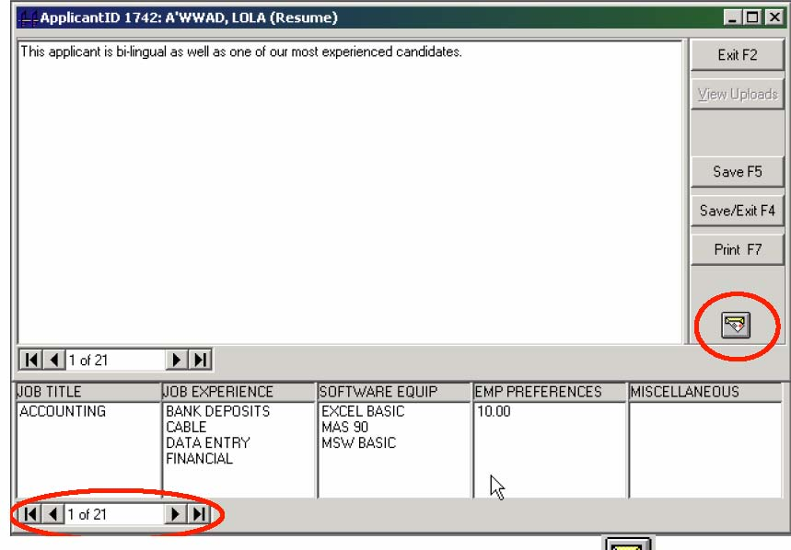

If more than 1 record is in the recordset then pressing the

 button will prompt you with the “Email All?” prompt which allows you to send all resumes in the recordset in a single step.

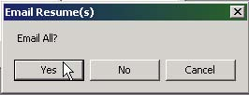

• Entering “Yes” will email all the applicant resumes from the recordset

• Entering “No” will email only the resume for the single applicant

**The Default Method**

If you are using the default resume format, you are presented with an on-screen representation of the resume(s) to be sent. It may take a few moments to create the default file. When the build is complete an informational dialogue is displayed indicating that you can now edit/print the file prior to emailing.

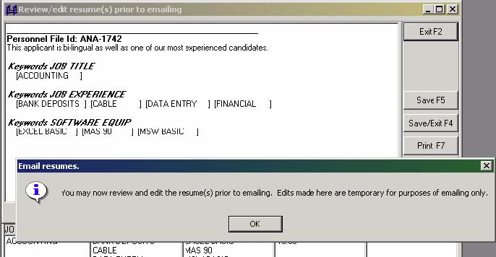

After clearing the dialog screen by pressing the [OK] button, you may make whatever changes to the system created resume file. Notice that any text that appeared in the resume screen for applicant(s) is displayed at the top of each section of the resume(s). Also, only the Company Code and Applicant Id are displayed to hide the indentity of the applicant(s) from the recipient(s).

The keywords for the applicant are also displayed by category. There is a feature in Keyword Maintenance that will allow you to exclude categories and/or keywords from displaying on resumes.

Pressing the [Save F5] button to continue, you are presented with your email client screen, where you may specify the recipient(s) for the email(s) (you may wish to setup a group in your email address book if you wish to send emails to more than one recipient at a time).

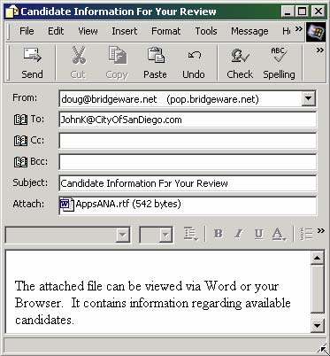

You can edit any other aspect of the message, including additional recipients, etc prior to sending the mail.

**The Resume.rpt Method**

If you’ve opted to use the Crystal Reports Resume.rpt format method, you are presented with a dialogue window that allows you to specify all aspects of the message: the file format of the Crystal report – for example, Rich Text or HTML or an Excel Spreadsheet, etc; the email recipient(s); a subject and the text to be sent in the body of the message. The resume(s) will be sent as an attachment, using the file format specified.

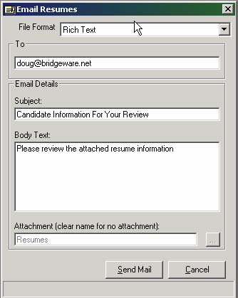

When you press the [Send Mail] button to continue, the Crystal report is created, exported in the format specified, and emailed.

### **Emailing Invoices**

When generating invoices in Temps Plus, you may specify a copy of any invoice being produced to be emailed.

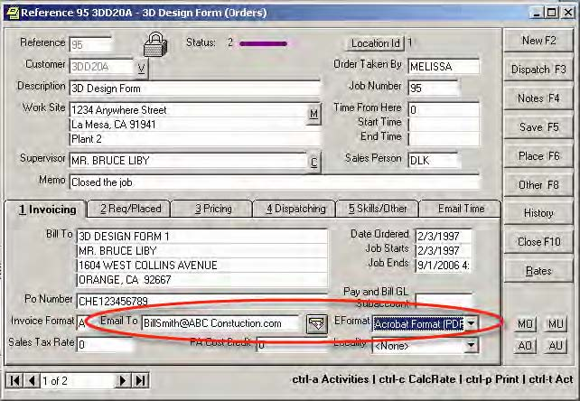

On the appropriate job order which is being used to create the invoicing information, enter information in both the “Email To” and “Eformat” fields.

### **Locations**

The “locations” feature of Temps Plus (version 4 and above) allows you to easily manage multiple sites using a single database.

Previously, multiple company codes (databases) were required to manage individual location job orders, applicants, customers, and reports.

• Database for Location 1

• Database for Location 2

• Database for Location3

Now, you can do so using a single database to manage, analyze and report information by location.

• Single Database with locations 1, 2 and 3

This approach eliminates the need to “combine” databases to get combined reporting and still provides the ability to maintain location information seperately.

Each applicant, customer or order in the system has a “home” location, depending on which location code the user was using when entering the data. You may change the Location Id by pressing the

 button on the screen (*for applicants, customers, or orders*).

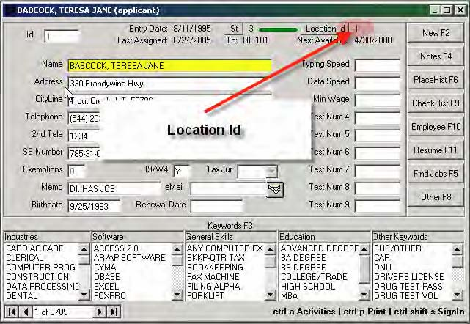



Users are assigned a home location using the security options in the SuperJKM module.

*Accordingly, if a user has a home location of 1, then any applicants, customers, or orders created by that user will carry the location as well.*

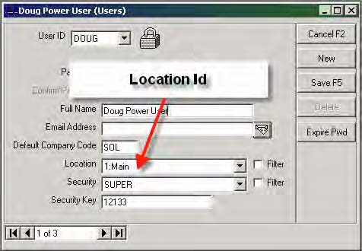

Users may also be set to allow the viewing of all other location information.

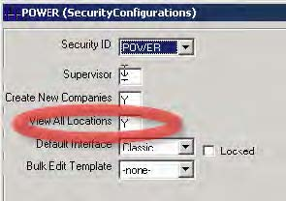

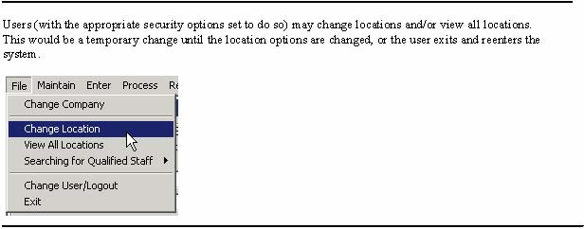

Users (with the appropriate security options set to do so) may change locations and/or view all locations. This would be a temporary change until the location options are changed, or the user exits and reenters the system.

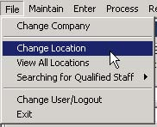

When printing reports, press the

 button to select which locations to include on the report.

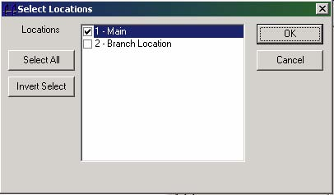

If the user is set to view all locations, by default the report(s) will reflect all locations without making selections in this window.

When appropriate, you may choose to base the report with the location based on the Applicant/Employee, Customer, or Job Order Location.

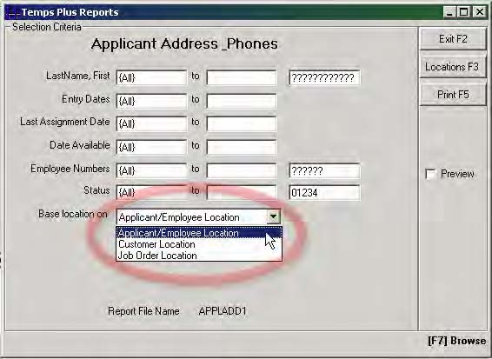

User can see and perform operations for only the location(s) that they are set to at the time.



For instance, a user set to location 1 will not normally see the data entered by a user set to location 2 – unless the user is set to “View All Locations”.

This allows each location to work with only their own applicants, customers and orders – as well as time card entries, checks and invoices. Closing payroll or printed invoices to history will only affect transactions for the location the user is currently set to.

For example, users could enter their own time cards, print checks and invoices using only the data entered while in the location they are currently using. Or, by changing the location or viewing all locations, work with only the data from other location(s).

**Location 1 user sees:**

Entry 1 – location 1

Entry 2 – location 1

Entry 3 – location 1

Entry 6 – location 1

Entry 8 – location 1

**View All Location sees:**

Entry 1 – location 1

Entry 2 – location 1

Entry 3 – location 1

Entry 4 – location 2

Entry 5 – location 2

Entry 6 – location 1

Entry 8 – location 1

**Location 2 user sees:**

Entry 4 – location 2

Entry 5 – location 2

Entry 7 – location 2

**Check Queues**

Check Queues may be setup and assigned to specific locations. This allows different locations to print to different printers in the system as needed.

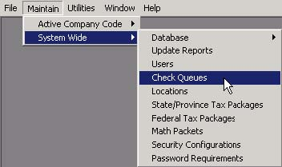

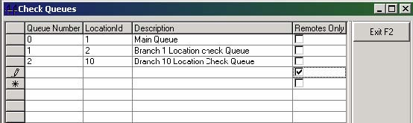

There are many situations for which multiple check queues can be usefull. For example, by using separate check queues, each location could use a different sequence of check numbers assigned for use only at that location.

W



applicants may be searched and used from other locations automatically if locations are setup to usSeamless Resource Locations.

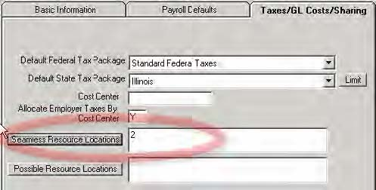

location 2 can automatically be seen or used (without changing the location or viewing all locations)

**S**

### settings for certain deductions and/or taxes

provide an on screen description for certain weekly pay numbers (like the first or last pay of the week) For instance, perhaps you pay certain employees an additional check (such as a bonus, commission, etc.ccasionally, and choose not to have any automatic deductions (such as insurance, 401K, etc.) withheld

o

from such checks. By using a “Special Pay Number”, you can accomplish this task without going throughthe longer process of disabling automatic deductions, printing the checks, then enabling the automatic deductions again.

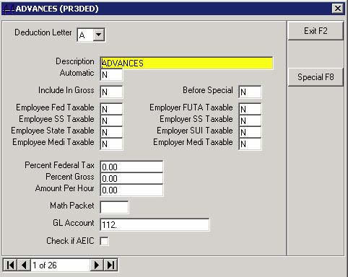

se

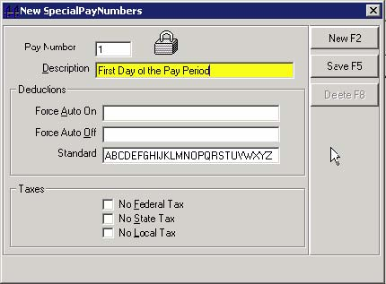

In addition to including or excluding specific automatic deductions, you may control whether Federal or State taxes are withheld, regardless of how the employee screen is configured for Federal and State taxes.

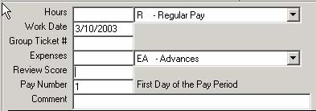

If the Pay Number selected during Time Card Entry has been set up as a "Special Pay Number" the description of the special pay is displayed next to the pay number field (on the time card entry screen) when using the special pay number. This is to provide visual confirmation to the user that special rules will be in effect when the payroll is calculated for any entries created under this pay number.

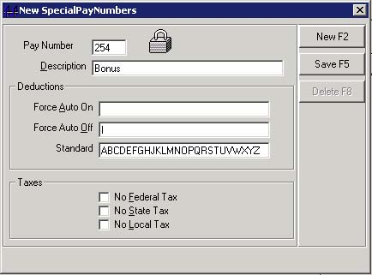

**Description** – Text entered here will appear to the user when using the pay number.

**Deductions** - By placing deductions in the “Force Auto On” or “Force Auto Off” boxes, the Pay Number you setup will force the deduction to be treated accordingly for the deduction. Deduction boxes are mutually exclusive. For example, a deduction cannot be in more than one of the three boxes in the Deductions area simultaneously. The program will assist you by updating the three boxes automatically as you type deductions in the boxes, thereby assuring no duplications.

**Taxes** – You may also disable Federal, State, or Local Taxes for the Pay Number by checking the appropriate box(es) in this section.

#### ***Prior Period Pay Numbers***

Using pay numbers greater than 100 can serve a special purpose in the system. When unpaid entries with pay numbers greater than 100 are encountered during the updating of the current payroll, these entries are renumbered with new pay numbers 100 less than the original pay number (for instance 101 would become 1, etc.).

This allows for the data entry of entries you wish to not become “current” until the payroll is updated. See the section on “Daily Pay Considerations” for more on this feature.Attachments

The attachments feature appears on the main menu bar and adds the capability to add attachments to applicants/employee/orders/customers/placements. The folder for attachments is specified in the Supervisor option under “Features”.

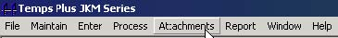

Pressing the Attachments, New menu selection will allow you to add (by browsing or “aquiring” from your scanner) attachments for the applicant, customer, order or placement you are on at the time you press the attachments item.

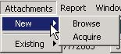

Pressing the Attachments, Existing menu selection will allow you to access or manage existing attachments for the applicant, customer, order or placement you are on at the time you press the attachments item.

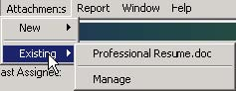

#### ***Drag and Drop***

You may alternately drag and drop attachments to records. To use, drag the file(s) to the heading area of the form for the applicant/employee/order/customer/placement you want the file(s) attached to. You will be prompted for a description and the file(s) will be copied to the attachments folder.

**Attaching Emails**

You can also select a message from Outlook Express and drag it. The text portion will be saved in the attachments folder (if you want to attach the complete message together with any attachments - use Outlook Express to save the message to file and then drag and drop the file.) In Outlook, you can drag any number of selected messages and the message(s) will be copied together with any associated attachments.

#### ***Attachment Templates***

You can create new attachments by using templates written in Microsoft Word. These templates can refer to variables in Temps Plus and these variables will automatically be populated with appropriate data from Temps Plus when the template is attached to a given record.

Variables are implemented using the Bookmarks capability of the Word document. Bookmarks are named placeholders in a document. To create a bookmark, simply position your document cursor at the position in the document that you want to have data inserted. Then, from the menu, choose “Insert>>Bookmark.” A dialog window will open showing all bookmarks that exist in the current document. From this dialog you can create a new bookmark by simply giving the bookmark a legal name and pressing the “Add” button. (You can also manage existing bookmarks from this dialog by highlighting the desired bookmark and clicking the “Goto” and/or “Delete” buttons)

What should you name a new bookmark? For the most part, if you want to refer to data in Temps Plus, simply give the bookmark a name identical to the name of the field in Temps Plus. However, some of the field names in Temps Plus are not legal names for bookmarks. For instance, bookmarks cannot begin with a number, nor can bookmark names contain spaces or special characters. So if you want to refer to a Temps Plus field that has one or more spaces in the field name, simply eliminate the spaces from the bookmark name. And if a Temps Plus field name begins with a number, precede the bookmark name with the letters “bk.” For instance, to create a bookmark that refers to the Temps Plus field “2nd Line Address” in the applicants table, name the bookmark “bk2ndLineAddress”

Bookmarks have another limitation. Each bookmark name must be unique because bookmarks refer to specific positions in the document. What if you want to refer to the same Temps Plus field in more than one place in the document? Simply put a number at the end of the bookmark name to make it unique. For example, “LastnameFirst” and “LastnameFirst1” and “LastnameFirst99” will all be seen by Temps Plus as a request for field “LastnameFirst.”

There are a few reserved bookmark names that can be used to place other Temps Plus information in the document:

“TpUser” – the user creating the attachment

“TpUserEmail” – the email address of the user

“TpUserFullname” – the full name of the Temps Plus user.

“Computer” – the name of the computer the attachment was created from.

“OSLoginName” – the name of the user logged in (at the operating system level)

“TPCoCode” – the name of the Temps Plus company code.

The following are used to grab individual parts of the applicant’s name field.

“FirstnameOfLastnameFirst” gets applicant’s first name.

“LastnameOfLastnameFirst” gets applicant’s last name.

“MiddlenameOfLastnameFirst” gets applicant’s middle name.

“SuffixOfLastnameFirst” gets any suffix of the applicant name (JR, SR, DR etc)

These special names can also be used more than once in a document by giving a numeric identifier at the end of the name (“FirstnameOfLastnameFirst” and “FirstnameOfLastnameFirst99” would both refer to the applicant’s first name.

How does Temps Plus decide which tables you are referring to when you specify a field name? You cannot use special characters in the bookmark name so there is no way of specifying “Table.Fieldname” Temps Plus attempts to find the field name in the currently loaded recordset of the calling form. For example, if you are creating a new attachment for an applicant, the recordset for that form is looked at first. If the field is not found, a secondary recordset is created for the calling form (in this case, joining the applicants, pr3mstr, notes, otherapplicants and resumesapplicants tables) and that recordset is searched.

Once you have established the template the way you want it, save it in the Temps Plus attachments folder with a “.dot” extension (document template) or a “.doc” extension. Using the template extension requires a user to use the “Save As” option when making changes to the document so if you want to make changes to the template itself you must rename it to “.doc”, make and save your changes and then rename it back to the “.dot” extension.

**Integrating the document templates into the attachments feature of Temps Plus**

Each Temps Plus database uses a “Templates” table to store information about your templates. Run dbValidator if your database is missing the Templates table. To integrate your document templates, from the query window, execute the following query:

*SELECT * FROM Templates*

This will return a grid where you can maintain information about your templates. The Id field is automatically assigned so if you are creating a new record, simply leave this field empty. The 3 other fields in the Templates table are discussed below:

“**DescriptionOfFile**” – the description entered here will be displayed to the Temps Plus user in the “Attachments>>New>>Create from template” menu.

“**FileName**” – the name of your template file. Do not include the path – the file must be stored in the Temps Plus attachments folder. Be sure to include the extension of the file (“.dot” or “.doc”).

“**UseWithForm**” – specify “Applicants” or “Orders” or “Placements” or “Customers.”

Any templates marked as “Applicants” can be used from the Applicants/Employee maintenance forms and from the “Who’s Here” grid of Warboard.

Any templates marked as “Orders” can be used from Orders maintenance or from the Orders grid in Warboard.

Any templates marked as “Placements” can be used from the Job Order Placements screen (and Warboard Placements grid) and from the Employee’s Placement History form.

Any templates marked as “Customers” can be used from the Customer Maintenance form.

Menu items in Temps Plus menu “>>Attachments>>New>>Create from template>>…” will automatically be built based on the active form and the templates available for that form.

You can download a sample document that already has certain named bookmarks in use. It is meant to be instructional at 2 levels. Try the new feature by saving this document in your attachments folder and creating an item for it in the Templates table. Specify “Applicants” as the “UseWithForm” value. Call up an applicant and select “>>Attachments>>New>>Create from template>>” and the new item you created should appear there. Select it, and this document will be populated with information about you and the selected applicant.

You can find the sample document named “test.dot” in the GoldPlus40 folder on the bridgewaregold ftp site.

## **Master Screens**

### **Applicant Screen**

The Applicant Screen lets you enter personal data and W4 information, which will automatically be used by the applicant’s employee record when the employee record is first created. You may also enter information that can be used in a search, as well as an optional memo field, optional second phone number, and email address.

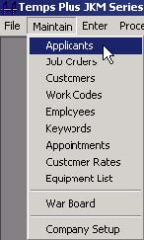

 Changing the Screen

The field labels on your screen may vary from the one shown if you have made changes in the screen definitions in Maintain, Company Information, Screen Defs.

For instance, you may want to change any of the nine number field labels to represent what kind of number you store there. Some examples could include Typing Speed, Minimum Desired Salary, and QWIZ Test Score.

Similarly, you may change the field labels on the two date fields, and the category fields. For example, you might change Category 1 to read “Experience” and Category 2 to read “Software”.

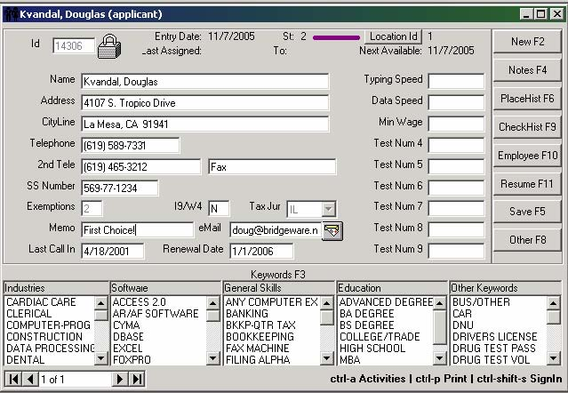

When you first enter the screen, the cursor is in the field labeled “ID”. To create a new applicant record, just press the [TAB] key or click the mouse on any field in the applicant screen, and finish filling out the screen for the new applicant.

*Alternately, you may find an existing applicant by entering a few letters (try the first three letters of the last name) and pressing the [ENTER] or [F7] key. Then choose the applicant you wish from the browse screen.*

While you are entering a new applicant (or editing an existing one), the following action bars are available:

• **[New F2]** - Abandon creating the new record, or abandon the changes if editing an applicant.

• **[Notes F4]** - Brings up the notes screen, where you may create or edit notes for the applicant.

• **[Save F5]** - Saves the new record, or the changes if editing. This action bar only appears if there is something to save.

• **[**Find Jobs **F5]** – This button only appears on a non-blank applicant screen, and when selected will search all customers or job orders for matches to the displayed applicant.

• **[PlaceHist F6]** - Shows any placements that exist for the applicant being edited. If you are adding a new applicant, this action bar brings up the first valid placement, since a new applicant would not yet have any placements. If you press this action bar when the screen is empty, all applicants with active placements are selected.

• **[CheckHist F9]** - Shows any historical check information for the applicant. When chosen, a screen prompting for the range of dates to include appears, defaulting to dates to include the last year of data. To include a specific range of dates, just modify the dates on the screen prompt, taking care to keep the syntax of the prompt shown. A shortcut you may use is to type "+-99" - where "99" is the number of days prior to today's date you wish included in the report.

• **[Employee F10]** - Takes you to the employee screen for the applicant. If the employee record has not yet been created, creates it. If you press this action bar when the screen is empty, all unreviewed (yellow) employees will be selected.

•  **[Resume F11]** - Brings up the resume window, which works just like the notes screen. You may drag and drop anything into this screen, including resumes browsed previously with any browsing software and scanner. You may email a resume (or group of resumes) by pressing the

 button on the Resume screen. See the section on Emailing Resumes.

• **[Other F8]** (Applicant) - Brings up the optional Applicant Information Screen, if it exists.

• **[Search F8]** - Appears instead of [Other F8] when you have a blank applicant screen, or have not yet saved a new applicant screen.

#### ***Applicant Assignment Section***

The top two lines of the applicant record provide additional information about the applicant.

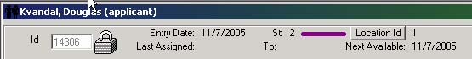

**Id** - The system assigned record number of the applicant.

**Entry Date** - The date the applicant record was first created.

**Location Id** – If you have multiple locations, the “home” location for the applicant. You can change the location by pressing the Location Id button.

**Last Assigned, To, Next Available** - The last assignment and next available date from the last job order the applicant was assigned to.The "To:" field identifies the customer number.

**[St] (Status Button)** – Selecting this button for an applicant will toggle the applicant status between active and inactive.

#### ***Demographic and W4 information***

Most of the fields on the screen are used for storing demographic information, except for the Marital, Exemptions, and Tax Jurisdiction fields (which are used to assist with default payroll tax withholding information when an employee record is first created). Some fields (such as the Marital Status, Taxing Jurisdiction and Exemptions fields) are carried over to matching fields on the employee screen.

**Address Line** - You can enter a 2 line address in the applicant maintenance form by separating the first and second lines in the address field with a pipe character (|). For example, if you enter "Suite 100|123 Main Street" then "Suite 100" will be stored in the [Address] field of the applicant's record and "123 Main Street" will be stored in the [2nd Line Address] field of the applicant's record.

When the data is retrieved from the applicant record, if the [2nd Line Address] has something in it, the pipe character will be added to the end of the address and the contents of [2nd Line Address] will be appended.

Once the employee screen is created, the matching fields on the applicant and employee screens are independent, and as such may be maintained separately. More importantly, changes to these fields will not automatically update the corresponding fields.

The “Sex” and “Marital Status” fields only show upon initial entry of an applicant. After that, the fields are no longer shown on the applicant screen. They may be found and changed on the employee screen.

#### ***Numeric and Date Fields***

Two date and nine numeric fields are provided for searches. When searching on these fields, "conditional" criteria is used.

#### ***[Keywords F3]***

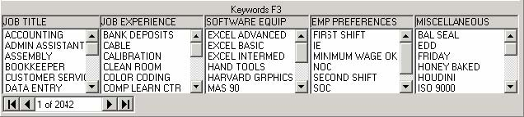

The keyword screen allows the assignment of keywords from the dictionary to the applicant's screen. The screen can be activated by pressing the F3 command bar or F3 function key - or by moving the mouse over any category title in the keyword section of the applicant screen. The cursor will change to a magnifying glass, at which point a left mouse click will bring up the screen.

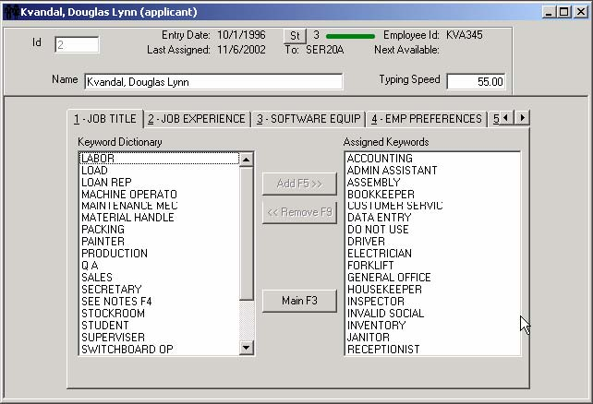

You may move keywords from the dictionary windows on the left to the category windows on right by double-clicking with the mouse on a single keyword. Keywords may also be moved from right to left by double-clicking on a keyword in the category window.

The standard Windows marking conventions also apply here.

• Selecting a keyword while the Ctrl key is depressed selects keywords, without deselecting any previously selected keywords.

• Selecting a keyword, then selecting another while the Shift key is depressed will select all keywords between the two selected keywords.

After selecting several keywords, press [Add F5 >>] to move them en masse.

Use [<< Remove F9] to move keywords from categories back to the dictionary, and [Main F3] to return to the applicant screen.

#### ***Performing a Search***

Pressing the F8 command bar from a blank applicant screen initiates the search routine. It may also be started while inserting a new placement from the placement screen of a job order. Searching from within a job order has the added advantage of excluding applicants whose employee record does not have a status of "active".

A search may be performed on any item within the applicant screen by choosing the appropriate tab from the search screen and selecting the item to be searched. Tabs are available for each keyword category, date fields, numeric fields, as well as the other information fields on the applicant screen.

Searches may be on a "must" or "must not" match basis for keywords

Searches use "conditional" criteria for all other types (as dates, numbers, etc.)

Searches use "and" logic when selecting multiple items on a search, but may also use "or" logic for additional items by selecting the "Or" checkbox on the search screen.

##### **Printing Your Search Results**

From the “Search Results” screen, pressing the Alt-P key sequence presents the “Print Search Results Dialog Box”, where you may enter a title to be included on your printout.

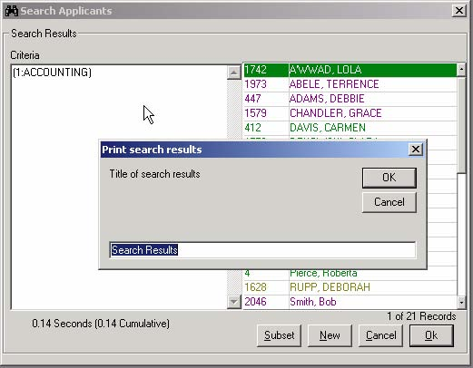

###### **Modifying Your Search Results Printout**

Next, the “Search Results Grid” is displayed. This screen shows all the information available to be printed in a column and rows format. You may change how the data is displayed in this grid by moving, changing the size, or eliminating columns of data. This is accomplished using standard “spreadsheet” type mouse movements (grabbing a column boundary line and shrinking or expanding the column, grabbing a column heading and moving it to a new location). To eliminate a column, shrink the column size to nothing using your mouse.

You may print directly from this screen by choosing the Print [F7] command bar, or choose from a list of previously saved “layouts” by choosing one from the “Saved Layouts” box.

Saved Layouts

After making changes to the Search Results Grid, you may save your changes in a “Layout” by pressing the Layout [F10] command bar, and giving the layout a name.

These layouts are stored in each user’s program folder in a file named “search.grx”. You may copy this file from one user’s program folder to another user’s program folder, if you wish to share previously saved layouts created by a user.

#### ***Find Jobs***

Choosing the [Find Jobs F5] button on the applicant screen will present a dialog box with choices of how to search for job orders for which the applicant is qualified.

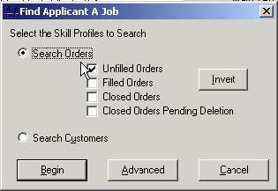

You may [Search Orders] by:

• Unfilled Orders

• Filled Orders

• Closed Orders

• Closed Orders Pending Deletion

• Any combination of the above

Alternately, you may [Search Customers], or by pressing the [Advanced] button, enter a custom limiting phrase to search by.

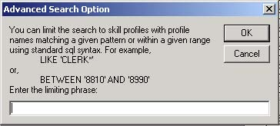

What’s returned after the search is completed is a “recordset” of the job orders (or customers) that were found.

### **Job Order Screen**

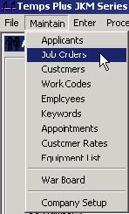

The Job Order Screen is divided into several sections:

General Information

Invoicing

Required/Placed

Pricing

Dispatching

Skill Profiles/Other.

Additional action bars allow access to:

[Dispatching F3]

[Notes F4]

[Placements F6]

Custom Information Screen [Other F8]

[History]

Customer [Rates]

Four “quick-action’ buttons are provided as well - [MO], [MU], [AO], and [AU].

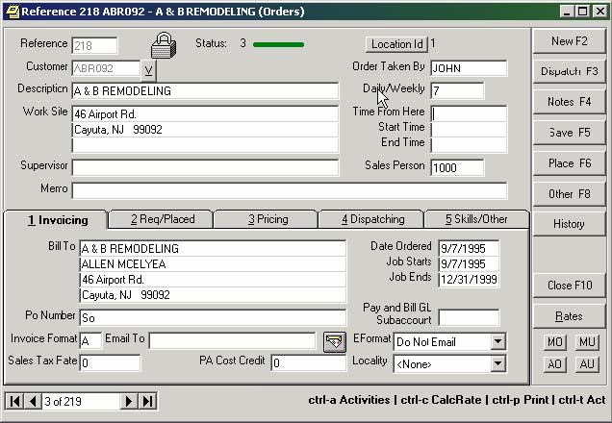

Pressing the [Browse F7] or [Enter] key from a blank job order screen will browse only orders marked with a dispatcher that matches your User ID where the dispatch date is greater than or equal to the current date.

#### ***Job Order General Information***

##### **The Billing section**

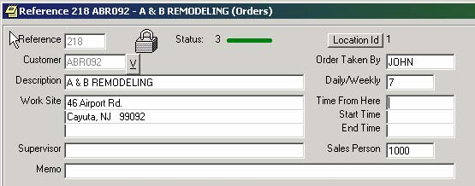

**Reference Number** – This number is automatically assigned by the system, and will display the word “New” when a new job order is being created, but not yet saved.

**Customer Number** - The Customer Number to assign all billings to in Accounts Receivable for this job order.

You may jump directly to the customer screen by pressing the

 button directly to the right of the Customer field.

**Job Description** - An optional name for the Job Order. By default, the Customer Name is used when creating a new Job Order. Change it if you would like something different to show while browsing Job Orders.

**Work Site** - Enter the physical address where the work is to be performed. The default is the customer address.

**Supervisor** - Enter the person to report to at the job.

**Memo** – You may enter a short description here for any purpose that suits you.

**Order Taken By** - By default, the User Id of the person that created the order is shown here. Change it if you would like the User Id to be different

**Job Number** –By default, a number will automatically be assigned to this field. You may change it to match a source document from your paper work.

**Time From Here** - Enter a number that represents the time (usually in minutes) necessary to travel to the job.

**Start Time** - Enter the daily starting time for the job.

**End Time** - Enter the daily ending time for the job.

**Sales Person** - All billing transactions created from this Job Order will carry the 1 to 4 character code entered here. The default is whatever is in the Sales Person field in the Customer screen in the Temps Plus JKM module.



**The Status Bar** – This section of the screen uses Color Bars to displays that status and color of the job order, as well as the The location id of the order.

You can change the location by pressing the

 box.

#### ***1 Invoicing Tab***

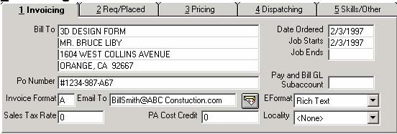

**Bill To Lines 1 to 4** - The name and address information, which can appear on all invoices for this Job Order.

**PO Number** - Use this field to assign an optional purchase order number to the Job Order.

**Invoice Format** – If you are using multiple invoice formats, specify the format letter to be used with this Job Order.

**Email To** – You may enter an email address here. Later, pressing the

 icon will automatically bring up a new email form (from your default email application – if it is MAPI compliant) with the address already filled in to the recipient. You must fill in this field if you wish to automatically email a copy of any invoice printed for this job order.

**Eformat –** This drop down box allows you to choose a format for the invoice being emailed. When in doubt, Rich Text is a choice that works well for many users. If you do not wish a copy of the invoice to be automatically emailed, you must choose “Do Not Email” (which is the default). The “Email To” field will determine where the invoice is emailed.

**Sales Tax Rate** - If you wish to calculate sales tax for invoices, enter the percentage here. You must have your invoices formatted to show the sales tax. You must also set the “Subject to Sales Tax” flag to yes on any work codes that are taxable.

**PA Cost Credit** - This is a special field used only for the state of Pennsylvania.Services are taxable in Pennsylvania. However, they are only taxable on the percentage of the sale that excludes your operating expenses. Therefore, you may enter a "cost credit" as a percentage in the "Pricing" screen of the job order that will be excluded when calculating the sales tax.

**Locality** - This field can reference a user defined "locality code" for use in tracking "local taxes". Set these codes up in Setup, Company Information, Maintain, Localities. See the appendix section on local taxes for more information.

**Job Number** - This number is automatically assigned for you when a new Job Order is created. You can override it (in order to match a physical document in your office).

**Date Ordered** - Enter here the date the Job Order was actually ordered. The default is the current date.

**Job Starts** - Enter the date the Job Order is to start. The default is the current date.

**Job Ends** - Enter the date the Job Order is to end. The default is no date (in other words, an open ended order).

**Pay & Bill GL Sub Account** - This allows you to attach a SubAccount to all entries generated from this Job Order. SubAccounts are 1 to 6 character codes that can appear to the right of the decimal point in the General Ledger account number. This could be used for branch reporting (or any other departmental reporting). The appropriate general ledger account numbers with subaccounts should already exist in your Temps Plus Chart of Accounts, as well as any interfacing General Ledger module, since no verification is done, and the subaccount is automatically attached to the transactions.

#### ***2 Req/Placed - Job Requirements Tab***

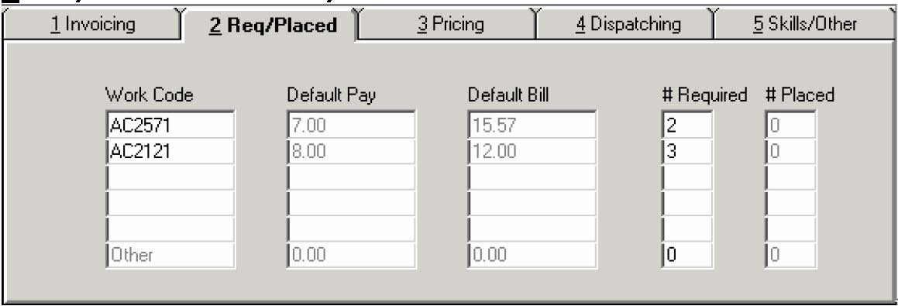

If items are entered in this section, they will be used as defaults when entering placements. You may choose not to enter the pay and bill rates so that the defaults when entering placements are zero and must be entered by the person doing the actual placement.

The idea here is that you may tell the system what the customer is requesting. This information will be compared to actual placements and used in determining the status of an order (and its color code).

**Work Code** - Enter (or browse for) the 1 to 6 digit work code required to fill this Job Order. These Work Codes may already have been created in the Work Code file (using Maintain, Work Codes), or you can enter a new code “on-the-fly” by typing the new work code and pressing the enter key. You may enter up to 5 lines of work codes.

**“Other” Work Codes** - If you have more than 5 lines of Work Code requirements, you may group any others on this line. This will allow you to track the required and placed for “Other” codes than those specifically on the first five line.

A sixth line titled "Other" can contain totals for any additional work codes (other than the first five) you wish to track.

**Default Pay, Default Bill** - Enter the pay and bill rate for each work code line. The amounts will default to the amounts in the Work Code Maintenance Screen.

**# Required** - Enter the number of placements needed to fill the order for each Work Code line.

**# Placed** - This field is automatically updated by the system. It reflects the number of placements on the Job Order for each Work Code line. You cannot alter this number, except by changing the placement screen.

#### ***3 Pricing Tab***

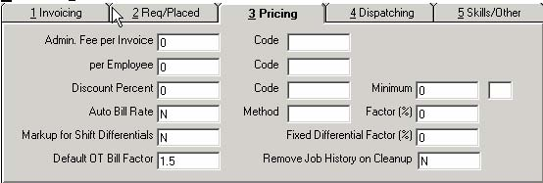

This section provides a variety of data entry fields to control various features of the job order.

**Administrative Fee Per Invoice, Code** - You may have the system calculate and charge an administrative fee per invoice and attach a work code to the transaction. Enter a fixed amount and the work code you wish to use.

**Administrative Fee Per Employee, Code -** You may have the system calculate and charge an administrative fee per employee included on the invoice and attach a work code to the transaction. Enter a fixed amount and the work code you wish to use.

**Discount Percent, Code, Minimum and Basis -** You may have the system calculate and enter a discount percent based on a minimum billing (or quantity of hours) for a single invoice. Enter the percent, work code, and minimum amount to use for the calculation. The final text box on this line is for specifying the discount basis. Enter an "H" if the minimum is based on or a "D" if the minimum is based on dollars.

**Auto Bill Rate** - You may have the system automatically determine bill rates for placements on the order based on a percentage markup of the pay rate by answering "Y" to Auto Bill Rate. This field is used in conjunction with "Method" and "Factor" as explained below. The Auto Bill Rate feature is only applicable if you are NOT using the Customer Rates feature for the given customer. When Auto Bill Rate is in effect, the user cannot get to the Bill Rate field for placements (or in the Defaults tab of the Job Order). Rather, the user simply enters a Pay Rate and the system computes the Bill Rate.

If you change the factor or method on an existing order with existing placements, the system does not automatically update the existing placements although it will update all the defaults in the "Defaults" tab of the Job Order. *Note: If you wish to change the rates on the existing placements, you may use an SQL statement to do so or you can selectively update each placement you want changed by going to the Pay Rate and appending a "+0" to the existing pay rate. This results in adding 0 to the Pay rate and the Bill Rate will then be recalculated.*

**Method** - Used in conjunction with Auto Bill Rate. Enter a P to calculate the bill rate based on the pay rate times the Factor %. Enter a C to calculate the bill rate based on the effective pay rate with the workers comp rate factored in.

**Factor %** - Used in conjunction with Auto Bill Rate. Enter the percentage to use when calculating the Auto Bill Rate.

**Markup for Shift Differentials -** Answer yes if you are using shift differentials and want to mark them up, or if you have certain deductions designed to be marked up on pass through to billing.

**Fixed Differential Factor % -** Only applies when "Markup for Shift Differentials" is set to "Y." Enter the % to mark up shift differentials that are specified as flat amounts. For example, if a given Work Code has a 2nd Shift differential of 25 cents/hour, the percentage entered here will be used to mark up that amount. Also, if you have certain deductions designed to be marked up on pass through to billing, they will be marked up by the factor specified here.

**Default OT Bill Factor** - If you wish to use a default OT markup rate of other then the normal 50%, enter the amount here.

**Remove Job History On Cleanup** - This applies to the Company Maintenance option, “Clean Up Job History Files” option in the Utilities Menu, Sub-Option B (Clean Up Temps Plus Files). That option is date sensitive. It only removes Job History up to and including a cutoff date you supply. Answering yes here will delete all history for this Job Order, regardless of the cutoff date entered

#### ***4 Dispatching Tab***

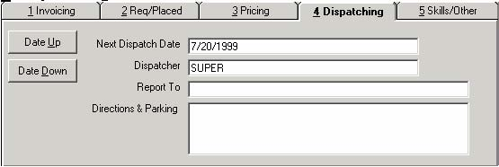

Pressing the [4 Dispatching] tab or the [Dispatch F3] action bar allows you to enter information for how a currently displayed order should be handled by the system for dispatching.

The Dispatching Feature is helpful in presenting you with Job Orders that need attention according to the information entered on the dispatching screen. When you browse Job Orders without entering anything in the Reference field, it displays the browse screen with the Job Orders ordered by dispatching information, using the last date and dispatcher name entered for the Job Order*.* The idea is that the browse will display the orders that need attention first as the first orders in the browse.

**Next Dispatch Date** - Enter the next date you wish to be used to position this order with the dispatching feature.

**Dispatcher** - Enter the User Id for the dispatcher name to be used to position this order with the dispatching feature.

**Report To –** Enter an optional name to report to.

**Directions & Parking** – Enter optional information for Direction & Parking.

You can use the [**Date Up**] and [**Date Down**] action bars to move the date by one day at a time, instead of typing in the date manually. You can also use date math shortcuts (see Data Entry Shortcuts) in the Next Dispatch Date field.

#### ***5 Skills/Other Tab***

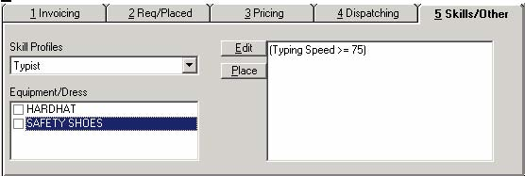

The Skills/Other tab provides a way of attaching one or more skill profiles to an order, placing employees based on a given skill profile as well as identifying any equipment or dress requirements for the order in the Equipment/Dress list.

The list of available equipment/dress items may be maintained under the Maintain, Equipment List selection from the menu bar. If you have added or changed Equipment/Dress items you should close and re-open the Job Order Maintenance screen so that your changes are reflected.

The list of Skill Profiles can be selected, added to and/or changed by pressing the [**Edit**] button. Creating and Maintaining Skill Profilesis discussed at length in the Customer Maintenance section. The big difference when maintaining a Job Order is that the Skill Profile list is presented in a way that allows you to place a check mark next to any Skill Profile that applies to the particular job at hand. You can select any and all Skill Profiles that are applicable to the current job. The selected profiles will appear in the drop down list of profiles in the Skills/Other Tab.

You can then select the profile you want to work with from the drop down list in the Skills/Other tab and press the [**Place**] button. You will be taken to the standard placement screen for the job order -- but with a couple of important differences from pressing the standard Place button: all available applicants satisfying the Skill Profile you are working with *that are not already working for that customer* will be selected in the Search Results window of the placement screen. If the given Skill Profile is linked to a customer rate, you will automatically be put in insert mode with the Pay Rate/Bill Rate and Work Code already selected. If the Skill Profile is not linked to a customer rate, you will be prompted for the default work code prior to being taken to the insertion mode.

For more information about finding possible employment for an applicant read about the Find Jobs button on the Applicant Maintenance screen. For more information about finding applicants/employees matching the requirements of a given profile see both the Find Staff button on the Skill Profiles Maintenance screen and the Placements - [Place F6] button, in the [***5* Skills/Other**] tab of the Job Order Maintenance screen.Once the skill profile is created, the applicant database can be searched (from either the Applicant Screen, Customer Screen, or Order Screen) for matches to the skill profile.

##### **The MU (My Unfilled) or the AU (All Unfilled) job orders buttons**

When you press the MU or AU buttons, all “red” or “yellow” job orders are selected in the current recordset of orders.

“UNFILLED” job orders (displayed as a “red” status) are orders for which there are currently no placements. These could be orders which have never had a placement, or orders where the total number of active placements is zero.

“PARTIALLY FILLED” job orders (displayed as a “yellow” status) are orders where there are currently less active placements than are required. If *any* “Reqd/Placed” line has fewer active placements than are specified in the required column, then the job order will have a partially filled status.

##### **The MO (My Open) or the AO (All Open) job orders buttons**

When you press the MO or AO buttons, all *open* job orders are displayed. This includes orders with a color status of green, yellow or red (closed orders are displayed as magenta or blue, depending on whether the order has been marked for deletion (blue)).

##### **Managing your Job Orders**

If your orders are not kept up to date, these buttons will not be of much use to you. Therefore, when adding or closing placements, you should update the “reqd/placed” section of the job order.

For instance, you have an already filled job order (green). The client calls and requests another placement for the same job order. If you do not update the “reqd/placed” section on the job order, it will remain showing as filled. In order to track the job order as partially filled (you need one more placement), you must update the “# Required” column to reflect the new total of placements necessary to fill the job order. In this example, if you had three required and three placed, you would change the “# Required” to four.

You may wish to review your Help screens for information on “Closing Job Orders”, “Color Bar Meanings While View Job Orders”, and “Color Bar Meanings for Placements”.

##### **What makes an order “MY” order?**

The user name assigned in the dispatching tab is the user that is seen as responsible for the order. By default, this is the person who entered the order although any user name can be entered there – or it can even be left blank. So when you press the MU or MO buttons, the system selects orders where the dispatcher is set to your user id.

While we’re at it, you can use the next dispatch date to use as a tickler for when to follow up on an open order. When you press F7 at a blank job order screen the system retrieves all open orders where your user id is assigned as the dispatcher and the next dispatch date is greater than or equal to the current date. It then sorts the records according to next dispatch date.

#### ***The Notes section - [Notes F4]***

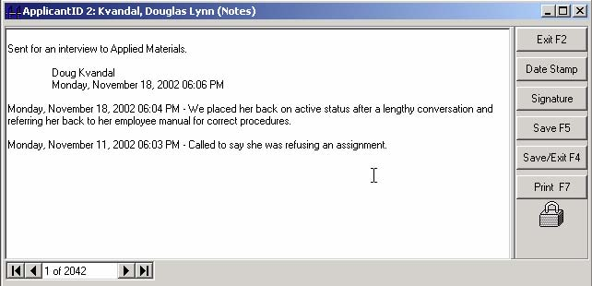

This screen can contain not only typed text, but also any Windows object. Just drag and drop the object into the screen, or cut and paste it to the note screen.

You can use the [**Date Stamp**] action bar to insert the date and time at your cursor position into the text.

Use the [**Signature**] action bar to insert the user name and date (including day of the week) into the text.

 Windows Shortcut - As an alternative to dragging and dropping, after cutting or copying an object from Windows Explorer (or another application), press [Ctrl-V] to paste into the notes screen.

#### ***Placements - [Place F6]***

Pressing this action bar when there is no job order on the screen will select all orders with expired placements.

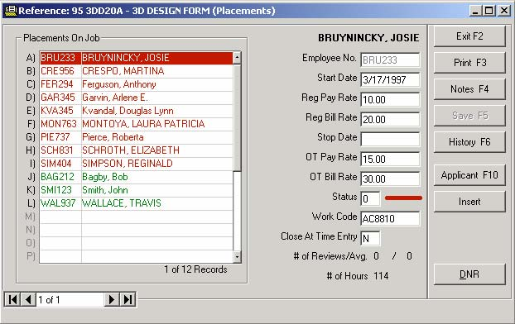

If this is a Job Order with previous placements, the screen with the existing placements appearing in a window will appear. Refer to the color bars section for information on the color code meanings.

##### **Inserting A New Placement**

From this screen you may press [**Insert**] to insert a new placement, or choose an existing placement to edit.

If this is a new job order, the Default Work Code screen will appear to select a default work code for any new placements you are about to enter.

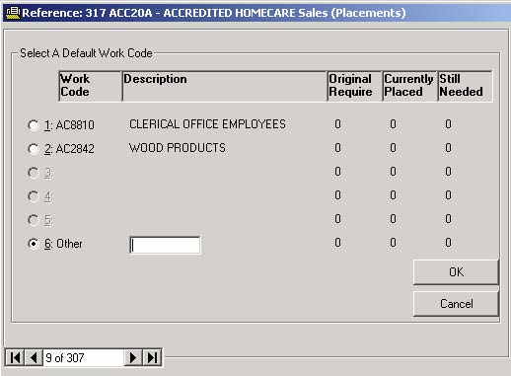

The screen will only show codes entered in the job requirements section of the Job Order Screen. You may alternately choose any other code in the system by choosing the “6: Other” selection and entering the desired work code.

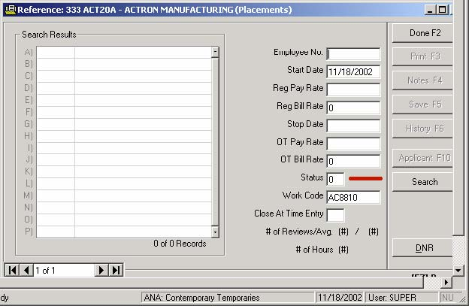

At this point you may enter the new placement by filling out the various fields. This procedure applies when editing an existing placement, or adding a new one.

**Employee Number** - Choose the person you wish to place on the order by entering either the employee number, the applicant record number, or by entering letters from the persons last name, followed by the [ENTER] key. If the person does not yet have an employee record, the system will create the employee record for you and it will appear during applicant browsing as yellow, as an unreviewed, placed employee.

**Start Date** - Enter the starting date for the placement. Note that you may have start and stop dates for each placement, as well as overall start and stop dates on the entire Job Order. The default is the Start Date on the entire Job Order.

**Reg Pay Rate** - Enter the regular pay rate. The default is the amount from the requirements section on the job order for the work code you are using for this placement.

**Reg Bill Rate** - Same as above, except enter the regular bill rate.

**Stop Date** - You may enter a stop date for this placement. The default is the end date on the entire Job Order.

**OT Pay Rate** - Enter the Overtime Pay Rate. The default is 150% of the Reg Pay Rate.

**OT Bill Rate** - Same as above, except enter the overtime bill rate.

**Status -** This field defaults to “0”, and determines the status of the placement.

0 = Active Placement

3 = Closed Normally

1,2,4 are reserved for user-defined closings. See the section on Color Bars for more information.

**Work Code -** This is the code you are using for the placement. In the case of a new placement, it will default to the work code chosen from a previous screen. If you are editing a placement, it contains the work code used the last time the placement was created or edited.

**Close at Time Card Entry** - If you would like the system to prompt you to automatically close the placement the next time it is selected during time card entry, set the status field to "3" and this field to "Y".

**# of Reviews/Avg** – This section will show (if you are using the employee reviews feature), the number of reviews and a running average, as well as updating the customer satisfaction index on the job order screen.

**# of Hours** – Shows the number of hours for the highlighted placement.

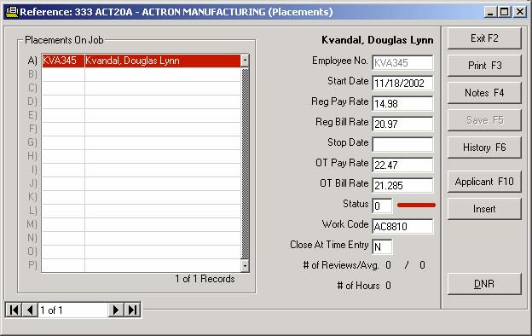

After saving the placement by pressing [**Done**], the placement is added to the “Placements On Job” window. At this point you can add more placements, edit any other placements on the job, or choose one of the action bars in the action bar.

#### ***Place and Print [Print F3] or [Print Shift-F3]***

You can print a work ticket for any highlighted placement by pressing [**Print F3**]. [**Print Shift-F3**] will print a group ticket that includes all active placements on the order. You must use the keyboard to choose Shift-F3 and not the mouse to print a group ticket.

**For any highlighted placement:**

[**Notes F4**] - Enter or edit notes for a highlighted placement.

[**History F6**] - View Placement History

[**Applicant F10**] - Open Applicant Screen for the placement

#### ***[DNR] – DO NOT RETURN***

When you want to prevent an employee from being assigned to a given customer you can set a DNR for the employee by highlighting the placement record and pressing the DNR button on the Placement (or placement History) screen. The system will ask for a confirmation and if you respond in the affirmative it will create a record BASED ON THE SOCIAL SECURITY NUMBER in a special table in the TpCtrl database. It will then search all active placements and shut down any that the DNR has been set for. A DNR that has been set in error can be released by pressing the same DNR button -- it acts as a toggle. When a DNR is removed the placements are NOT automatically reactivated.

If you have a problem with an employee and you don't ever want to send them to any customer you can call up the individual's Employee record and press the DNR button. Again, you will be asked for a confirmation. If you choose to create the DNR the system will shut down all placements for the employee and set the employee's status to "terminated". You must have supervisor equivalence to set an employee DNR.

##### **Security Options for DNRs**

There are 3 menu objects that can be used to control users' access to setting and releasing DNR records. You can use the Temps Plus security editor to add these 3 menu options and they will then appear in the User exclusions table of the User Maintenance Screen. The names of the menu objects and their functions are:

mnuDNRs - use this option to disable a user's access to any DNR function

mnuDNRCustomer - use this option to disable a user's access to setting/releasing DNRs for employees to a given customer. It will disable the DNR buttons on the Placement and Placement History screens.

mnuDNREmployee - use this option to disable a user's access to setting/releasing global DNRs for SS Numbers. It will disable the DNR button on the employee screen. (If an employee does not have supervisor equivalence they will not have access to the DNR button on the employee screen.)

DNR's are universal. If you set a DNR for a Social Security number, that SSN will be blocked in all Temps Plus company codes. If you have already hired the employee in multiple branches it will not shut them down automatically in all branches -- but any future placement activity will be barred.

For a complete list of the object that may be used in the security editor, see Security.

#### ***Job Order Information Screen - [Other F8]***

If you have setup the optional Job Order Information Screen in Maintain, Company Information, Screen Defs, Other Orders, you may view and use the screen by pressing [**Other F8**].

#### ***Billing History - [History]***

Pressing the [**History**] action bar when there is no order on the screen will select all orders with billings in the last 30 days.

Pressing the [**History**] action bar will display a browse type list of any past placements. Selecting any placement and pressing [Details] will display the “Billing History” window. Historical billing information for the selected placement may be viewed here, in summary or detail – by Job or for all jobs for the customer on the job order.

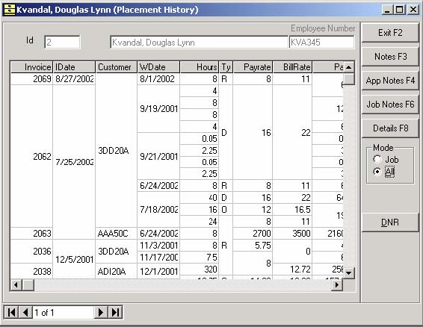

 Every column can be resized by dragging the column separator lines between each title field. You may also drag a column to a new location.

If you drag a column to the first column position, you will be prompted “Sort in Descending Order?” Answering “no” will sort in ascending order.

#### ***Rates [Rates]***

Customer “Rates” are work codes with specific pay and bill rates that can be custom configured for each customer.

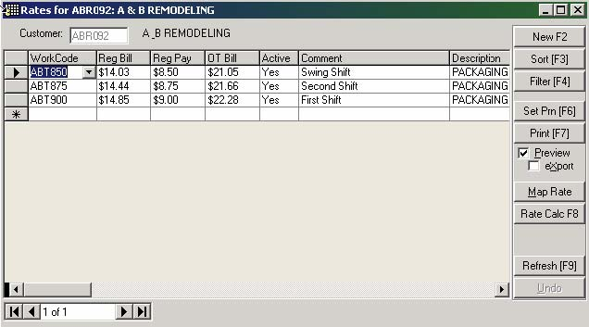

This can help insure that data entry made on job orders for each client for which rates are setup is limited to those rates. You can also access this feature from the customer screen.

#### ***Close Job Order - [Close F10]***

Pressing the [**Close F10**] action bar when there is no order on the screen will select all orders scheduled to close - making it easy for you to scroll through and attend to those orders.

You may close the job order by pressing [**Close F10**]. Closing a job order does not remove it from the system. It just sets the status on all placements on the job order to closed and sets the job order itself to closed.

If you have active placements on the job order, you will be prompted, "Are you expecting final time cards?" Answering yes will close the placements and place a "Y" in the "Close at Time Card Entry" field on each placement, as well.

You will also be prompted, "Do you want to mark this order for deletion?” Answering yes will not delete the order, but "mark" it for deletion. Any orders marked for deletion can be deleted later using a utility option.

You may reactive the order by accessing the order again later.

 You may REOPEN a closed order by:

Adding or reactivating a placement on the order.

Pressing the [F10] key will toggle an open order to closed, or open a closed order.

#### ***Closing Job Orders***

As job orders finish, you may close the job order. You may also close individual placements on job orders without closing the entire job order.

##### **Closing an Entire Job Order**

When you close an entire order, all placements that have not yet been closed are marked as closed normally and display as green while browsing placements. The closed job order itself also shows as magenta while browsing job orders.

Closing a job order is not irreversible unless you mark a job order for deletion, and actually delete it using the utility option to remove job orders marked for deletion. Editing a job order will reactive it for you, but the placements on it automatically remain closed.

##### **Closing Individual Placements**

Sometimes you may wish to close a particular placement on the job order without closing all other placements on the job order.

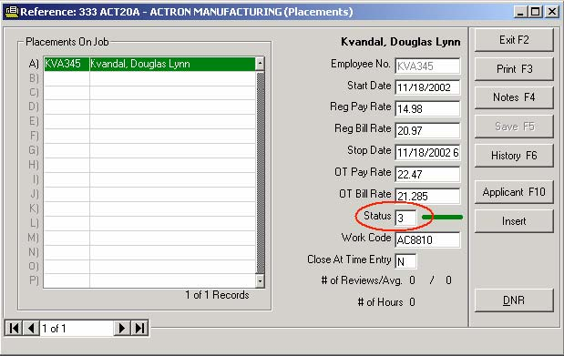

 You may edit the status field with the code signifying the status you wish to apply.



The colors displayed while browsing placements change to reflect the status here.

Closing an entire job order changes all status “0”(active) placements to “3”(closed normally).

You should also change the Stop Date to reflect the date the placement was closed.

To close a placement (one that is red), double-click your mouse on the placement you wish to change.

Remember that reactivating a job order does not reactivate the placements. They remain closed until you reactivate them.

Consult the detailed section on Color Bars for an in depth discussion of color bar coding and status numbers.

### **Time Card Entry Screen**

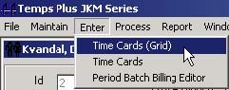

Time Card entries can be made for groups of employees or jobs where all hours are the same using the Group Time Card Entry screen. This is the screen that initially appears upon choosing **Enter, Time Cards (Grid)**. In addition to the Time Card Entry Grid Screen, there is an alternate time card entry screen.

#### ***The Group Time Card (Grid) Entry Screen***

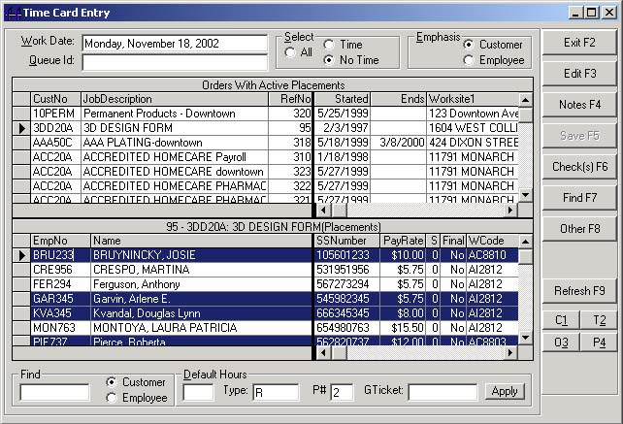

Each employee you wish to pay must exist as a placement on a Job Order.

##### **Selecting Multiple Placements**

You may highlight more than one non-contiguous record from the top or bottom pane by using [**Ctrl**] on your keyboard while selecting records with your mouse.

You may select contiguous records by pressing [Shift] on your keyboard (after first selecting one record) and selecting the last record you wish to highlight. This conforms to standard Windows selection conventions.

##### **Emphasis**

View employees to be paid by Customer or Employee Emphasis by selecting the Emphasis, Customer or Employee buttons.

• Customer emphasis displays all placements (in the bottom pane) for the job order highlighted in the top pane of the window.

• Employee emphasis displays all job orders where the employee is placed (in the bottom pane) for the employee highlighted in the top pane of the windows.

##### **Selecting Multiple Placements – Batch Entry Mode**

1. Select the group of employees (or job orders) to which you wish to apply hours.

2. Enter information in the Default Hours section at the bottom of the screen, and press [Apply] to create entries for all highlighted records.

3. Press [Checks F6] to send the entries immediately to the Check Queue.

##### **Find - [Find F7] – Group Time Card Screen**

Entering characters into the Find area at the bottom left-hand corner of the screen will start searching your placements for matches based on what you type. You can choose Customer or Employees.

For example, you could scroll down to find job orders for a customer “Kitchen Warehouse” using the scroll bars, or you could enter the letter "K" in the find box (with the Customer button selected) and the screen will jump to the first customer starting with the letter "K". Entering more letters (like "KIT" will attempt to find the first customer starting with the letters "KIT".

Remember that you can be in Customer or Employee Emphasis. Choosing to "find" a customer while in Employee emphasis will search only customers for the currently highlighted employee. Likewise, choosing to "find" an employee while in Customer emphasis will search only employees for the currently highlighted customer.

##### **Other - [Other F8] (Employee Group Time Card)**

You can access the custom information screen for the highlighted employee by pressing the [**Other F8**] action bar.

##### **Select Screen Views (All, Time, No Time)**

If you are viewing entries while you have the "No Time" button selected, you initially see only active (or closed awaiting final time card) placements with no time yet entered this payroll period, and *only show placements that have started on or before the time period being entered*. The next time you enter the Time Card Entry screen, the entries displayed on the screen will have changed to reflect the data entry you did in the previous session and those entries made will now be displayed only when choosing the "Time" or "All" buttons. *The “Time” and “All” buttons do not have the limitation of placements that have started on or before the time period being entered.*

In this way, the system can help you determine who has not been paid in this payroll period, using current job order information. If you have placements remaining on the screen after entering all time cards, you are either missing time cards or your orders may be incorrect.

Switching from "No Time" to "Time" will change the screens to reflect any entries made.

Pressing [Refresh F9] will change the screen to reflect entries made (by you or another concurrent user in the system) without having to choose another screen view.

##### **Find - [Find F7] – Edit Time Card Screen**

The find function works on the detailed screen in much the same way as it does on the Group Time Card Entry screen. Pressing [Find F7] will bring up the Find dialogue box where you can "zero in" on the customer or employee you are looking for, without having to go back to the Group Time Card Entry screen to choose another placement.

##### **Other - [Other F8] (Employee)**

You may access the customer information screen for the employee you are editing time card entries for.

##### **Refresh - [Refresh F9]**

If there are entries that have been made by another user during your session, press [**Refresh F9**] to have them appear. This only applies, of course, to a multi-user environment.

##### **Hold Bill**

If you wish to enter items that will not be included on invoices until they are released later, you may check the "Hold Bill" box. Any entries made while this box is checked will be held, until the hold is released.

You can edit any previously entered items (in the existing transactions pane) to add or remove the hold bill status.

##### **Checks - [Checks F6]**

Pressing [**Checks F6**] sends any highlighted items in the Existing Transactions windows to the Check Queue. If the Check Queue is "running", the checks will print immediately. Otherwise, they will be printed when the Check Queue program is run next.

 If you would like to see the status of the Check Queue, you may press [**Ctrl-Q**] anytime during time card entry for a status report.

##### **Detailed Time Card Entry Screen - [Edit F3]**

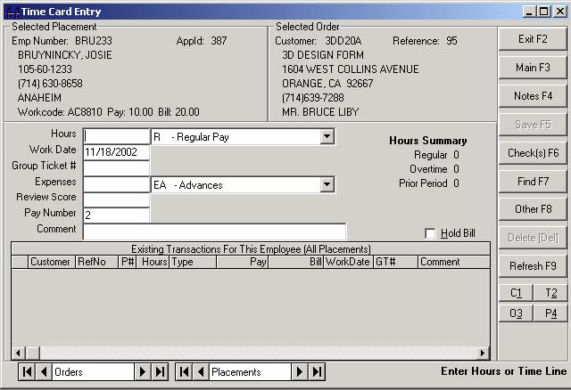

 There can be many types of pay, but just use R – Regular, O – Overtime, or D- Double time, unless you have purposely setup other types of pay you wish to use.

For more detailed data entry, pressing [**Edit F3**] brings up a screen where multiple and diverse types of entries can be made for the selected placement.

**Hours** - If you are entering an hourly item, enter the number of hours, and then use the scroll arrow on the box to the right of the hours box to choose the type of hours you are entering.

**Work Date** - Enter the period ending date for the hours you are entering.

**Group Ticket #** - Enter an optional 1 to 6 character string for a group ticket number, that may be used on reports and invoices for sorting and/or subtotaling. Examples of uses for this option could be to sort by shift, job site, work order number, department, etc.

**Expenses** - If this entry is a non-hourly item, enter an amount here, and then use the scroll arrow on the box to the right of the expenses box to choose the type of expense you are entering.

Entering a "Y" after the amount, entering a comment for the expense, or changing the bill extension to contain an amount will pass the amount to billing.

An expense can also be set to always pass to billing. See the information in the Company Setup chapter regarding Pay and Expense Types for more detailed information on passing expenses to billing (How to Pass Pay and Expense Items to Billing).

**Review Score** - Enter an optional number from 0 to 9 that can be used in calculations on reports for applicants and job orders. You may use this number to evaluate how your placements are performing for your customers.

**Pay Number -** If you are making entries to be included on other than the 1st check for this employee, change the number to another pay number where you wish the entry to apply. For instance, you may make entries for a time card for this week, for which you use the default Pay Number of 1. Next, you may make entries for a late time card from last week, which you want on a separate check. When making entries for this late time card, enter 2 in this field. You may make as many Pay Numbers (and therefore, checks) as you wish.

**Comment -** Enter a comment that may appear on invoicing reports and invoices. You may make extensive comments on invoices later using the Invoice Editor, but you are limited to one line of 72 characters during time card entry.

Previously entered hours are summarized on the screen under the title "Hours Summary". The field “Prior Period” displays hours for entries with pay numbers greater than 100.

Job Order and Placement information are displayed at the top of the screen.

##### **Color Coded Transactions**

During Time Card Entry (using the EDIT F3 screen):

• (CYAN) indicates items that are not yet paid, but have been moved to the period batch.

• (YELLOW) items are paid items, and takes precedence over any other color.

### **Alternate Time Card Entry Screen**

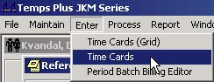

The alternate time card entry screen provides a more "traditional" time card entry screen that may be more familiar to Temps Plus RJM users.

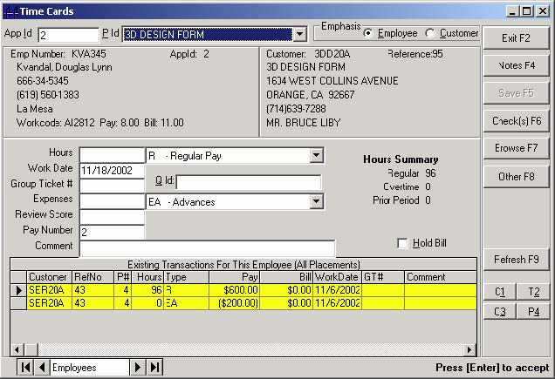

This screen has the advantage of being more easily navigated without the use of a mouse, and combines many of the features of the Main and Edit screens of the Time Card Entry Grid Screen.

### **Customer Screen**

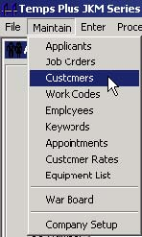

The Customer Screen stores the "master record" information for each customer in your system. This information is used as the default information when creating a job order.

While customers may be created here by choosing "Maintain, Customers” from the menu bar, you may also do so directly from the Job Order Screen. This facilitates setting up new job orders, and follows the philosophy of "chaining" that we try to achieve throughout the system.

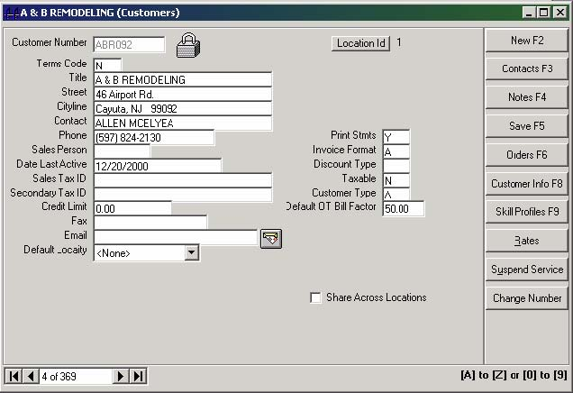

When you first enter the screen, the cursor is in the field labeled "Customer Number". To create a new customer record, enter a six-character code of your choosing as the new customer number (you may change this later, if you wish, using the [Change Number] button, and finish filling out the screen for the new customer. Using a combination of letters and numbers with the first three characters being the first three characters of the customer title is a suggested method for creating new customer numbers.

 *Alternately, you may find an existing customer by entering a few letters (try the first three letters of the company name) and pressing the [ENTER] or [F7] key. Then choose the customer you wish from the browse screen.*

**Location Id –** The “home” location for this customer.

You may change the location by pressing the

 button.

**Terms Code** - Enter the terms code (using a letter from A to Z). Terms codes are setup in the Accounts Receivable module for the general accounting module you may be integrated to.

**Title** - The customer name as you wish it to appear throughout the system.

**Street** - The street address for the customer.

**Cityline** - The city, state and zip are entered (as in the applicant screen) as one continuous line using the format "City, ST 99999". You may also use the "quick cities" feature.

**Contact** - Enter the billing contact name.

**Phone** - The customer phone number. Enter a 10-digit number.

**Sales Person** - Use from one to four characters as the default sales person for this customer. The sales person field on the job order will use this field as the default. The sales person from the job order is stamped on billing transactions. You may design reports to use the sales person field from the customer screen, job order screen or the actual transactions. The included reports in billing history are designed to use the sales person from the actual transactions.

*Title, Street, Cityline, Contact, Phone and Sales Person are used as defaults when a new job order is created.*

**Date Last Active** - The DateLastActive together with YTDSales gets updated when you close invoices to history. An intermediate table is created named "CustomerActivity" that summarizes sales by customer by year and includes the most recent invoice date for each customer within each year in a field called "LastActive". That table is then used to update the YTDSales and DateLastActive fields in the Customers table if the LastActive date in the CustomerActivity table is more recent than the DateLastActive in the Customers table (or if the DateLastActive in the Customers table is null as would be the case with a new customer.)

The following query demonstrates the logic employed:

UPDATE Customers INNER JOIN CustomerActivity ON Customers.Customer=CustomerActivity.Customer SET DateLastActive = LastActive, YTDSales = Sales WHERE DateLastActive Is Null OR DateLastActive<LastActive;

So the YTDSales field in the customer record would be the YTD sales for the last year in which the customer had activity as indicated in the DateLastActive field. A query totalling current years sales for all customers could be done as follows: SELECT SUM(YtdSales) as ThisYearsSales From Customers WHERE Year(DateLastActive) = Year(Now())

**Sales Tax ID** - You may enter a sales tax ID number here if you charge sales tax. Used for informational purposes only. This field is an excellent candidate for renaming and using an alternate field, such a second phone number, contact, etc.

**Secondary Tax ID** - You may enter a secondary tax id here if you charge sales tax. Used for informational purposes only. This field is an excellent candidate for renaming and using an alternate field, such a second phone number, contact, etc.

**Credit Limit** - You may enter a credit limit amount here. Used for informational purposes only.

**Fax** - Enter a fax number here.

**Email** - Enter an email address here. Selecting the magnifying glass icon next to the field will enter your email system (it will go to the email system defined as the default MAPI in your system), and use the email address entered here as the addressee.

**Default** Locality – If you are using the “localities” feature, you may choose from the localities you have setup.

**Print Statements** - Used as an information system only as of version 1.1.19. The accounting system you are integrated to may actually store this information for use in printing statements.

**Invoice Format** - This field is used as a default when entering a new job order for the customer.

**Discount Type** - Used as an information field only as of version 1.1.19. The accounting system you are integrated to may actually store this information for use in printing statements.

**Taxable** - Used as an informational field only.

**Customer Type** - Used as an informational field only.

**Default OT Bill Factor** - Enter a number (like 50) to use as the default OT Bill Factor percentage that will be used on new Job Orders setup for this customer. This number will be placed in the field with the same name on the 3 Pricing Tab screen on new job orders setup using this customer record.

#### ***[Contacts F3]***

Choosing this command bar will call up the "contacts grid", where an unlimited number of contacts may be entered.

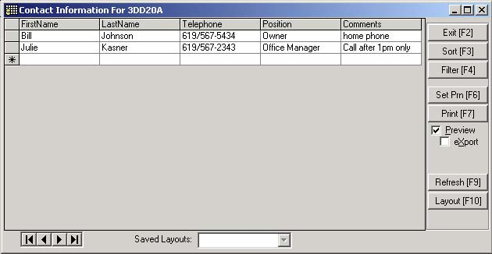

#### ***[Notes F4]***

Choosing this command bar brings up the customer notes field.

#### ***[Customer Info F8]***

If the employee customer screen has been setup, choosing this command bar will bring it up.

#### ***[Skill Profiles F9]***

##### **Creating and Maintaining Skill Profiles**

Skill profiles are defined at the customer level and can then be assigned to any job order for the customer. You can create one or more skill profiles "on the fly" while creating a job order for a customer or you can create skill profiles directly in the Customer Maintenance area.

You can think of a Skill Profile as a way of saving the criteria you use when performing a search. In fact, you use the Temps Plus Search form to assist you in creating a Skill Profile. The criteria you enter is saved together with a descriptive title and (optionally) the pay and bill rate and work code information for that customer for that type of work.

Skill profiles may be created for any customer or prospective customer, regardless of whether they have ever ordered from you. Once you have created a profile it can be used on any order for that customer to quickly find the right people at the right pay and bill rates. Creating profiles for prospective customers allows you to do prospecting in your existing applicant database from either the customer's or the applicant's perspective (find any customers or prospective customers that use the skills of a given applicant **OR** find any applicants/employees that match the requirements of a given profile)

For more information about finding possible employment for an applicant read about the Find Jobs button on the Applicant Maintenance screen. For more information about finding applicants/employees matching the requirements of a given profile see both the Find Staff button on the Skill Profiles Maintenance screen and the Placements - [Place F6] button, in the [***5* Skills/Other**] tab of the Job Order Maintenance screen.Once the skill profile is created, the applicant database can be searched (from either the Applicant Screen, Customer Screen, or Order Screen) for matches to the skill profile.

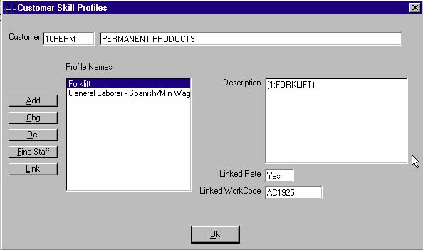

**Maintaining Skill Profiles**

You may display the maintenance screen in any of the following ways:

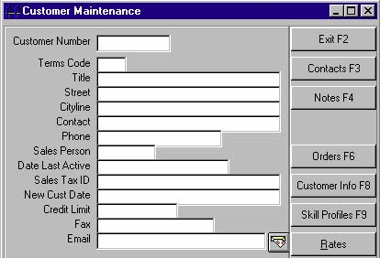

• Choosing the [Skill Profiles F9] button from the Customer Screen.

• Choosing the [5 Skills/Other] tab, and [Edit] button from the Orders Screen

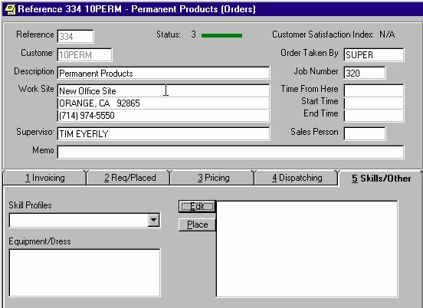

**Creating a Skill Profile**

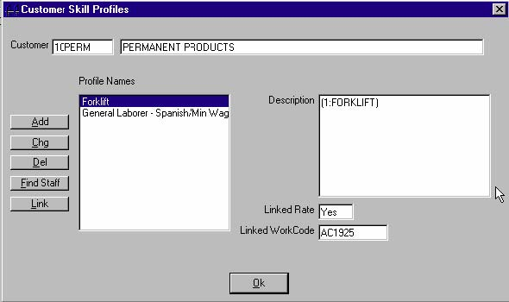

Pressing the [**Add**] button allows you to add a new profile.

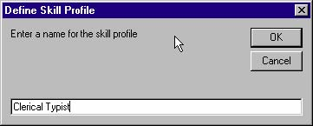

Enter a name for the skill profile

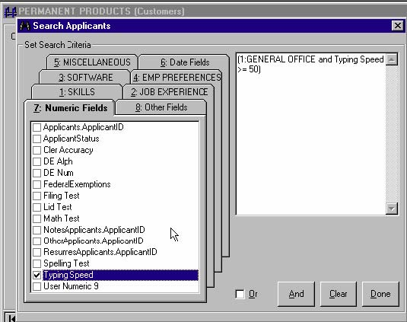

Enter the Search Criteria

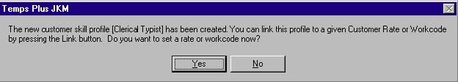

You are provided the opportunity at this point to link the profile to a Customer Rate or Workcode. Linking to a Customer Rate or WorkCode will automatically use the linked customer rate and/or workcode when placing an applicant using this skill profile (customer rates by definition already have workcodes associated with them).

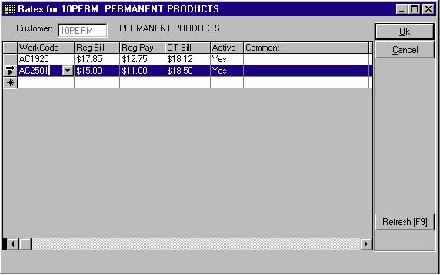

**Changing Skill Profiles**

Pressing the [**Edit**] button allows you to make changes to an existing profile.

Pressing the [**Del**] button allows you to delete a profile.

Pressing the [**Link**] button allows you to change the linking for the profile (see Linking and Unlinking Skill Profiles).

**Find Staff**

Pressing the [**Find Staff**] button presents a recordset of matching applicants for the profile.

##### **Selecting and placing matching applicants**

Pressing the [**Place**] button presents a list of qualified applicants for the active skill profile (since an order could have more than one skill profile). You may then immediately place any of the matching applicants to the order immediately by selecting the applicant from the list.

You may setup Skill Profiles for use on all job orders for the customer.

Find out more in the section on 5 Skills/Other Tab.

##### **Linking and Unlinking Skill Profiles**

When creating or changing a skill profile, you have the option to “link” a skill profile to a customer rate or a work code. Linking to a customer rate actually does both, since a customer rate is attached already to a work code.

If you wish to change the link, or remove the link, from a skill profile, pressing the [**Link**] button again will bring up either a customer rate screen, or a work code selection screen. Choosing a different customer rate or work code, will change the link. Choosing the [**Cancel**] option at this point will remove the link.

 If you are using customer rate for a customer, the only type of link you can use is customer rates.

#### ***[Suspend Service]***

Choosing the suspend service command bar will close all job orders associated with the customer (prompting as to whether final time cards need to be entered), and prevents any new job orders or placements to be made for the customer, until the suspension is lifted. This is done by reversing the process - choosing the suspend service command bar again.

#### ***[Customer Rates]***

You can create a set of work codes, bill and pay rates that are specific to a given customer. If you create a rates table for a given customer, users must pick from the established set of rates when placing employees on orders for that customer.

##### **Entering Customer Rates**

Choose Maintain, Customer Rates from the Temps Plus menu bar and the data entry screen for maintaining customer rates is displayed.

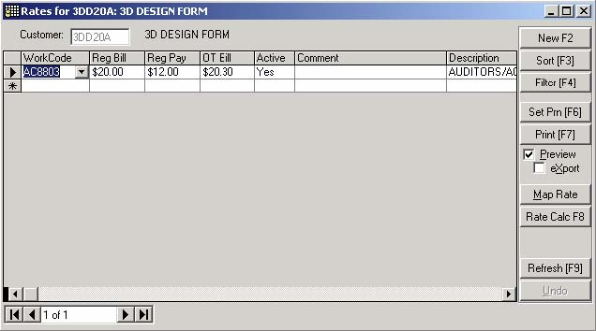

After selecting a customer, a grid is presented where you can enter the work codes and rates. You can also get to this grid by pressing [**Ctrl**]-[**R**]from either the job order screen or the customer screen – or by choosing the [**Rates**] button from the customer screen or job order screen. When you use the button or [Ctrl]-[R] method, the customer you were working on in the job order or customer screen is automatically selected in the Customer rates screen.

In addition to the work code, pay rate, bill rate, and OT bill rate fields, a comment field is available for making appropriate notations – like instructions to users about when to use a given rate. The description of the work code is displayed in the grid, but this is a read-only column presented for informational use.

When entering or changing a bill rate in the grid, the OT bill rate field is automatically updated based on the default OT Bill factor for the customer. This is merely for convenience. The OT bill rate can be edited to something other than the default.

An “Active” field is also available so that rates can be maintained ahead of time in anticipation of a price adjustment, or, in anticipation of implementing an initial rate structure for a customer. By default, the Active column is set to "yes" when you enter a new rate line. To make a rate inactive, just choose “No” in the active field.

Only active rates are presented to users during placement setup. If all the rate lines for a given customer are inactive, Temps Plus treats the customer as if no rate structure were in place. When moving a rate record from active to inactive you are offered the opportunity to close all open placements with that rate record.

When you change the work code, bill rate or pay rate on an *active* Customer Rate record, an option is given to update all active placements that had the old information to the new information. When you delete an active customer rate record, an option is given to close all active placements that matched the deleted rate record.

A Map function allows you to map one rate to a different rate. The map feature is designed specifically for updating active placements from an old rate and/or work code to a new rate and/or work code. This allows you to create a new rate structure for a customer and map from old to new at a different time.

To use the map feature, simply move to the old rate record and press the “Map” button. A message will be displayed advising you that the “Map From” record has been selected. Next, move in the grid to the new rate record and press the “Map” button. A message box will be displayed which explains in detail what will be changed and prompts for a confirmation. Note that the old rate record is deleted at the completion of the map process.

##### **Enforcement of Customer Rates**

If you have active customer rates setup for a customer then users must pick from one of these rate records when making or changing placements on both the placements and placement history screens. Overrides are allowed if the user has the ability to maintain customer rates.

Customer rates are also enforced when creating a job order and assigning default work codes and pay/bill rates. There is no override when creating the job order defaults – the override is only on a per placement basis. Remember, authorized users can press Ctrl-R from the job order screen and be taken to the rate editor to add or change the rates for the customer.

When re-activating a closed placement, a check is made to ensure it agrees with an active rate record.

When a user with rights to override rate defaults saves a placement record that does not match an active rate record, the user is notified and asked if they want to continue with the save.

##### **Security Option for Customer Rates**

There is one menu object that can be used to control user access to maintaining customer rates. You can use the Temps Plus security editor to add this menu option and it will then appear in the User exclusions table of the User Maintenance Screen. The name of the menu object is mnuCustomerRates.

If you exclude a user from maintaining customer rates, that option will not appear in the Temps Plus “Maintain” menu. Also, when making placements, that user will not have the ability to override the pay/bill/work code structure established for a given customer.

##### **Bill Rate Calculator**

A bill rate calculator can be called from the Job Order, Placement, or Customer Rates screens by pressing [**Ctrl**]-[**C**].

The bill rate calculator can be used to calculate bill rate dollar amounts, or margin/markup percentages. You can have the system use information from your work codes table, or you may manually override the pay rate, burden, or WC rate to arrive at your calculation.

You can move to a specific work code in the Bill Rate calculator by typing in any portion of the work code. As you type each character of the Work Code the program will seek out the first work code that matches the information you have typed. You can also move forward and backward through the work codes by pressing the directional keys on the data control at the bottom of the calculator.

#### ***[Change Number]***

You can change the customer number here. You can only change to a new, unused customer number.

This will change all references (including history, etc.) in Temps Plus to the customer. It will, however, NOT change the customer number in AR, it will add the new number. Use the Cross Reference feature in AR as needed to accommodate the new customer number(s).

#### ***Share Across Locations***

Checking this box will allow all locations to share customer records on job orders, regardless of the customer “home” location.

#### ***Customer Code Prefix***

As an option, you may specify that the first two characters of each customer code will use a "branch prefix" of your choosing. You may setup this option by selecting Maintain, Company Information, [Features]. Find out more under Features – Company Setup.

Doing so means that each customer code will start with the specified two characters, followed by four characters of your choosing. This feature allows your branches to have unique customer codes.

For instance, if you set a prefix of "B1", you would only be able to enter 4 characters for any new customer code, each of which would be preceded by the characters "B1" (entering "AB12" would result in "B1AB12").

If you choose to implement this feature after your database already contains customer numbers (using a different customer coding scheme), you would have to change each previously existing customer code if you wish to standardize on the new coding system.

### **Employee Screen**

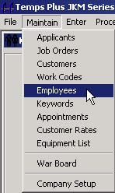

 While you may enter the employee screen from the menu bar, it is more normally accessed from the applicant screen by choosing an applicant and pressing the [F10] bar.

#### ***Employee Master Screen***

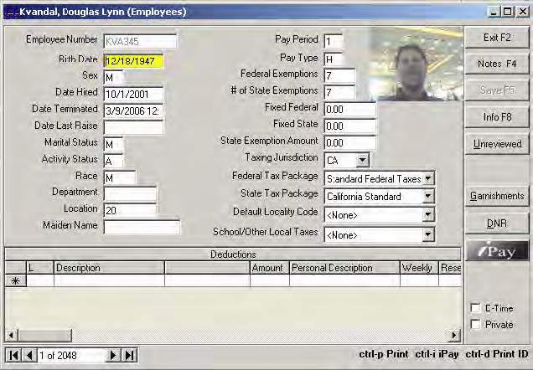

All employee information not contained in the Applicant Screen, but necessary for payroll processing is contained in the Employee Screen

Please note that when this screen is first created, a number of the fields default automatically in relation to information from the Applicant Screen. Making changes to the Applicant Screen after the Employee Screen has already been created will not make changes to the Employee Screen. Such changes must be made manually.

**Birthdate** - enter an optional date to store the employee's birthdate

**Sex** - enter M for male or F for female

**Date Hired** - this field defaults automatically to the date the employee screen was first created. You may change the date if you wish. This field is for information or reporting purposes only.

**Date Terminated** -this field will not designate an employee as terminated. It is for informational or reporting purposes only (see Activity Status).

**Date Last Raise** - this field is for information or reporting purposes only.

**Marital Status** - enter S for single, M for married or H for Head of Household. This field defaults to the Marital status field from the Applicant Screen when the Employee Screen is first created.

**Activity Status** – Normally this would be “A” for active. However, it may be “I” for inactive, or “T” for terminated. This field is automatically updated when toggling the status on the applicant screen using the [**St**] button.

**Race** - you may enter up to two alphanumeric characters that indicate the employee's race for information and reporting purposes.

**Department** - you may enter up to four alphanumeric characters that indicate the employee's department for information and reporting purposes.

**Location** - you may enter up to four alphanumeric characters that indicate the employee's location for information and reporting purposes.

**Pay Period** - enter a number (1-8) to indicate the employee's pay schedule.

*1 - Weekly 2 - Bi-Weekly 3 - Semi-Monthly*

*4 - Monthly 5 - Quarterly 6 - Semi-Annual*

*7 - Annual 8 - Daily or Miscellaneous*

**Pay Type** - enter H for hourly or S for Salary. This field is for informational and reporting purposes only.

**Federal Exemptions** - enter the number of exemptions declared for federal withholding purposes.

**# of State Exemptions** - enter the number of exemptions declared for federal withholding purposes.

**Federal, State, Social Sec., Medicare, Employer SUI Tax Packets** - Math Packets are user definable, and as such, may be unique to your system. These Math Packets determine how each associated tax calculation is determined according to how the rules are set in the Math Packet.

**Taxing Jurisdiction** - if your employees are in a multi-state or multi-national payroll situation, enter a two-character code to identify the state or nation in the Taxing Jurisdiction field for which taxes are withheld. The taxing jurisdiction can be specified independently of the home state or employer state.

Reports in Process, Payroll, End of Quarter Payroll Tasks can make use of the Taxing Jurisdiction field in printing the various reports available by pressing

**Fixed Federal** - enter up to eight characters to indicate a predetermined federal withholding tax amount. This field can also be used to withhold specific amounts in addition to the calculated federal withholding in the math packet. When this figure is entered as a positive amount, it acts as a tax credit. If you want the amount deducted, it must be preceded by a minus sign.

**Fixed State** - enter up to eight characters to indicate a predetermined federal withholding tax amount. This field can also be used to withhold specific amounts in addition to the calculated federal withholding in the math packet. When this figure is entered as a positive amount, it acts as a tax credit. If you want the amount deducted, it must be preceded by a minus sign.

**State Exemption Amount** - this field is generally used as a variable in a math packet. For example, the example in the appendix concerning 401K withholdings uses this field.

**Default Locality Code** – The default is <None> for this field which may be used for reporting local taxes.

School/Other Local Taxes – The default is <None> for this field which may also be used for reporting local taxes.

##### **[Notes F4]**

This command bar allows you to store notes for the employee. Employee notes have a special significance during Time Card Entry. Employee notes that are not empty will “pop-up” automatically during time card entry for the selected employee. This feature is probably most useful in "remembering" items to be processed during time card entry.

##### **[Info F8]**

If the employee information screen has been setup, choosing this command bar will bring it up.

##### **[DNR] – Do Not Return**

This option will prevent an employee from being rehired under any circumstances across any and all branch databases. The social security number (and optionally, a customer number) are stored in the “Banished” table in the tpCtrl database for all customer/order placements, or just for a single customer (if the DNR button is used from the order screen).

##### **[Mark As Unreviewed]**

When an employee screen is created while placing an applicant for the first time ever on any job order, it is set as unreviewed, and the applicant status color shows as yellow. You may manually set an employee as unreviewed by choosing this menu bar.

 Unreviewed employees may be viewed, en masse, by pressing the [**Employee F10**] command bar from a blank applicant screen.

##### **[Garnishments]**

See the section “Garnishments (Temps Plus JKM v3.1.x method)” in the appendix section.

##### **[E-Time checkbox]**

See the section on “Email TimeCard Spreadsheets” on using this option.

##### **[Private checkbox]**

If the current Temps Plus user is authorized to access records marked as “Private”, the box will appear and may be checked or unchecked as needed. The ability to access private records is granted in the User security screen in company setup under SystemWide options.

### **Work Codes**

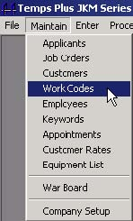

Before you can enter placements (and therefore before time card entry), you must enter at least one work code. Most users set up several work codes to facilitate reporting, minimize data entry, and control GL posting and pay differentials. Work codes are used during setting job requirements or doing a placement.

Work codes consist of from one to six digits containing numbers, letters or a combination of the two.

Simple examples of work codes could be “**SEC”** for secretary and “**REC”** for receptionist. This would allow you to print sales reports for all secretaries and receptionists.

A more complex example could be “**CI1234**” where the 1st digit “**C**” stands for California, the 2nd digit “**I**” stands for Industrial, and the 3rd to 6th digits “**1234**” stand for a type of work. This combination would allow you to print reports by state and/or category of work and/or type of work.

You should design your work codes carefully, based on the reporting capabilities you require. This may require a more experienced understanding than you may have when initially setting up the system, so you may wish to consult your dealer before committing to a work code system that doesn’t give you the flexibility you need on reports.

 Use a consistent number of characters for all codes (to make your life easier). This may also allow for more flexibility later if you need to add more levels to your coding system.

**Work Code** - Enter from 1 to 6 characters for your code.

**Description** - The description you enter here may appear on invoices and reports.

**Workers Comp Class** - Enter the numeric class you where this code should appear on your worker’s comp report.

**Comp Cost per Hundred** - The amount here will be used to calculate the liability amount for worker’s comp.

**Burden** - The amount here can be used on analysis reports. You should calculate and enter your employer's costs (FICA, Medicare, SUI, FUTA, etc.) as a percentage in this field.

**Standard Pay, Bill Amount** - Default amounts to be used in data entry can be entered in these fields.

**Standard Pay, Bill Account** - Default General Ledger account numbers to be used for this work code.

**Subject to Sales Tax** - If you charge sales tax on invoices, you must enter “Yes” here for sales tax to be calculated on the invoice. The sales tax rate is entered on the job order “price” screen.

**Pay Differentials** - You may enter here how pay differentials are calculated during time card entry for entries using this work code.

### **Keywords**

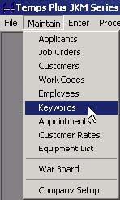

You may use Maintain, Keywords to add, change, or delete keywords.

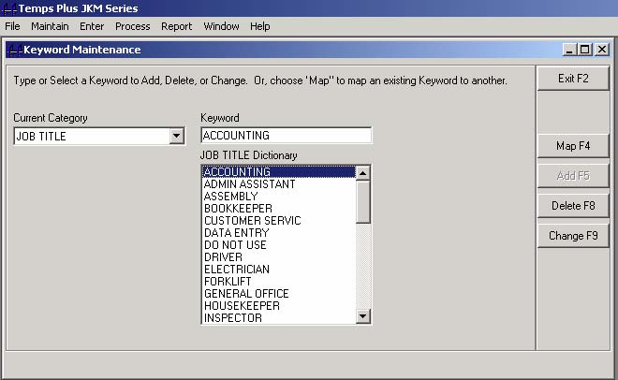

By choosing a category, the keywords for the selected category show in the Job Title Dictionary window.

##### **[Map F4]**

"Mapping" a keyword means to "move" all references to a previously created keyword to a different keyword. This is most commonly used to combine duplicate keywords with different (mis)spellings.

##### **[Add F5]**

Add a keyword by choosing this command bar.

##### **[Delete F8]**

Delete a keyword by choosing this command bar. This will delete all instances of the keyword in all applicant screens.

##### **[Change F9]**

Change the name of a keyword to something else by choosing this command bar.

### **Appointments**

The Appointments module of Temps Plus allows you to schedule items called "appointments".

An "appointment" could be any activity you wish to track by date and time. You may relate the activity to an applicant, a job order, a placement, a customer, or nothing at all.

#### ***Features***

• User-definable Appointment Types

• User-definable Disposition Types

• Graphic Calendar Date Selection

• Easy-to-use On-screen Filtering

• Relate Appointments to Applicants, Orders, Customers, or Placements

• Customizable Screen Layouts

• Automatic Relationship Assignments from Applicant, Order, and Placement Screens

• Print or Export Appointments

• Create Custom Management Reports in Crystal Reports

• Track Interviews, Quality Assurance Calls, etc.

• Track (audit) changes to customers, placements, etc.

#### ***Activating The Appointments Screen***

You may activate the appointments screen in the following ways:

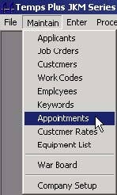

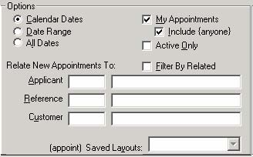

**Maintain, Appointments -** this brings up the appointment screen in its generic form - with no relationships set.

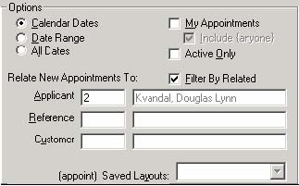

[**Ctrl**]**-**[**A**] **from the applicant screen** - this will not only bring up the appointment screen, but it also fills-in the appropriate information boxes with the current applicant ID and Name - thereby allowing you to relate any appointment you may be about to make to the applicant that was on the screen when you pressed [Ctrl]-[A].

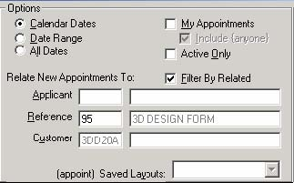

[**Ctrl**]**-**[**A**] **from the Job Order screen** - this will not only bring up the appointment screen, but it also fills-in the appropriate information boxes with the current reference number and customer - thereby allowing you to relate any appointment you may be about to make to the job order that was on the screen when you pressed Ctrl-A.

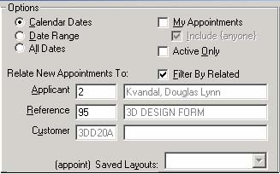

[**Ctrl**]**-**[**A**] **from the Placement screen** - this will not only bring up the appointment screen, but it also fills-in the appropriate information boxes with the current applicant, reference number and customer - thereby allowing you to relate any appointment you may be about to make to the placement that was on the screen when you pressed Ctrl-A.

[**Ctrl**]**-**[**Shift**]**-**[**A**] from the Placement screen chooses the entire job order instead of just an individual placement.

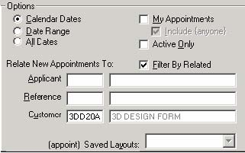

[**Ctrl**]**-**[**A**] **from the Customer screen** - this will not only bring up the appointment screen, but it also fills-in the appropriate information boxes with the current customer - thereby allowing you to relate any appointment you may be about to make to the customer that was on the screen when you pressed Ctrl-A.

#### ***Appointments Overview***

##### **The Calendar**

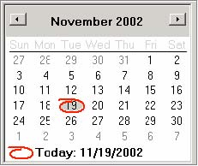

The calendar allows you to easily navigate to any date. Double-clicking on a date when in the date column on the appointment grid will automatically fill in the date for you.

##### **Options**



The options screen allows you to "filter" your view of the data that appears in the appointment grid. All selected options work simultaneously to filter your data.

**Calendar Dates -** will show only appointments within the current calendar display month.

**Date Range** - will prompt for and show only appointments within the range selected.

**All Dates** - will show appointments for all dates.

**My Appointments -** will show only appointments assigned to you - (the currently logged in user matches the user name in the "AssignedTo" column of the appointment grid.

**Include {anyone} -** will additionally show those appointments with the user name "anyone" assigned to him or her.

**Active Only** - will show only appointments

**Filter By Related** - will use the "Relate New Appointments To:" boxes to filter your data.

The "**Saved Layouts:"** - box allows you to create, save, and recall different views of the appointment grid. After arranging the widths and relative positions of the columns in the appointment grid, you may save the "layout" by pressing the F10 button on the command bar.

**Relate New Appointments To** - boxes will allow you to enter applicant, job order, placement, or customer information for filtering (when the "Filter By Related" box is checked), or to use in setting relationship on a new appointment item.

Whenever you create a new appointment item, any relationships in these boxes will be used on the new appointment item, whether you manually enter them, or they were automatically filled out because you activated the appointments screen using the Ctrl-A keys.

*By placing your cursor on the applicant, reference, or customer boxes, a tool tip will appear telling you how to find the applicant, reference, or customer to place in the box.*

##### **The Appointments Grid**

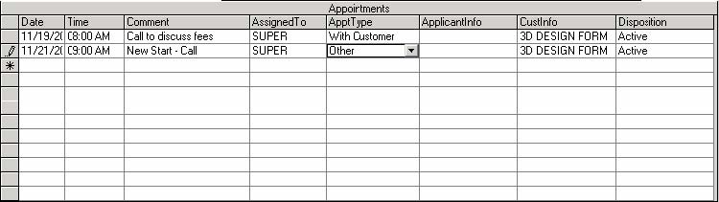

**Date, Time** - you may enter the date manually, or by selecting the date on the calendar while in the date column, then manually editing the time, if necessary.

**Comment** - if the appointment does not reference an applicant, job order, or placement, you may find it helpful to enter a comment for the item.

**AssignedTo** - selecting this item will bring up a drop down list of available users.

**ApptType** - you may use a previously created appointment type, or create a new one by pressing the F8 key.

**ApplicantInfo** - shows the applicant information if the appointment is related to an applicant or placement record. Placing your cursor on the ApplicantInfo item for any appointment will show expanded information for that Applicant.

**CustInfo** -shows thecustomer information if the appointment is related to a job order or placement record. Placing your cursor on the CustInfo item for any appointment will show expanded information for that Customer.

**Disposition** - you may use a previously created disposition type, or create a new one by pressing the Shift-F8 keys.

##### **The Command Bars**

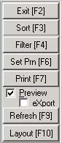

**Exit [F2]** - exits the Appointments Screen.

**Sort [F3]** - prompts for a column name to sort by. Column titles are aliased. To sort or filer you need to use the actual field names. For example, the “For User” column actually refers to the field

“AssignedTo”.

The actual field names of fields you can sort by or filter by in the appointments screen are:

AppDate, ApplicantId, Comment, AssignedTo, AppTypeCode, DispTypeCode, Customer, Reference, ContactId, Entered, EnteredBy, LastNodified, LastModifiedBy, Id, ApptType, and Disposition(the date and time columns are combined into one field in the database and use the column name of "AppDate" for purposes of use in the appointments screen).

**Filter [F4]** - prompts for an SQL statement of your choosing to use as a filter.

When prompted for the column name or filter expression, use one of the fields names shown described above. *Advanced Tip: The Sort and Filter buttons can be used by the user familiar with SQL to completely configure the way the appointment grid looks, by entering the appropriate SQL statement.*

**Set Prn [F6] -** goes to the printer setup screen.

**Print [F7]** - allows you to print the appointments on any available Windows printer.

**The Preview box** - displays the printout when pressing the Print [F7] button instead of immediately sending it to the printer. You may press the printer icon from the preview screen to print your report after is it displayed.

**The eXport box** - strips the displayed or printed report of the report headings to allow for an export file that contains only the data when sending the report to another application such as a spreadsheet.

**Refresh [F9]** - redisplays the information on the screen to reflect the most recent changes to the appointments grid. If you are concerned that other users at other workstations may have made changes to appointments during your current appointment session, pressing Refresh [F9] will update your screen with the changes.

**Layout [F10]** - allows you to manage different views of your appointment grid. The information for these layouts is stored in a file named "APPOINT.GRX" which is stored in the folder from which the Temps Plus JKM program was started. You may "trade" layouts with other users by copying this file to their program folder. Deleting this file will let you start over again with a blank layout file.

##### **Grid Notes**

You may make changes by directly changing any item that appears on the grid. Use the delete key to delete any item highlighted item. “System” records cannot be deleted in this manner. There is an option to remove Activities/Appointments under the Utilities section in Company setup.

The number of records the appointments grid can show is not limited when the grid is accessed using the Ctrl-A key from a master screen. When accessed using Maintain, Appointments, it is limited by a setting that can be changed, if necessary. The default is 250 records. Increasing this number may lead to slower response times. Use the query “SELECT * from ProcessOptions” to find this setting.

#### ***Appointment Tutorials***

##### **Applicant Interviews**

**Setting up the interviews**

1. From the Applicant Screen, browse for and select an applicant.

2. Press [**Ctrl**]-[**A**] to activate the appointments screen. Notice that the applicant information now appears in the "Relate New Appointments To" section.

3. Make sure your cursor is in the date field on the first blank appointment line in the appointment grid.

4. Double-click on the date for which you wish to set the appointment.

5. Change the time for the appointment.

6. Now make any appropriate entries to the other columns, including setting the ApptType to "Initial".

Make several such "interviews" with different applicants.

 *You do not have to go back to the applicant screen to choose another applicant. Just place your cursor in the applicant box in the "Relate New Appointments To" section, type in a few letters of the applicant’s last name, and press enter to browse for and select the next applicant.*



**Viewing the interviews**

Now that you have several "interviews" setup, try viewing them in different ways by selecting some of the different filtering options at your disposal. This will be more interesting if you used different dates.

##### **Quality Assurance Calls**

1. Activate the appointments screen by choosing Maintain, Appointments.

2. Enter a new ApptType by pressing the F8 key and entering a new ApptType of "QA Call".

3. Press F2 to exit the ApptType setup screen.

4. Browse for and select a placement from a job order.

5. Press Ctrl-A to activate the appointments screen.

6. Notice that the appropriate information for the placement now appears in the "Relate New Appointments To" section.

7. Make sure your cursor is in the date field on the first blank appointment line in the appointment grid.

8. Double-click on the date for which you wish to set the appointment.

9. Change the time for the appointment.

10. Now make any appropriate entries to the other columns, including setting the ApptType to "QA Call".

Make several such "QA Calls" with different applicants.

 *You do not have to go back to the applicant screen to choose another applicant. Just place your cursor in the applicant box in the "Relate New Appointments To" section, type in a few letters of the applicant’s last name, and press enter to browse for and select the next applicant.*

**Viewing the QA Calls**

1. Now that you have several "QA Calls" setup, try viewing them in different ways by selecting some of the different filtering options at your disposal. This will be more interesting if you used different dates.

2. If you also performed the "Interviews" tutorial, you now at least have two different types of appointments. Let's try changing the ApptType on some of the appointments. Press the Sort [F3] or Filter [F4] button.

• Type ApptType = "Initial" when prompted then view your resulting appointment grid.

• Type ApptType = "QA Call" when prompted and view your resulting appointment grid.

3. Now try changing the disposition types on a few appointments and experiment further with your filtering options.

4. Don't forget to experiment with the "layouts" feature and use your imagination in setting up your appointment and disposition types

### Maintain Customer Rates

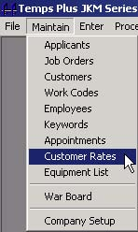

[Customer Rates] are described in detail in the Customer Screen section.

### **Maintain Equipment List**

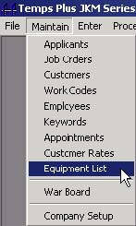

This is where you may setup a list of Equipment (or other similar items to be used on the Job Order 5 Skills/Other tab.

### **Maintain Warboard**

Warboard is an alternate Job Order Screen interface that provides features not available in the normal job order screen interface. [The documentation for Warboard is in the Bridgeware University Library](http://www.bridgewaregold.com/BSIU/BsiLibrary.htm).

## **Process Menu**

### **Queue All Unpaid Entries**

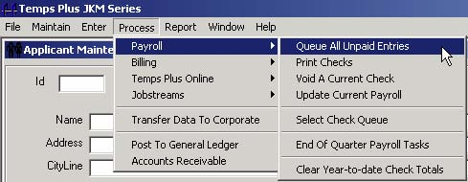

To Queue All Unpaid Entries, choose Process, Payroll, Queue All Unpaid Entries.

If there are time card entries, which were not sent to the check queue as you were making entries in the time card entry screen, you may send all those not yet sent with this option. Any checks already sent once to the queue (printed or not) will not be sent again.

### **The Check Queue (Print Checks)**

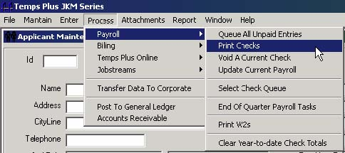

**Running the Check Queue**

To start the Check Queue program, choose Process, Payroll, Print Checks

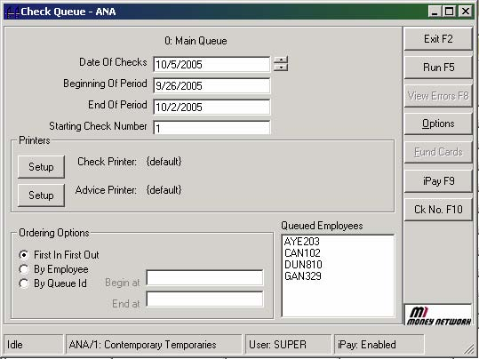

 To start the Queue running, enter the dates, starting check number, change the printer setup if necessary, and press the [Run F5] button to start printing checks.

If you start this program after you sent checks to the queue, **the Queued Employees** window will show the queued checks waiting to be printed.

 By default the [View Errors F8] button is dimmed out and unavailable for selection. However, if the program is unable to print a check for some reason, this button may become enabled, and provide some information about any check(s) that could not be processed (see following screen).

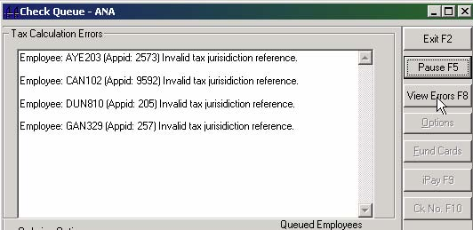



The [Options] button brings up a window that allows you to set various parameters when checks are printed.

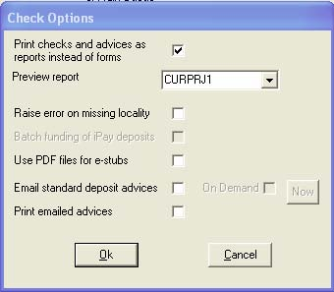

**Print checks and advices as reports instead of forms** – check this box to print checks and advices as reports instead of forms. Normally, when this section is not set to print checks as reports, and each check (or advice) is sent to the Windows printer as a separate form. For instance, printing three checks would produce three print jobs when sent to the printer.

By checking the “Print checks and advices as report instead of forms” box, if the check format is formatted properly (see Printing Checks as Reports in the Appendix for detailed information), two things take place:

• If you have chosen a valid report format in the “Preview report” box (you may choose {No Preview} as an option), the report is displayed to the screen (a preprint report of checks and calculcations).

• You will then be prompted as to whether you wish to continue to print the checks.

**Raise error on missing locality** – Expanded error message to include number of records checked if an employee or job is assigned to a locality that does not exist in the Localities table.

**Batch funding of iPay deposits** – Checking this box allows you to fund iPay deposits (by pressing the “Fund Cards” button at the check printing screen) at any time after you have printed deposit advices. This allows you to effectively “hand-out” iPay deposits as you would later distribute checks that were previously printed.

**Use PDF files for e-stubs** – Check this box if you would like your emailed deposit advice stubs formatted as PDF files.

**Email standard deposit advices** – Check this box to have deposit advices emailed (to the email address in the applicant screen) at the time they are printed. The **On Demand** button emails standard deposit advices on demand rather than at time of calculation .

**Print emailed advices** – Check this box if you would like a paper copy of emailed deposit advices.

#### ***Selecting the Check and Advice Printers***

If you have run the check queue previously for the current company code, the default printers you used previously will be displayed. If you wish to change them, press the [Setup] button for the appropriate printer.

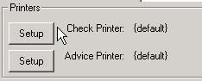

**Check Printer**

The check printer is the printer where you wish checks with a net amount of more than zero to be printed.

**Advice Printer**

The advice printer is the printer where all checks with a net amount of zero (or less) will be printed, as in the case of direct deposit, where the net amount of the check is zero (thus the term “Deposit Advices”.

**DO NOT** use the same printer (or printer tray) as your check printer, unless you are certain you will have no deposit advices. Deposit advices do not use a check number, but if you print them on check stock by using the same printer as your check printer, your check numbers will get out of sequence by one number after each deposit advice is printed.

Any checks that print on this printer that you did not intend to be zero (or less than zero) contain a combination of entries (or automatic deductions) that are causing the zero condition. This can be used to your advantage in identifying checks with problems – just make the deposit advice printer

**Special “Bogus” Printers**

If you use a printer that has the word “Bogus” anywhere in the printer name, using that printer will perform the action of printing the checks to the data files, but no actual checks will be printed. Additionally, if you are printing checks as “Reports”, a preview of the checks will appear on the screen after they are processed.

 The [iPay F9] button is used by the iPay application (instant credits applied to an employee debit card). You will need assistance and further information to use this feature. Contact sales and/or technical support if you are interested in the iPay program.

 ***Selecting the [Ck No. F10] button will allow you to reset the allowable range of check numbers entering the new range of check numbers. This should not be necessary under normal circumstances, as the system “remembers” the last check number used, and will be automatically incremented the next time you print checks*.**

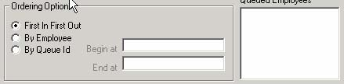

#### ***Ordering Options***

The Ordering Options section may be used to reorder the Queued Employees before printing checks. The Queue ID (entered during time card entry) may be used to limit which checks are printed, in addition to being used as a sorting option.

#### ***TPCHECKS.EXE***

You may also start the Check Queue program by running the program "TPCHECKS.EXE". The easiest way to do this would be to setup an icon on your desktop.

#### ***Maximum Quick Check Option***

If a check in the queue has a net amount greater than the setting in Company Setup, a prompt will appear requiring an override code, which is stored in the same location in Company Setup. *You can effectively disable this option by setting the maximum amount to a very high number*.

#### ***Using Unique Check Numbers***

The Temps Plus check printing routine will use unique check numbers if the box in Maintain, Company Setup, [Features], “Force unique check numbers” is checked. This means that a previously used check number (for the current company code) may not be entered on the Check Printing Screen.

#### ***Printing Checks On-The-Fly***

If you start the check queue (and press Run F5) before sending checks to the queue, checks will be printed immediately as they are sent to the queue.

#### ***Multiple Check Queues***

By default, there is 1 check queue in Temps Plus and often this is enough. Time card entries are "queued" for payroll processing and check printing and any number of users can send new activity to the queue. Only 1 user can run the check printing process for a given queue.

When the check printing process begins, it flags the queue as inaccessible to other users for purposes of check printing. Users can continue to send new activity to the queue even while the checks are being printed -- but the printing process itself is locked and limited to a single user.

In high volume, day pay environments -- or when multiple remote branches are acting on a centralized database but need to print checks locally, a single check queue is often insufficient. For this reason, Temps Plus allows you to create as many check queues as you need to satisfy your operational requirements.

##### **Defining Additional Queues**

Check Queue Definitions are global within a Temps Plus installation, that is, you define them in the control database and each Temps Plus database creates its own check queue records for each defined queue. To create the global definitions go to the Control Database Table Editor in the Supervisor program. From the list of tables presented, double click on the "CheckQueues" table. A grid will be presented where you can add new records and change or delete existing records. Do not remove the QueueNumber 0 record -- you can change its Description but do not remove it. If you are using a new queue for remote printing enter the Temps Plus Serial Number of the remote branch's license.

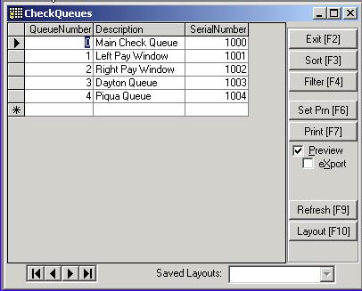

**Using Multiple Queues**

When multiple check queues are available you can use the Temps Plus Process, Payroll, “Select Check Queue” option to select the queue you want to work with. Temps Plus remembers the last queue used at a given workstation so you need not set the queue each time you enter Temps Plus. You can verify the Queue you are currently working with during Time Card Entry by pressing Ctrl Q. This will tell you the current status of the queue as well as the queue name. Any employees you queue during Time Card Entry or by calling the Process, Payroll, “Queue All Unpaid Entries” option will be queued to your current queue.

If an employee has already been queued into a given check queue, the system will not allow the employee to be queued again for the same pay number in another queue. You can remove all queued items for an employee by going to the Time Card Entry - Edit screen and pressing F6. This will remove all queued items regardless of queue number (if no items are in the queue for the employee it will queue all items to the current queue - so if it tells you that checks were queued simply press F6 again and the new items and old items will be removed.)

Temps Plus authorizes each queue with a given range of check numbers. This feature is best appreciated when using multiple check queues. You can split a box of checks among a number of different printers in an office and assign each queue with the range of checks loaded.

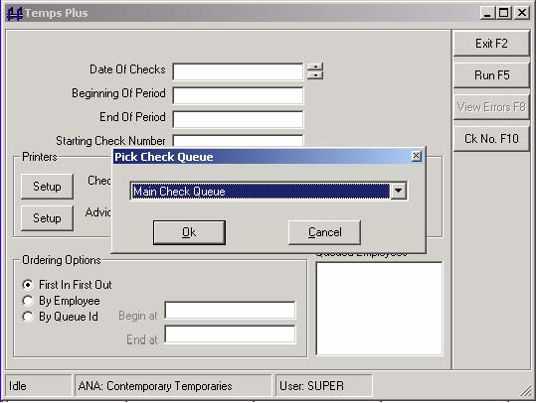

When the range is consumed the check queue pauses until it is reauthorized with a new range of checks. This prevents accidentally using the same check number at different queues.

##### **Remote Branches**

Remember, each remote location accessing Temps Plus must be licensed regardless of where the data or programs reside -- even if the connection is made via Terminal Server, Citrix, PcAnywhere, etc. Temps Plus is site licensed.

### **Void a Current Check**

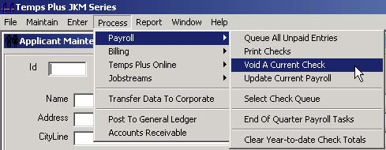

This option deletes all the current transactions for the check number entered. Reprinting a check will also void the previous check, as will making changes to entries to previously printed checks in the Time Card Entry Screen.

### **Update Current Payroll**

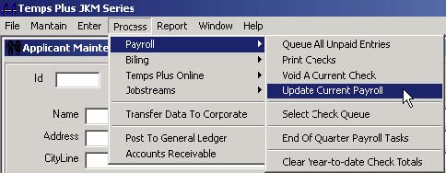

To close the current payroll period, in preparation for the next one, choose Process, Payroll, Update Current Payroll. You are prompted to enter the date of the last check you wish included in the update process. Checks with dates after the date you provide will NOT be updated.

### **Select Check Queue**

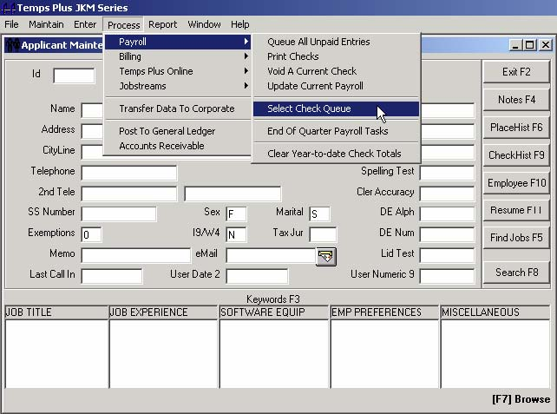

You may wish to have more than one check queue available, and if so, choosing this item will allow you to do so. See the section on Multiple Check Queues for more information.

### **End Of Quarter Payroll Tasks**

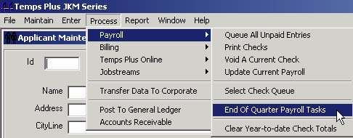

To start the End Of Quarter Payroll Tasks program, choose Process, Payroll, End Of Quarter Payroll Tasks.

This process allows you to print Quarterly Earnings reports, as well as any magnetic media reports you may have installed on your system.

There are three tabs available for this task.

#### ***Quarter Info Tab***

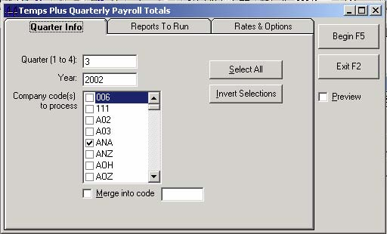

**The Quarter Info Tab** lets you specify the company code(s) and period to report.

#### ***Reports To Run Tab***

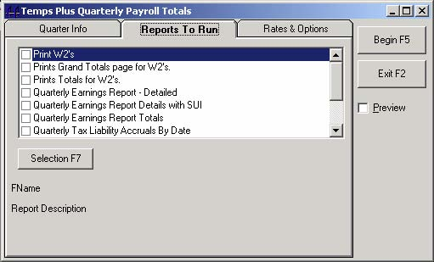

**The Reports To Run Tab** lets you specify the reports to run.

##### **Quarterly Selection Criteria - [Selection F7]**

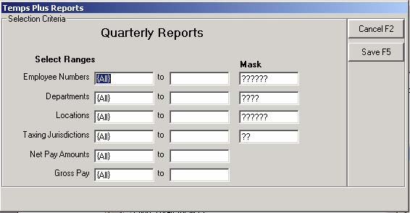

Selecting the [Selection F7] button presents a Selection Criteria Screen where you may limit entries which are considered for any reports you run.

#### ***Rates and Options Tab***

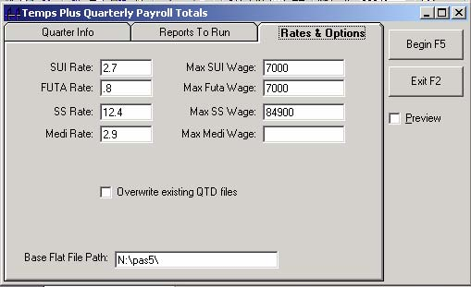

**The Rates & Options Tab** lets you enter and verify the rates and limits for the report. If you have previously run this task for the current company code, the figures will default to the last ones used.

**Overwrite existing QTD -** This option lets you rebuild quarter to date totals that may have been stored from a previous run. If you are just reprinting a report you have previously run, and no new changes have been made to data, which would affect the report, you may save time by leaving this box unchecked.

**Base Flat File Path**

You should enter the directory where your program files for magnetic media processing and/or CYMA PAS5 program files are stored. The system always rebuilds the flat file data files used for DOS magnetic media and PAS5 payroll module processing, using the Base Flat File Path at the bottom of the screen.

• Press the [Begin F5] command bar to start the task.

• If you chose to preview reports by selecting the [Preview] box, the reports selected will appear on the screen for your review before printing. Otherwise, any reports selected will be sent to your printer.

##### **Magnetic Media Reporting**

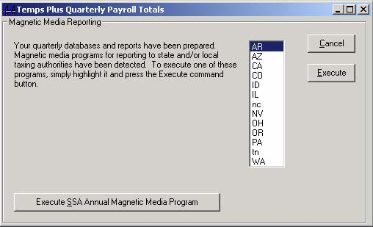

If you entered a valid path in the Base Flat File Path field, and the task finds magnetic media reporting applications there, they will be displayed. You may then highlight the two-letter code (which will most likely be the state code) you wish, and choose the [**Execute**] button.

##### **SSA Annual Magnetic Media Program**

If the SSA Annual Magnetic Media Program (SSA.EXE) is found, a button appears allowing you to access the application which

#### ***Clear Year-to-date Check Totals***

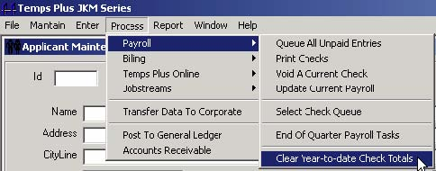

Clear Year-to-date Check Totals will zero out the Year-to-date information for all employees. This step would normally be done before the start of the first new payroll period of the year.

### **Move Current Billings to Period Batch**

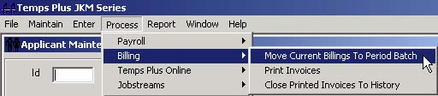

Before you can Print Invoices, you must move the current billings to the period batch by choosing Process, Billing, Move Current Billings to Period Batch.

If the operation is successful, you will get a message telling you how many entries were moved. You cannot tell the system how many entries to move. It moves all the entries in the current period batch at the time you run the operation.

#### ***Period Batch/Current Batch***

##### **Period Batch/Current Batch Overview**

The Current Invoice Batch is automatically created when you enter hours in time card entry. Any items in the Current Invoice Batch are moved to the Period Invoice Batch when you perform Process, Billing, Move Current Billings To Period Batch.

If you just bill once a week, this feature may mean nothing to you. You can just move the entries to the Period Batch and be done with it.

If you are a “daily pay” company, then this feature will enable you to print each day’s billing entries (Current Batch Invoice Preview), then move each day’s entries to the Period Batch for billing at the end of the week, effectively giving you an audit trail of each day’s billings.

If you have multiple invoicing cycles (not weekly), this feature may facilitate running multiple invoicing cycles in the same week.

##### **Why are there a current batch and a period batch?**

For many users, this is a feature they may just ignore by always moving the current batch to the period batch. However, it does allow for some special processing features

• It allows you to make time card entries, move those entries to the period batch for invoicing, and continue making time card entries that you wish to invoice later after you've closed out the printed invoices in the period batch history.

• Some users may find it useful to break the entire weeks entries into separate batches, which are easier to review. This feature allows you to make a batch of time card entries, review them and move them to the period batch, clearing the current batch for a new batch you can then enter and review separately.

### **Printing Invoices**

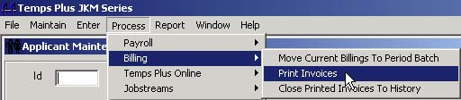

Printing invoices can be as simple as entering the appropriate dates, verifying the starting invoice number for the week, and pressing the [**Run F5**] action bar.

If you have only one invoice format in your system (see section on Job Orders for a discussion on multiple invoice formats), that’s all you have to do.

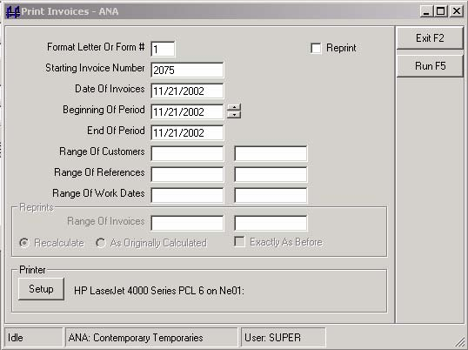

**Format Letter Or Form #** - If you have setup job orders with different form numbers, you should perform an invoice "run" for each form number can do this. See the section relating to invoices in company setup for more information on format letters and form numbers.

Different format letters can call different invoicing print routines that "look" different or perform differently (sorting, subtotaling, etc.). Format letters for invoices may be stored in the 1 Invoicing Tab on the Job Order Screen.

**Starting Invoice Number** - Enter the starting number for the invoices you are about to run. You should note that the system automatically increments the Invoice Number for you.

**Date Of Invoices** - All invoices in this "run" will carry the invoice date entered here.

**Beginning of Period, End of Period** - The dates entered here can be used by the invoice format you design to appear on the invoice. They are used for display purposes only, are not used to select which items appear on the invoices.

**Range of Customers, Range of References, Range of Work Dates** - Data entered in these fields are used to select which items appear on the invoices. Range of References and Work Dates fields are not used when reprinting invoices if the Recalculate button is checked.

**Printer Setup** - When you select a printer by pressing the Setup button, the system "remembers" that printer by the Form # on the screen at the time you setup the printer. In this way, you can use form numbers to automatically select the printer. For instance, you may have different customers, which require different invoice types. Assign job orders to use the format letters and form numbers that will produce your desired results, including which printer to use.

**Reprinting Invoices and the Period Batch** - Items stored in the period batch comprise the information used when printing invoices. Printing an invoice "stamps" information, including invoice numbers and dates on the transactions in the period batch. Reprinting an invoice does not create new transactions; it just "restamps" the information on the transactions. Therefore, you can safely reprint invoices as many times as you wish without worrying that you are creating new transactions each time.

You may reprint any Invoice in the Period Batch, until such time as you perform the Close Printed Invoices to History operation.

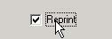

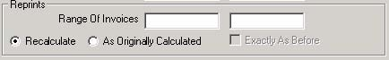

By using different combinations of buttons and data entry in the fields of the screen, you can get varied results when reprinting invoices.

**Range Of Invoices** - These fields determine which invoices should be reprinted.

**Recalculate** - All selected invoices are "cleared" first using the Range of Customers, Invoice Numbers and Form Letter/Form # fields only. Then invoices are recalculated and reprinted using data entry from all fields.

**As Originally Calculated** - The counterpart to recalculate, no changed information in your data files is used when reprinting invoices. Typically, you would use for invoices that were jammed, or if you needed copies of invoices. Use with the "Exactly As Before" button to get exact copies, including the original invoice numbers.

**Exactly As Before** - This box controls the numbering on reprinted invoices. If it is selected, invoice numbers will not use the Starting Invoice field for assigning invoice numbers, but will use the original invoice numbers. If you do not select the "Exactly As Before" box, reprinting will also renumber reprinted invoices using the "Starting Invoice Number" field.

#### ***Examples:***

**Reprinting invoices with no changes**

1. Check the "" Reprint box".

2. Select the "As Originally Calculated" button.

3. Check the "Exactly As Before" box.

4. Enter appropriate data in the "Range Of Invoice" fields to select the original numbers of the invoices you wish to reprint. Leaving these fields blank would reprint all invoices.

**Reprinting invoices with changes to existing transactions in the period batch**

1. Making changes to existing entries in the period batch editor will set all affected entries on the same invoice to "unbilled".

2. Since all items are now unbilled on the invoice, print the invoice just like it had never been printed.

**Reprinting an invoice after making new entries**

1. Make your new entries.

2. Move current billings to the period batch (after printing any current period reports).

3. Now reprint the invoice - Check the "" Reprint box".

4. Select "Recalculate" button.

5. Enter the invoice number you wish to appear on the invoice in the "Starting Invoice Number" field.

6. Enter the original invoice number in the "Range Of Invoices" fields to select the original number of the invoice you wish to reprint. Leaving these fields blank would reprint all invoices.

You must check the Reprint box to reprint invoices.

**Printing Newly Added Items Only** - The occasion may rise when, after printing invoices, you need to go back, enter more hours, print more checks, and deal with these newly created items (in the period billing batch).

If you just print invoices again as usual, only the new items will be included on invoices printed. These will be new invoices, different from any invoices for the same customer that were previously printed.

If you wish to reprint invoices including the new and previous items together on the same invoice, see the section "Reprinting Invoices" above.

**Reprinting Invoices Already Closed To History**

Reprinting invoices already closed to history is essentially the process of printing a report from the Reports Library using the Bill History tab, providing a criteria range using the original invoice number.

Such a report would be the same design as the your regular invoice format, except different in its' design. Instead of getting its' data from the period batch table in the database, it should be designed to get data from the history detail table.

You'll find examples of this format for the included invoices formats with an extra "R" at the end of the format name (for "Reprint"). For example, if the included invoice format name is TPINVA, the reprint format is TPINVAR.

If you are using a custom invoice format, you will need to design another and place it in the reports library. You do not need to name it according to the naming convention described here, but it may be helpful for your own documentation purposes, and anyone who follows in your tracks.

### **Close Printed Invoices To History**

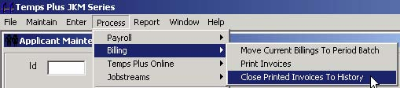

Closing the Printed Invoices To History closes out the payroll period in respect to billings, and is usually done at the same relative time as the Update Current Payroll task. When you do so, all printed invoices will be moved to the HistoryDetails table in the database, where you can run date-sensitive reports using the Billing History Tab in the Reports Library.

Additionally, if the current company code is linked to a Temps Plus AR company code, the accounts receivable records will be updated at the same time. [The Accounts Receivable has its own documentation](http://www.bridgewaregold.com/BSIU/BsiLibrary.htm).

### **Archiving Invoices**

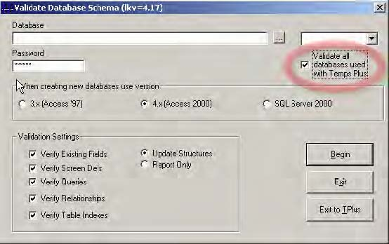

**To implement the feature:**

4. In “Maintain Company Setup, Features, General, Archive Copies of Invoices” set the number of days for which to archive invoices (‘0’ disables the feature).

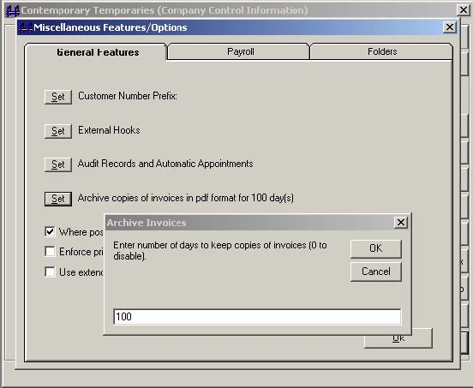

After closing printed invoices to history, you may view and print the archived invoices from the Maintain, Customer Screen, by pressing the “Invoice Copies” button.

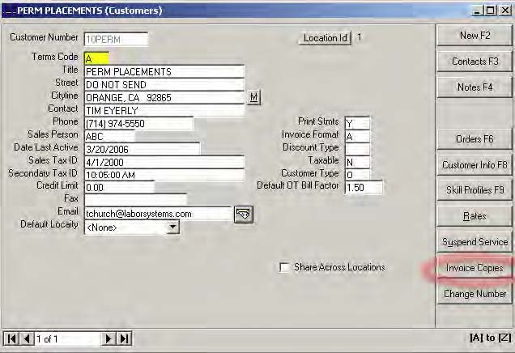

Any available archived invoices will appear in the grid. You may view them (as a .pdf file) and then print them if you wish (by pressing the ‘Print’ on the .pdf file displayed).

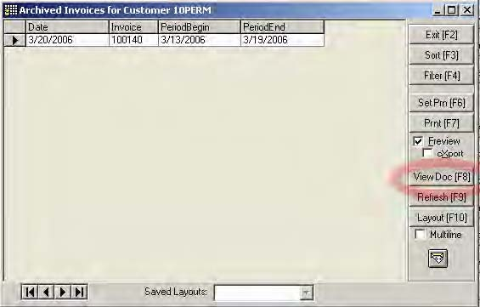

The system places the invoices in .pdf format in your \npath\attachements\invoices folder (when the feature is enabled). Archived invoices will be automatically cleared when they reach the number of days you specified when enabling the feature.

### **Temps Plus Online**

The Temps Plus Online option allows you to create an application form as a web page that may be placed on a web site. Applicants may then submit to you applications over the internet. Complete documentation may be found in the [Bridgeware University Library](http://www.bridgewaregold.com/BSIU/BsiLibrary.htm).

### **Jobstreams**

The Jobstreams option allows you to maintain and run jobstream collections and tasks from within the Temps Plus environment. Complete documentation may be found in the [Bridgeware University Library](http://www.bridgewaregold.com/BSIU/BsiLibrary.htm).

### **Transfer Data To Corporate**

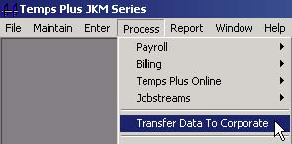

The Transfer Data To Corporate (Transfer and Gather) application allows you to transfer branch data to a corporate site for review and posting to accounting modules. It consists of a "transfer" and a "gather" mode.

To minimize the amount of information that needs to be transferred, only new and changed items are captured in the transfer file. These items are then "gathered" and merged to a copy of the branch database at the corporate site.

 Transfer transfers data from a branch database to a corporate copy of the *branch* database. It is not designed to synchronize databases or integrate branch data into a multi-office database. Transfer is designed to let a branch manage the front office side of their data and have it transferred to corporate for billing and/or paychecks.

#### ***Transfer Mode***

After selecting the Company Code(s) and Data Table(s) to work with, select the "Transfer to Corporate" button to start processing the transfer file. The transfer file will be placed in the Destination Path you select. If you have configured the "Mail Setup" box, the file will be sent automatically to the email addressed you have selected.

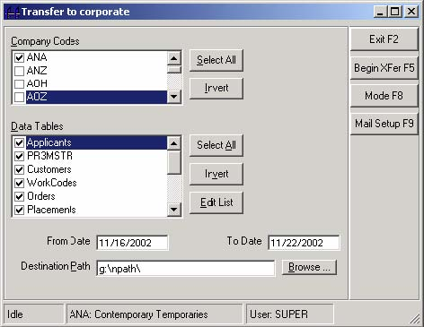

If you are not using email to transport your data, the files must be transported to the site where they will be "gathered". This is usually done electronically via modem using Symantec's pcAnywhere or a similar software product.

[**Mode F8**] - The [Mode F8]button toggles between the “Transfer" and "Gather" modes.

[**Mail Setup F9**] – If you wish to automatically transfer the file via email, use this button to setup the email address. If there is an email address setup, the system will automatically attempt to send the transfer file via email to the designated email address

[**Begin Xfer F5**] – This starts the creation of the transfer file

**From Date, To Date** - The application only transfers changes to records between these dates. New transactions (the Current Checks, Current Batch and Period Batch items) always get transferred, regardless of date.

**Destination Path** – Enter the path where you wish the transfer file to be stored.

#### ***Gather Mode***

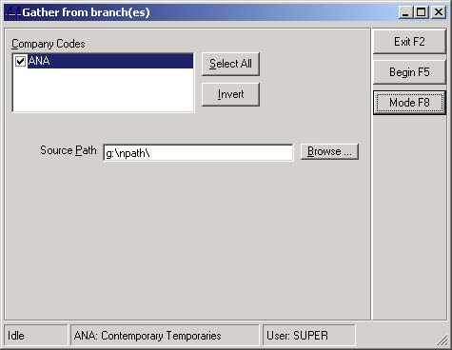

After selecting the Company Code(s), select the [**Begin F5**] button to merge the transferred information.

#### ***When to transfer***

The point at which the branch stops processing and transfers to corporate depends on where the checks and invoices are printed.

The branch must not Update Current Payroll or Close Printed Invoices to History before creating the transfer file, as information from history files cannot be transferred.

• ***If the checks and/or invoices are printed at the branch***, then the branch should stop processing after the checks and/or invoices are printed and execute Transfer Data to Corporate.

• ***If the checks and/or invoices are to be printed at corporate***, then the branch should stop processing after all data entry and necessary auditing reports are generated. Invoice entries must be moved from the current to the period batch before transferring to corporate.

• After corporate has received and "gathered" the information, the branch should be released, and ***both the branch and corporate should Update Current Payroll and Close Printed Invoices to History*.**

 Any checks and/or invoices that are printed at corporate must be simulated as printed at the branch prior to updating.

• To simulate the printing of the invoices, set up the invoice formats as form number "255" and print the invoices. This will result in the system marking the invoice items as printed, but will not actually print the invoices.

• To simulate the printing of the checks, print the checks to a printer that is defined as "off-line" or "paused" in your printers folder, then delete the checks from the print spooler. Anothed method is to setup a printer on your system (any printer) and insert the word “bogus” anywhere in the printer name. Any printer with the word ‘bogus” in the name will not print paper checks, but will execute all the actions in the data files as if they had actually been printed.

#### ***Miscellaneous Transfer/Gather Information***

• After the very first payroll/billing period, the databases at the branch and corporate should be synchronized by copying the entire database from the branch to corporate. Transfer and Gather can then be implemented starting the second payroll/billing period.

• "Notes" are not transferred using transfer and gather. Therefore, re-synchronizing the databases after notes have been entered on the branch system will result in the loss of notes in the branch system.

Sample Branch Checklist

(where Checks and Invoices are printed at Corporate only.)

|  |  |  |  |  |
| --- | --- | --- | --- | --- |
| 1. Enter all time cards | | | | |
| 2. Print current batch invoice preview | | | | |
| 3. Move Current Billings to Period Batch | | | | |
| 4. Transfer to Corporate | | | | |
|  | | | | |
| *After being released by Corporate…* | | | | |
| 5. Print checks to a “paused” or “bogus” printer | | | | |
| 6. Print invoices (make sure invoice formats are setup with form number as "255") | | | | |
| 7. Delete check run from spooler if you printed checks to a "paused printer" | | | | |
| 8. Update Current Payroll | | | | |
| 9. Close Printed Invoices to History | | | | |

### **Posting to Accounting – Configuration**

#### ***Configuration for CYMA IV Accounting (Windows)***

Before you can post to the general accounting modules, you must first configure the system properly. In addition to installing the CYMA IV software, and configuring your company codes for your installed modules, the following interfacing issues must be addressed:

1. The correct versions of the files ARAPI.DLL, GLAPI.DLL, C4INTF.DLL, POSTWIN.EXE, and TPTOCYMA.INI must be copied to your CYMA IV program folder.

2. Additionally, the TPTOCYMA.INI file must be edited to reflect which company codes exist on your system, and how they are to be posted. The syntax for the file is:

TPCo:CymaCo,DefArAcct,PrintedYN,DefTaxCode,DefSalesCode,DefSalesAcct,DefPcode,PayrollPayable,PayrollCash,PayrollJournal

**TPCo** - The Temps Plus Company Code.

**CymaCo** - The CYMA Company Code

**DefArAcct** - The default AR Account number to use when posting entries to the accounts receivable module. (CYMAIV only)

**PrintedYN** - Whether or not invoices are treated as printed already when they are posted to CYMA IV. In this way, invoices may be printed from CYMA IV, instead of, or in addition to printing them in Temps Plus. (CYMA IV only)

**DefTaxCode** - The default tax code to use when creating a new company shipping address in the accounts receivable module. In CYMA IV this is the tax category. (CYMA IV only)

**DefSalesCode** - The default sales code in TpToCyma.ini is only used when the sales code in Temps Plus is blank or null -- otherwise the sales code on the invoice is used. Cyma windows requires a valid sales code. You can force all Temps Plus invoices to the default sales code set in TpToCyma.ini by preceding the default sales code with the "!" character; for example, an entry in TpToCyma.ini of "!HOUS" would force all invoices to a sales code of HOUS.

**DefSalesAcct** - If there is no match in the account number field in the chart of accounts, the sales code entered here will be used. The default sales account in the TpToCyma.ini is only used when the corporate account for an item being posted is blank or null. Otherwise, the corporate account of the individual item is used.

**DefPcode** - if this field is left blank, the Work Codes in Temps Plus are used. The corresponding product codes must exist in AR already. If you fill in this field, all transactions will use this carry this work code as the AR product code. It then will be the only product code that must exist in AR.

**PayrollPayable** - the payroll payable account

**PayrollCash** - the payroll cash account

**PayrollJournal** - the payroll journal in GL where the posting should go.

Example:

**DMO:DEMO,1200-000-000,Y,CA,DLK,5000-100-001,TEMPS,2200-000-000,1005-000-000,PR**

Make a separate entry for each company you wish to have processed. Only the active CYMA company code will be processed in a given session. This means you must be running CYMA on the machine where you are executing the TpPost program. If you have multiple CYMA company codes, simply switch companies in CYMA and run the routine again.

1. The Chart of Accounts must be setup using the SuperJKM application with the corporate account number field referencing the GL module account number to post to for each associated internal COA account number. Make sure the corporate account number matches the way the account number appears in the GL module. For example, the CYMA IV General Ledger account segments are separated by a "-", not a period (1000-1AB instead of 1000.1AB).

2. You must setup a Chart of Accounts Account with the format of TaxJur.MP and assign the account number where the taxes are to be posted in GL for each tax calculation. For example, "WA.FI" would be for taxing jurisdiction "WA" and tax calculation "FI". In the Corporate Account field, enter the account number the amount is to be posted to in the General Ledger module.

3. Your General Ledger and AR modules in CYMA must be properly setup, including any default codes referenced in the above section.

4. In AR:

You must setup a customer type that matches the Temps Plus company code you are posting from. For example, in the above example, you would setup a customer type of "DMO".

When a customer record is created in the AR module by the Temps Plus posting routine, it creates a shipping address named "MAIN". If the customer already exists in the AR module, you must set this shipping address up manually before posting from Temps Plus, or you will receive a posting error message, and transactions for that customer will not post.

If you are posting sales tax, you must setup a Chart of Accounts Account number of "TAX." In the corporate account number field enter the account number in the GL module where you wish the taxes posted.

You must setup any sales codes in the AR module previous to posting from Temps Plus.

If there is no terms code on an invoice then a default terms code of "A" will be used (actually, because Cyma Windows only supports a single terms code for an entire invoice, the first item in the details of an invoice determines the terms. if it is blank or null then 'A' is used -- so terms code A should always be set up Cyma windows.)

**Skip Posting Payroll to the General Ledger**

NOTE: You may disable the posting of Payroll to General Ledger by setting the "SkipPayroll" key in your Windows registry as shown to "Yes":

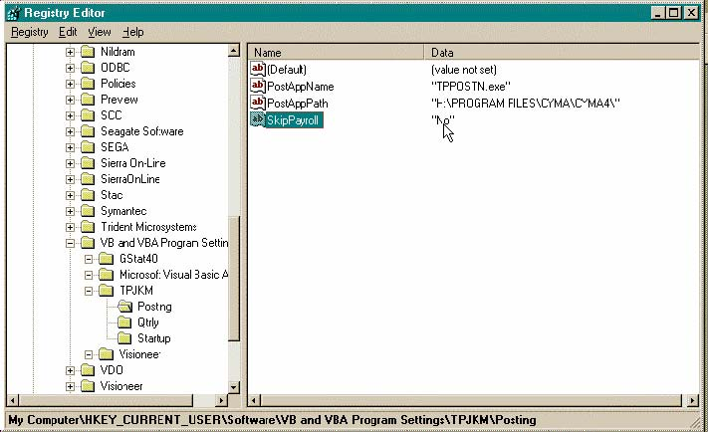

#### ***Configuration for CYMA PAS5 Accounting (DOS)***

Before you can post to the general accounting modules, you must first configure the system properly. In addition to installing the CYMA PAS5 software, and configuring your company codes for your installed modules, the following interfacing issues must be addressed:

1. The correct versions of the files POSTDOS.EXE and TPTOCYMA.INI must be copied to your CYMA PAS5 program folder.

2. Additionally, the TPTOCYMA.INI file must be edited to reflect which company codes exist on your system, and how they are to be posted. The syntax for the file is:

TPCo:CymaCo,DefArAcct,PrintedYN,DefTaxCode,DefSalesCode,DefSalesAcct,DefPcode,PayrollPayable,PayrollCash,PayrollJournal

**TPCo** - The Temps Plus Company Code.

**CymaCo** - The CYMA Company Code

**DefArAcct** - (Not used in PAS5)

**PrintedYN** - (Not used in PAS5)

**DefTaxCode** - In CYMA IV this is the tax category. (Not used in PAS5)

**DefSalesCode** - The default sales code in TpToCyma.ini is only used when the sales code in Temps Plus is blank or null -- otherwise the sales code on the invoice is used. Cyma windows requires a valid sales code. You can force all Temps Plus invoices to the default sales code set in TpToCyma.ini by preceding the default sales code with the "!" character; for example, an entry in TpToCyma.ini of "!HOUS" would force all invoices to a sales code of HOUS.

**DefSalesAcct** - If there is no match in the account number field in the chart of accounts, the sales code entered here will be used. The default sales account in the TpToCyma.ini is only used when the corporate account for an item being posted is blank or null. Otherwise, the corporate account of the individual item is used.

**DefPcode** - if this field is left blank, the Work Codes in Temps Plus are used. The corresponding product codes must exist in AR already. If you fill in this field, all transactions will use this carry this work code as the AR product code. It then will be the only product code that must exist in AR.

**PayrollPayable** - the payroll payable account

**PayrollCash** - the payroll cash account

**PayrollJournal** - the payroll journal in GL where the posting should go

Example:

**DMO:DEMO,1200-000-000,Y,CA,DLK,5000-100-001,TEMPS,2200-000-000,1005-000-000,PR**

Make a separate entry for each company you wish to have processed. Unlike CYMA IV for Windows, you need not be running CYMA on the machine where you are executing the POSTDOS program.

1. The Chart of Accounts must be setup using the SuperJKM application with the corporate account number field referencing the GL module account number to post to for each associated internal COA account number. Make sure the corporate account number matches the way the account number appears in the GL module.

2. You must setup a Chart of Accounts Account with the format of TaxJur.MP and assign the account number where the taxes are to be posted in GL for each tax calculation. For example, "WA.FI" would be for taxing jurisdiction "WA" and tax calculation "FI". In the Corporate Account field, enter the account number the amount is to be posted to in the General Ledger module.

3. Your General Ledger and AR modules in CYMA must be properly setup, including any default codes referenced in the above section.

4. In AR:

If you are posting sales tax, you must setup a Chart of Accounts Account number of "TAX." In the corporate account number field enter the account number in the GL module where you wish the taxes posted.

You must setup any sales codes in the AR module previous to posting from Temps Plus.

If there is no terms code on an invoice then a default terms code of "A" will be used.

**Skip Posting Payroll to the General Ledger**

NOTE: You may disable the posting of Payroll to General Ledger by setting the "SkipPayroll" key in your Windows registry as shown to "Yes":



### **Post To General Ledger**

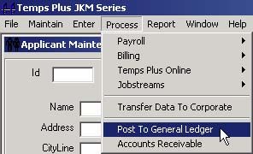

1. Make sure there are no users (including "phantom users") in the company codes for the PAS modules you will be posting to (AR and/or GL).

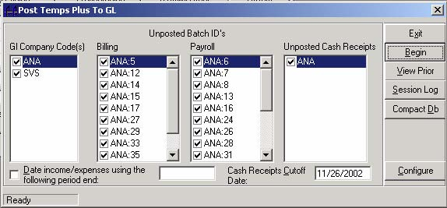

You will see any existing AR and PR batches that need posting. You should run prepost reports for all PR batches by pressing "Prepost GL" and "Prepost AR" then press "Begin" to post the batches.

See the section under "How entries are organized when posted to General Ledger" below for an explanation of using this option. You’ll also find a tutorial for the Post to General Ledger option in the Tutorials section at <http://www.bridgewaregold.com/BSUI>.

#### ***Fixing invalid posting entries***

You will be offered the choice to print only prepost entries with missing corporate GL numbers. Answering "Y" will bring up those entries for which the system could not identify a corporate GL number. You may type in the correct GL number (not corporate GL number) to fix the entry directly on this screen. If the GL corporate number for the GL number you type in on this screen is found, it will appear in the appropriate box on the screen when you leave the GL number field.

After pressing "Begin" to post the batches, and the program is finished posting, you will get a message about the posting, including how many items were posted, or any errors encountered.

#### ***How entries are organized when posted to General Ledger***

**Accounts Receivable**

Invoice entris originating from within Temps Plus are posted in summary by InvoiceDate, Account, CorporateAccount within a given batch. InvoiceDate becomes the entry date in the destination system.

Entries made via Apply Payments in Accounts Receivable are summarized by PostingDate, GlAccount, CorporateAccount, DepositID. PostingDate becomes the entry date in the destination system.

**Payroll**

Payroll transactions posted to the General Ledger module are organized and summarized *within a given batch* as follows:

• Manually created entries use the actual date used when creating the item and are summarized by account number by date. You may prefer to post in summary for a given period end date.

• Automatically calculated entries (net pay, withholding accruals, etc.) are summarized by account number by date using the appropriate check date. If you had more than one check date for the payroll period, you will have more than one date posting to the general ledger.

You can elect to have manual payroll entries post in summary. Simply check the box that says, "Date revenue/expenses using the following period end:" and then specify the period end date to use. All manual entries will be summarized by account and posted using that period end date.

## **Temps Plus Concepts**

### **Job Orders**

#### ***Front Office***

By careful design and use of the Custom Information Screen, one could capture, retrieve or view marketing information on Job Requests for unfilled orders, Sales Tickler information, etc.

#### ***Back Office***

At the very least, Job Orders contain information necessary to complete the Payroll/Billing cycle, such as which employees are working where (placements), pay and bill rates, work codes (which themselves determine several parameters), as well as customer billing information and miscellaneous billing information like discounts, sales tax, salesperson codes, etc.

How you use Job Orders will be a decision you should consider with your dealer’s guidance as it pertains to your unique office environment. For instance, using computerized (paperless) Job Orders in the front office won’t make much sense unless all coordinators have access to a computer whenever they need it.

Another important issue addresses the wisdom of allowing data entry of payroll and billing information by the front office being used to generate checks and invoices without some review controls in the accounting department.

#### ***Invoicing Issues***

Printing Invoices should be a very straightforward procedure for most users. Some customers, however, may create difficult invoicing situations Temps Plus can help facilitate.

For instance, the customer may require:

• One Invoice per Employee

• One Invoice per Job Site with many employees

• One Invoice with All Employees on it

• One Invoice sorted and subtotaled by work dates, job sites, employee numbers, etc.

...or any combination of the above.

Job Orders can help control these situations, as well as:

• Automatic Discounts based on hours or dollars

• Sales Person tracking for commissions, etc.

• Automatic Factoring of bill rates based on pay rates and/or Workers Comp

• Administrative Fees per Invoice or Employee

• Invoice styles, including sorting and subtotaling

• Enable Shift Differentials setup on the Work Codes

#### ***One Job Order/One Invoice***

The simplest relationship that can exist between Job Orders and Invoices is that an Invoice will be printed for every Job Order on which Employees are paid. This is the "default" invoicing situation in Temps Plus JKM.

If there are 10 Employees on a Job Order, and every Employee is paid from that Job Order, then when Invoices are printed, all 10 Employees will appear on the Invoice. If only 8 are paid, then only 8 will appear, and so on.

#### ***Multiple Job Orders/One Invoice***

Employees from more than one Job Order (from the same company) may appear on the same Invoice by designing and using a special invoice format where you have answered "Y" to "Combine Orders" in the Invoice Format setup screen in Maintain, Company Setup, Inv. Format.

The system keeps complete summarized and detailed Job History billing information, which you can access from the first Job Order Screen by pressing the [History] action bar while you have any Job Order on the screen.

#### ***Job Order History***

The system keeps complete summarized and detailed Job History billing information, which you can access from the first Job Order Screen by pressing the Billing History - [History] action bar while you have any Job Order on the screen.

### **Entering Hours and Printing Checks**

Temps Plus uses a unique method to capture pay information, which allows what would normally be several payroll operations into what can be one data entry operation. The system, from the Time Card Entry screen is capable of scanning Job Order and Employee information, calculating gross pay, taxes, deductions, net pay, and interactively printing checks (even from several workstations at the same time).

One need not enter all hours at the same time, either. For example, entering hours from time cards as they arrive prior to your “official” time card entry session could give you a head start on your workweek. Entering hours and printing an “early” check can satisfy that important employee request, if you wish (for example, a vacation check).

Each employee you wish to pay must exist as an active placement on a Job Order.

Time Card entries can be made for groups of employees or jobs where all hours are the same using the Group Time Card Entry screen. This is the screen that initially appears upon choosing Enter, Time Cards.

**Check Printing Options**

*There are three options available for printing checks from the Temps Plus system.*

You must choose the method that makes the most sense for you. Remember that you can use all three methods if you wish, as the situation dictates!

Consider the three methods carefully, and use these features to your benefit. Use the correct method for your firm, or a combination of methods.

#### ***Printing Checks Immediately***

By starting the Check Queue "running" before data entry, you can have checks print immediately as you send them to the print queue. This is one of the most common (and effective) uses of the Temps Plus system, and really the only method that makes sense for “Daily Pay” users. (See Daily Pay Considerations)

One of the biggest advantages is speed. When you are done entering hours and printing checks, the checks are ready to distribute (although printing a payroll journal and check register before handing out checks is highly recommended).

Users with many separate checks for the same employee to print may also find this feature makes things a little easier, as opposed to batching all the checks for one week. All multiple checks for the same employee could be produced one after the other if printed sent to the queue while the queue was running.

#### ***Printing Checks Later – Batch Printing***

The ability to sort checks, when printing checks that were “batched", is a primary reason many users choose this method.

For instance, checks queued for printing in the check queue can be sorted by First In First Out, Employee Number, or a Queue ID before starting the check queue. This option appears under the Ordering Options on the Check Queue screen.

Many users choose to batch print checks only because they feel “uncomfortable” printing checks “on-the-fly”. Do not let this prevent you from exploring print checks on demand. The reason many people feel uneasy about printing checks in real time is because other systems they have used only allow the batching method. Printing checks as you go is highly recommended if there’s no real reason not to-give it a try.

#### ***Printing Checks from more than one Workstation***

Users who would like to enter hours from multiple workstations at the same time and have the checks print immediately can do so by merely having the Check Queue "running" somewhere. Any checks sent to the queue within the same database by any user will print as they are entered.

This allows a virtually unlimited number of checks to be printed quickly by allowing multiple workstations to enter hours and print checks simultaneously. The only real limitation is the data entry speed of the operators and the speed of the check printer. It’s truly a remarkable sight to see several data entry personnel entering time cards and checks literally flying off the printer at several checks a minute!

#### ***Multiple Checks and Pay Numbers***

Sometimes an employee needs to have more than one check produced in the same payroll period. This could be because of pay for two weeks, say one check for this week, and one for last week on a late time card. You can use a pay number of "1" for the 1st check, then choose another pay number and produce another check for the same employee.

Producing more than one check, as opposed to including all pay on just one check also has tax calculation considerations - *more pay on one check places the employee’s wages in a higher tax bracket*.

Also, see the section on “Special Paynumbers” for using paynumbers with a paynumber greater than 100.

### **Invoicing Issues**

When entering hours and printing checks (or just entering hours), entries are automatically being made to the invoicing file. When you consider reprinting or voiding a check, you should be aware of what is happening in the invoicing file, or maybe more to the point, what may not be happening.

Your options are as follows:

**Just Get Rid of It!**

Make adjusting (and opposite) transactions and print the new check that nets to zero. This zero amount item is printed as a deposit advice using the Advice.rpt format in your NPATH directory.

**Reprinting the Check - No changes - You just need to reprint it.**

If a check got mangled in the printer, or the printer ribbon jammed, or for whatever reason you simply wish to reprint a check without making any changes to the amounts or calculations on the check, you may reprint the check. All you need to do is reenter the time card entry summary screen, and press the [Check(s) F6] action bar. These will automatically void the previous check in the system, and produce a new check when the check is next printed from the queue. If the check you wish to reprint is not a "pay number 1" check, change the pay number to the correct pay number. You may wish to view the details by pressing the [Edit F3] action bar to determine which pay number (P#) you need to use.

**Reprinting a Check With Changes**

If you need to reprint a check because it had something wrong with the hours, deductions, or calculations, you may do so making new entries to the same pay number, then sending the check to the print queue.

Note that changes could be positive or negative amounts. For instance, say you produced a check for 44 regular hours, and sometime after printing the check, you realized it should have been for 40 regular and 4 overtime hours. This could be corrected by reentering the time card entry screen and entering -4(minus 4) regular hours and 4(plus 4) overtime hours, then sending it to the check queue.

The previous check will be automatically voided. Your invoice will show +44 Reg., -4 Reg., 4 OT hours, which is correct, but you may wish to edit your entries using the period batch editor to combine the entries so the adjustment does not show.

### **Current Period vs. Previous Payroll Periods**

Making adjustments to checks in the Current Payroll Period is handled differently than adjustments to checks already updated to history (from a Previous Payroll Period).

### **Payroll Journals and Reports**

If you choose to make a change to a check in a Previous Payroll Period, you should remember that any reports produced previously for that payroll would, of course, no longer be accurate. Manually write any changes you made to the previous payroll period on the original report. In this way, your reports will still match, and you will have an audit trail of what you did.

### **General Ledger Considerations**

Please note that any changes made to a previous payroll period will not be posted to your General Ledger. You will have to make journal entries directly into the General Ledger Module to reflect any changes.

### **Applicant Payroll Check History**

The only option you should use to change a previous payroll period is to make a change to an applicant's check history file. Making these changes can automatically update your monthly, quarterly, and yearly employee totals if you inform that system which periods are affected by your changes.

You may make changes to, or delete a check from an employee’s check history by using the Edit Applicant Check History option in the SuperJKM program. All checks issued to an employee are available for modification in this option.

Again, you should take care to leave an audit trail when changing check history to leave an audit trail. Otherwise, you may have a lot of fun at W-2 time at the end of the year when you try to reconcile for the year, and wonder why your reports no longer match.

### **Check History and Workers Comp issues**

Please note that making new entries into Check History using the Applicant Payroll Check History option does not address work codes, and therefore, does not address workers comp reporting. Checks entered in this way will not appear on any workers comp reports, and will have to be adjusted manually when you report.

Also, making any edit to a check history item deletes the supporting check history details, which contains the work codes. These checks will also not appear on your workers comp reports.

You may identify such items by printing a workers comp exception report if your check history reports do not tie to your other check history reports. You will need to determine under which comp class the items on this report should be distributed.

### **Printing Reports for Previous Periods**

You can reprint reports for Previous Payroll Periods by printing reports that appear on the Payroll History tab in the Reports Library.

### **Company Specific Check Formats**

When printing checks (and deposit advices), the system "looks" for the files CHECK.RPT and ADVICE.RPT to use as the format for the checks and advices.

If you work with multiple company codes, and all the check formats for the various companies are exactly the same, all the company codes will use these two files.

However, some company codes have different check or advice formats, name the company specific formats as follows:

CHECKXXX.RPT

ADVICXXX.RPT

Where XXX is the company code the format refers to.

### **"Wav" File Alerts/Sounds**

During time card entry, audible alerts may be used to call attention to important events.

• Maximum "Quick Pay" limits

• Creating time card entries for pay numbers already printed on checks.

### **Invoicing**

After entering hours, printing an invoice preview, and making any invoicing edits, you are ready to print invoices. Invoices may be printed only from the Period Batch.

Invoice entries are automatically created by the entries made during time card entry. Optionally, other invoicing entries - not as a result of time card entry - may be made directly using the Period Batch Billing Editor, using Enter, Period Batch Billing Editor.

### **Period Batch Billing Editor**

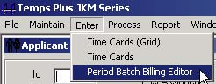

Before printing invoices, you may wish to make changes, additions, or deletions to the items that will appear on the invoices. The invoice editor is found by pressing Enter, Period Batch Billing Editor.

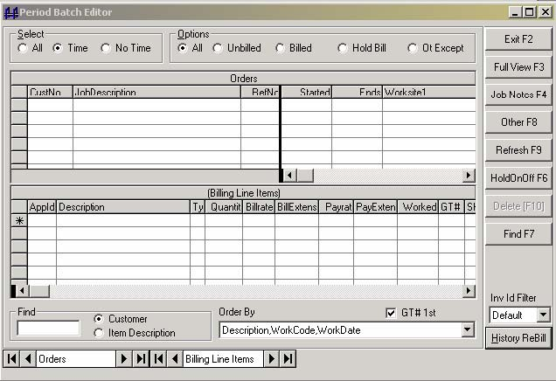

#### ***Changing Views***

By selecting the various buttons across the top of the screen, you can change what types of entries are displayed.

Color-coding signifies the status of the entries:

**Yellow** for "held" items

**Cyan** for 'billed" items.

#### ***Select and Options Buttons***

These mutually exclusive buttons work together to let you choose which job orders and detail activities are displayed. Selecting an Option button such as Unbilled, Billed, etc. will display a subset of the type of orders selected for display.

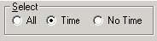

##### **Select All**

When this button is selected, all job orders are displayed.

##### **Select Time**

When this button is selected, all job orders with activity in the period batch are displayed.

##### **Select No Time**

When this button is selected, all job orders with no activity in the period batch are displayed.

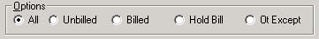

##### **Options All**

When this button is selected, all job order details for the job orders selected with the Select button are displayed.

##### **Options Unbilled**

When this button is selected, only unbilled job order details for the job orders selected with the Select button are displayed.

##### **Options Billed**

When this button is selected, only billed job order details for the job orders selected with the Select button are displayed.

##### **Options Hold Bill**

When this button is selected, only job order details marked with a "Hold Bill" for the job orders selected with the Select button are displayed.

##### **Options Ot Except**

When this button is selected, only job order details that meet the "Overtime Exception" specification for the job orders selected with the Select button are displayed. Normally, "overtime exception" items are those where an employee was paid overtime, but did not work at least 40 hours for the same customer in this payroll period. There can be any number of job orders for the customer. The number of hours can be changed from 40 in Maintain, Company Information, Time Card Entry Setup, in the "Regular Hours Before OT" field.

#### ***Order By***

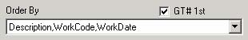

You may change the order in which items are displayed on the screen by choosing from one of the items in this box. Additionally, you may choose the GT#1st box, which further orders by the Group Ticket Number.

#### ***Find***

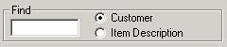

If you wish to jump to a Customer or Item Description instead of scrolling down through the order or billing items grid, you may check the appropriate button and type one or more letters in the Find box. This works in a similar manner to the Find box located on the Time Card Entry Screen.

#### ***Command Bars***

##### **Full View – [F3]**

You may expand the details section of the screen to include the space normally occupied by the job order display section if you need more room to work with your transactions. Press the [Full View F3] action bar again to bring the screen back to its' normal status.

##### **Job Notes – [F4]**

You may bring up the notes screen for a selected job order by pressing this action bar.

##### **Other – [F8]**

You may bring up the custom information screen for a selected job order by pressing this action bar. If you have not yet designed a custom information screen for job orders, you may do so in Maintain, Company Information, Screen Defs, and selecting "OtherOrders" from the scroll box.

##### **Refresh – [F9]**

If you, or another user on the system, have made changes to the entries on this screen, the display of added or deleted entries will not change until you press the [Refresh - F9] action bar.

##### **HoldOnOff – [F6]**

You may toggle the Hold status of entries by highlighting those entries and pressing the [HoldOnOff - F6] action bar. To toggle one entry, you don't need to highlight it - it can just be the current entry. If an entry has been paid and you put on it hold it will change the status of all entries that were billed on the same invoice to unbilled.

##### **Delete - [F10]**

You may delete entries by highlighting them and pressing the [Delete (Del)] action bar.

##### **Find – [F7]**

Pressing this action bar moves the cursor to the “Find” box on the screen

##### **Inv Id Filter**

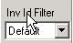

The Inv Id (or Invoice Id) field allows for distinguishing items you want printed on different invoices for the same job order in the period batch. When invoices are printed, separate invoices will be created for each Invoice Id. This should not be confused with the Invoice number which is assigned when invoices are printed. If you had 10 line items for a given job order in the period batch and you wanted certain of these line items to appear on different invoices, you could simply enter Invoice Id's of 1,2, and 3 on the various line items in the grid to determine what items should appear on what invoices. You can edit the Invoice Id for a given item directly in the grid.

Additionally, you can filter the activity for a given job order in the period batch so that you can work on the details for a given Invoice Id without being distracted by details meant for a different invoice. You do this by selecting the appropriate Invoice Id from the drop down list. When you set a filter, it also becomes the default Invoice Id to use as you create new line items for that order in the period batch. You can create new Invoice Id's by selecting 'New' from the Inv Id drop down list. When you select "New", you are prompted for a new Inv Id number to use and the current line items are filtered out so that you can enter new items you want to appear on a separate invoice. To go back to viewing all items for the current job, simply select 'All' from the Inv ID dropdown list.

##### **[History ReBill]**



This features allows for making adjusting entries to automatically “back out” an invoice from billing history , and brings it into the period batch billing editor for reprinting with or without changes on a new invoice number. You cannot use the old invoice number on the new invoice, as the old invoice number is still in history with adjusting entries to bring it to a balance of zero.

Such billing items always carry an “InvId” of 255 (see the section on InvId for more info on using Invoice Ids in the period batch billing editor.

Pressing this action bar prompts for an invoice number.

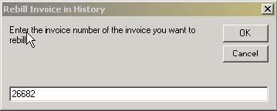

Entering a unique invoice number that exists in the billing history will restore the invoice to the period batch for rebilling and remove it from history.

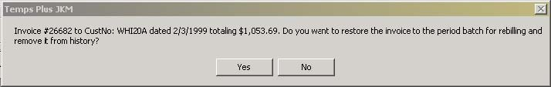

###### **InvId (Invoice Id)**

Items in the period batch billing editor have an “InvId” field which can be used to control how invoices will be printed.

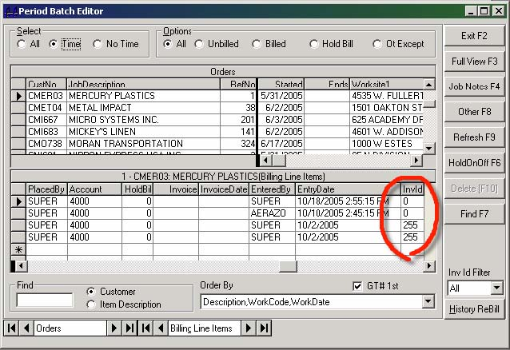

• Items with the same InvId will print on the same invoice.

• When time card entries are made and moved to the period batch editor the “InvId” field will either be blank (equivalent to a zero), or another number.

• Items moved from history using the [History ReBill] option will always carry an InvId of 255.

By managing the InvId of each item you can completely control which items are shown together on each invoice.

### **Invoicing Items With No Time Cards**

You can produce invoicing items at this point, even though no time card entries were made for a customer in the current period. First, if you do not have a job order for the customer, create one. Then highlight the job order on this screen, and type in your billing detail in the Billing Line Items pane.

In this same way, you can issue credits, adjustments, permanent placement billings, etc.

### **Designing Invoices**

Designing an Invoice is accomplished by using the Crystal Report Writer application. See the section on Reports for more information.

Twenty-six Invoice Formats are possible (A-Z). Each format can be unique to suit your purposes.

### **Daily Pay Considerations**

Temps Plus JKM provides certain conveniences on the time card entry screen for the daily pay user. To make use of some of these features, the "Daily Pay" question in Company Setup should be answered "yes". This can be found in Maintain, Company Information, under the Default Pay Info tab.

**When the daily pay option is set:**

The period ending date on the time entry screen defaults to the current date.

1. The pay number field is automatically incremented each new day of the pay period. For example, if the first day of the week you pay is Monday, the pay number field (P#) will be 1 on Monday, 2 on Tuesday, etc.

**There are some other features you can use:**

If you enter a pay number greater than 100, the hours on the pay number will not be seen as a current check for considering automatic overtime flagging on subsequent entries, regardless of pay number. When making entries for pay numbers over 100 the system will not prompt about overtime unless the number of hours just entered was over the regular hours limit.

1. If you enter a pay number greater than 100, after updating the current payroll, these pay numbers will decrement by 100 after the update, if they were not updated. In this way, you can enter checks for the following week - using next week's dates on the checks - before you have finished with the current week. When you update the current payroll - using the cutoff date for the current week - the next weeks checks will not be updated, and the pay numbers will now be 100 less than when they were entered. For example, an employee gets 5 checks this week, one each day Monday through Friday. But you also prepay him 2 checks for next week. The first five checks for the current week are pay numbers 1-5, and the two checks for next week are pay numbers 101 and 102. After you update, you have pay numbers 1 and 2 left in the current payroll.

**Some more techniques:**

1. If an employee gets more than one check in the same day, use a pay number ten greater than the normal pay number for the day for the extra check. For instance, pay numbers 1 and 11 on a pay number 1 day, 2 and 12 on a pay number 2 day, etc. In this way, you will not interfere with the possible pay numbers 1-7 that automatically increment each day of the pay period in a daily pay environment.

### **Reports**

Because all the reports in Temps Plus were created using Seagate's Crystal Report Writer, all the included reports can be changed to your own specifications. You need to purchase a copy of Crystal Report Writer and become familiar with it in order to change reports yourself. You do not need Crystal Report Writer to just run reports, as this ability is built into Temps Plus using the ActiveX control provided by Crystal for developers.

#### ***The Reports Library***

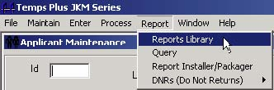

Pressing Reports, Reports Library brings up a screen where you can choose from included reports shipped with the system, as well as any reports you may add on your own. See the section on the Reports Library for more details.

#### ***Payroll/Billing Analysis Reports***

Several Payroll/Billing Analysis Reports are shipped with the system. In the Reports Library they are located under the "Bill History" tab.

These reports can produce detailed (or summarized) “at-a-glance” analysis information about any billing cycle that was produced using the system.

As each payroll/billing period is closed, the invoicing information (and associated pay information) is saved in a history file. It is from this file that reports are produced. Therefore, using a range of dates, you can print reports for any billing period.

You can choose to print information selected by:

• Range Of Invoice Dates

• Range Of Customers

• Sales Code Range Or Mask

• Work Code Range Or Mask

• Range Of Invoices

Several formats are provided to show different views of your data, including an example of how you can see your data with color graphs!

#### ***Workers Comp Reports***

Workers Compensation Reports can be printed from the Check History Tab in the Reports Library.

Any Expense (Deduction or Addition to Pay) that is set to "Y" to "Include in Gross Pay" in the Deductions screen of Company Setup will be included on the standard Workers Comp reports included with the system.

If this is not how you wish your reports to function, you will need to customize the Workers Comp Reports on your system with Crystal Reports.

#### ***Other Included Reports***

Refer to the reports digest for examples of the included reports that ship with Temps Plus JKM.

Also, check the [Bridgeware Webhelp](http://www.bridgewaregold.com/webhelp) site for more reports designed since the initial release of Temps Plus JKM

#### ***TPREPORT Database***

The Reports Library in Temps Plus contains many predefined reports so you can immediately use the system. Using the same software application we used to design the reports - Crystal Report Writer 6.0, you can modify any of these reports by Seagate Software.

Using this same application, you can also design additional reports and add them to your report library.

The Reports Library automatically "sees" any reports setup in your system.

It does this by using a Microsoft Access Database named "TPReport" (with a filename of "TpReport.mdb) that can be found in the NPATH folder on your computer system. By modifying this database, you can have the system find any new reports you may add to the system. You may purchase a copy of Microsoft Access 97 to modify the database, or use the program VISDATA provided by with Temps Plus.

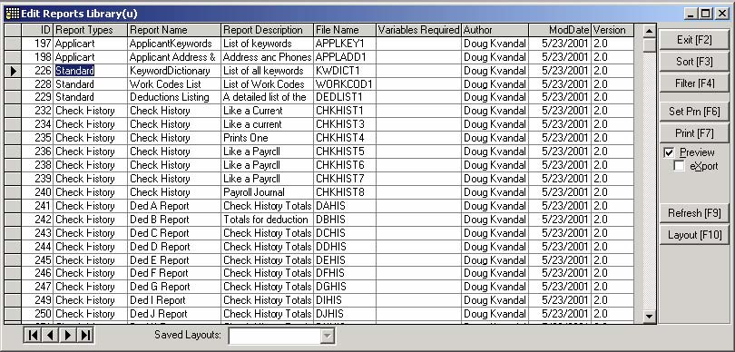

Using the database, you can setup and/or change the following:

• The Report Type

• The Report Title that shows on the screen when selecting a report

• A Report Description that shows on the screen when selecting a report

• The Filename of the report

• Special Variables that will be passed to the report

##### **ID**

This field is an "auto number" field and is automatically assigned by the system.

##### **Report Type**

This field indicates to the program which selection criteria screen to use for the report. You should use the appropriate report type for the report. Valid report types and corresponding selection criteria are:

**Placements**

Start Date

Stop Date

Employee Number

Placement Status

Customers

**Applicants**

LastName, First

Entry Dates

Last Assignment Date

Date Available

Employee Numbers

Status

**Bill History**

Invoice Dates

Customers

Sales Codes

Work Codes

Invoices

**Current Checks**

Check Dates

Employee Numbers

Departments

Locations

Taxing Jurisdictions

Check Numbers

Net Check Amounts

Gross Check Amounts

Pay Numbers

**Customers**

Customer Numbers

Customer Types

Discount Types

Sales Codes

YTD Sales

Date Last Active

Terms Codes

**Jobs**

Customers

Start Dates

Order Dates

End Dates

Sales Codes

Order Status

Dispatchers

Dispatch Dates

Placement Status

**Standard**

Reports where no selection criteria are appropriate would use this type. For example, you may have designed a report that always prints all the data, or you may have designed the selection criteria directly into the report design.

**Current Batch**

ID Numbers

JO Reference Numbers

Customer Numbers

Pay Numbers

Work Dates

Type of Hours

Employee Numbers

Entered by Names

Entered Dates

**Period Batch**

Batch ID Numbers

JO Ref Numbers

Customer Numbers

Work Dates

Work Codes

Group Ticket Numbers

Type of Hours

Invoice Numbers

Sales Codes

**Check History**

Check Dates

Employee Numbers

Departments

Locations

Taxing Jurisdictions

Check Numbers

Net Check Amounts

Gross Check Amounts

Pay Numbers

**Employees**

Employee Numbers

Departments

Locations

Taxing Jurisdictions

Hire Dates

Termination Dates

**YTD Payroll**

Employee Numbers

Departments

Locations

Taxing Jurisdictions

Net Pay Amounts

Gross Pay

**Quarterly**

This type is used to place the report on the list of reports available when you run Process, Payroll, End of Quarter Payroll Tasks

**Checks, Invoices**

These two categories may be used simply to record what your various formats are in your system, for reference purposes only. For instance, entering your Invoice and Check format information in the database allows you to have the information print out on the Report Library Report (one of the supplied system reports).

**AR Report Types**

The Accounts Receivable module has it's own Reports Library with it's own set of Report Types and selection criteria.

**ARAging**

Report Cutoff Date

Invoice Dates

Customers

Invoices

Branch ID

Branch Customer

**ARStatement**

Report Cutoff Date

Invoice Dates

Customers

Invoices

Branch ID

Branch Customer

**ARCustomer**

Customer Numbers

Customer Types

Discount Types

Sales Codes

YTD Sales

Date Last Active

Terms Codes

**ARLedger**

Report Cutoff Date

Invoice Dates

Customers

Invoices

Branch ID

Branch Customer

**ARDeposits**

Posting Date

Document

Pay Code

Gl Account

Deposit ID

##### **Report Name**

Enter a Report Title that you wish to be displayed on the screen when you are selecting a report.

##### **Report Description**

Enter a description that you wish to be displayed on the screen when you are selecting a report.

##### **Filename**

Enter the name you gave the report when you saved it.

#### ***Required Variables***

Temps Plus can send special variables to reports. Your reports **must** contain these variables, or you will get an error when running the report from within Temps Plus. The included system reports have the special variables already setup. If you design you own reports, and wish to have any of these variables sent to your reports, be sure to include them in your report, or you will get an error. You may also enter them in this variables column in the TPREPORT database for documentation. These variables are used so that you may have date, time, company, and user information contained in your reports. The included system reports use these variables at the top of most reports.

The valid variables are:

**UserID** - sends the User Identification

**UserName** - sends the User Name

**UserEmail** - sends the User Email Address

**CompanyCode** - sends the Company Code

**CompanyName** - send the Company Code

**Criteria** - sends the Selection Criteria used in the report as an SQL string

**Check History, Payroll**

In addition to the variables above, any reports with a type of "Check History" or "Payroll” must contain the following additional variables:

Dedlist1

Dedlist2

Dedlist3

**Quarterly Type Reports**

In addition to the variables above, any reports with a type of "Quarterly" must contain the following additional variables:

FULIMIT

FURATE

SULIMIT

SURATE

SSLIMIT

SSRATE

MCLIMIT

MCRATE

QuarterNumber

QuarterYear

Checks also require variables. While you may record the variables on the screen for reference, you must use these variables in your check format, regardless of whether they are listed here or not.

The necessary variables are:

**Checks**

DedList1 - contains descriptions for deductions A-N

DedList2 - contains descriptions for deductions O-X

DedList3 - contains descriptions for deductions Y-Z

Each deduction variable contains a string of 21 characters for each deduction, the first position contains an "*" if the amount is included in gross pay, followed by 20 characters containing the deduction description.

PEDate - contains the Period Ending Date from the Check Queue screen

PBDate - contains the Period Beginning Date from the Check Queue screen

RateLine1 - contains the first line of rate data (Cust#, hrs, and rate for each customer)

RateLine2 - contains the next line of rate data

RateLine3 - contains the next line of rate date

QueueId - contains the Check Queue ID number

Reports in the Temps Plus Accounts Receivable module**, in addition to the basic variables required by all reports**, require additional variables for reports under the following report types:

**ARAging, ARStatement, ARLedger**

Cutoff Date - contains the Cutoff Date passed from the Selection Criteria in the Reports Library.

Aging1Days - contains the aging days for the first aging bucket

Aging2Days - contains the aging days for the second aging bucket

Aging3Days - contains the aging days for the third aging bucket

#### ***Special Report Names***

Some printing functions look for specific file names when printing. They are:

**Checks** - Checks.rpt in the npath directory, or CHECKXXX.rpt in the data directory, where 'XXX" is the company code.

**Deposit Advices** - Advices.rpt in the npath directory or ADVICXXX.rpt in the data directory, where 'XXX" is the company code

**Place and Print work ticket for selected applicant** - PLPRN.rpt in the npath directory, or PLPRNXXX.rpt in the data directory, where 'XXX" is the company code.

**Place and Print "gang" work ticket** - PLPRG.rpt in the npath directory; or PLPRGXXX.rpt in the data directory, where 'XXX" is the company code.

**Check Histories** - CKHIS.rpt is the file name of the file that is used when you press the F9 command bar from the applicant screen. It must be in the npath directory.

**Invoices** use the names you have setup in Maintain, Company Information, [Inv. Format] action bar. They must be in the npath directory. Example: TPINVA.rpt is format A.

**Master File Screen Information -** While you have a master record on the screen (applicant, job order, customer, etc.), you may print a paper record of the record on the screen (by pressing the [Ctrl-P] keys. Each master record screen "looks" for a special format as follows:

PRAPP.rpt - Applicants

PRCUS.rpt - Customers

PREMP.rpt - Employees

PRWOR.rpt - Work Codes

PRJOB.rpt - Job Orders

PRKEY.rpt – Keywords

These report formats must reside in the npath folder.

**Emailing Resumes** - . The Email Resumes feature will look for a Resume.rpt file in the Npath. If found, it will create the resumes to be emailed using the crystal report format method instead of the default format method. Additionally, you may also add a ResumXXX.rpt file in the Npath, which will be used by the company code (represented by the ‘XXX’ in the file name) instead of the Resume.rpt file. Regardless, the Resume.rpt must exist to invoke the alternate (Crystal Report) method.

**AR Module** – When pressing [Ctrl-P] from the "Apply Payments" screen, the following formats are used

ARDEP1.rpt – Prints a deposit report when no customer is selected

ARLGR1.rpt – Prints a ledger for the current customer selected.

PRARC.rpt – AR Customers

These reports must reside in the NPATH\Reports folder.

**In Process at a glance** – When printing reports from the In Process at a glance window (by pressing the

 button next to a selection on the screen, report formats with the following names must exist in the \Npath\Reports folder for each selection.

IPAAG0.rpt – New billing in Current Batch

IPAAG1.rpt – Net yet invoiced in Period Batch

IPAAG2.rpt – Invoiced in Period Batch

IPAAG4.rpt – Unpaid transactions in Current Batch

IPAAG5.rpt – iPay Deposits queued

IPAAG6.rpt – Gross payroll processed

You will find default formats for these reports on the BridgewareGold Website, or you may design your own(again, these reports must reside in the \NPATH\Reports folder).

#### ***Designing Reports***



Using Crystal Report Writer, you have a powerful way of getting exactly the information, the way you want it, out of your data.

Using the "Wizard" feature, which appears after you choose File, New from the action bar in Crystal Reports, you can quickly design new reports that can be run immediately, without adding the report to the Reports Library. If you would like to store the report for continued use, you should add it to the TPReport database.

To make things easier, you may wish to set Crystal Report Writer to automatically save reports in the directory used by Temps Plus, so you don't have to search for it each time you create or edit a report. The default directory is a folder named "reports" in the NPATH folder. For example, if your NPATH is "C:\Program Files\Temps Plus JKM\npath", then your default directory should be "C:\Program Files\Temps Plus JKM\npath\reports".

*You may set the default directory in Crystal Report Writer by pressing File, Options, Database, and filling in the Data Directory field.*

#### ***Report Installer/Packager***

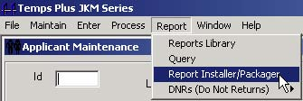

Temps Plus has a way of packaging reports so that they can be delivered and installed with a minimum of support from our website, or from your system to another. The Report Packager can be used to create a .tpr file (temps plus report) This .tpr file has all the information necessary to install the report.

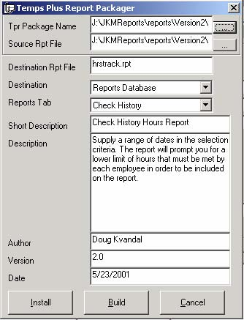

**Report Packager Fields**

**Tpr Package Name** – You may type a new "tpr" file name, or search for an existing "tpr" file by using the ellipses button to the right of the field. There is tool tip text for the TPR file name and the source file name so that if the file name is too large for the text box, the tool tip can display additional data.

**Source Rpt File** – If you are building and/or refreshing a report package, enter the complete path and file name of the report you want to create the package from. You can browse to the file you want to package by using the command button to the right of the field. There is tool tip text for the TPR file name and the source file name so that if the file name is too large for the text box, the tool tip can display additional data.

**Destination Rpt File** - The file name the report will be saved as in the destination system. A path name is not specified. The path is controlled by the "Destination" below.

**Destination** If you are installing a package, this is the area the report file will be installed. If you are building and/or refreshing a report package, pick a destination from the drop down list. If you want to have the report appear in the list of available reports within Temps Plus you would specify "Reports Database" and then designate a Tab for the report to be classified under in the "Reports Tab" dropdown list that follows. Check formats, time ticket formats and the various "Screen Print" formats like prApp belong in the Npath.

**Reports Tab** – If you specified a destination of "Reports Library" then select the Reports Tab to install the report in from the available Tabs in the dropdown list. These Tabs correspond to the captions on the tabs dividing the various reports available in the Reports Library. Notice that AR tabs are available as well as Temps Plus tabs

**Short Description** – If destination is Reports Library, the description entered here will be displayed in the list box of available reports under the specified tab.

**Description** – If destination is Reports Library, the description entered here will be displayed in the "Description" area of the Reports Library form, when the report is highlighted in the list box of available reports. If a pipe character(|) is used in the description of a report and the report is installed in the reports database, only the description to the left of the pipe character will be stored as a description of the report. This allows you to insert comments and/or installation notes in the description area without having those comments appear as a user navigates the reports library in Temps Plus. You can create a new line in the description area by holding the shift key as you press the enter key.

**Author** – For documentation purposes. It is also recorded in the Reports Library database, for reference purposes only.

**Version** – For documentation purposes.

**Date –** For documentation purposes.

[**Install**] – Selecting this button installs the report according to the fields shown on the form

[**Build**] – Selecting this button creates the “tpr” file according to the fields shown on the form

[**Cancel**] – Cancels the form.

##### **Building a Package**

When you have completed the form information as described above, simply press the Build button and your package will be built and named as specified in the "Tpr Package Name." You can also update existing packages as long as the source report name is still available in the location specified. After building the package you can email it to branch offices or to other Temps Plus users. You might even want to have your report made available on the Bridgeware Gold web site for other Temps Plus users to benefit from. You can also Install the package, immediately after building it, to update your own Temps Plus reports. This is especially convenient when you are updating descriptions of reports.

##### **Using the Report Installer**

When you double click on a report package (a .tpr file) – or download a report from the Bridgeware Website directly, the tpreport program will run in install mode -- it will hide a few of the text boxes and a command button used during the building of a tpr file. In install mode, the program will automatically exit after installation or when cancel is selected. You can read the information about the report and elect to install it by pressing the Install button.

[Instructions for installing from the Webhelp website.](http://www.bridgewaregold.com/webhelp/reports/VersionHistory/reportsdownloadinginstructions.htm)

##### **Using the Report Packager**

If a pipe character (|) is used in the description of a report and the report is installed in the reports database, only the description to the left of the pipe character will be stored as a description of the report. This allows you to insert comments and/or installation notes in the description area without having those comments appear as a user navigates the reports library in Temps Plus. Oh, and by the way, you can create a new line in the description area by holding the shift key as you press the enter key.

You can create a new line in the description area by holding the shift key as you press the enter key. There is tool tip text for the TPR file name and the source file name so that if the file name is too large for the text box, the tool tip can display additional data.

#### ***Report Queries and SQL***

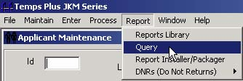

The Report, Query command allows you to create (and store, if desired) SQL-type statements that can access your data directly.

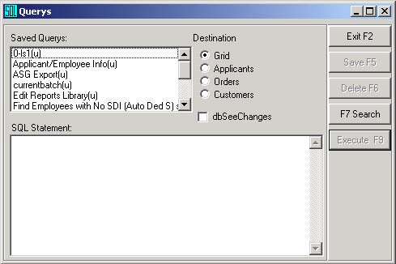

This is a very powerful feature that can modify your database directly instead of using a Temps Plus form, and as such, you can perform many functions that Temps Plus does not perform through the regular forms and menus. Therefore, you must login as “SUPER” to create the queries. However, saved queries can be executed by other users, depending on how you save the query and the Supervisor status of the user.

**DO NOT use this feature unless you know what you are doing, or are under the direction of our technical support department.**

## **Appendix**

### **Checklists**

#### ***Weekly Checklist***

This is an example of a typical checklist to keep track of where you are in your payroll/billing cycle. If you wish to use such a checklist, you should modify this example to suit your own needs, adding any notes that your feel are appropriate.

|  |  |  |  |  |
| --- | --- | --- | --- | --- |
| Activity | | Operation | | |
| 1. Add or Change Customers | | Maintain, Customers | | |
| 2. Add or Change Applicants | | Maintain, Applicants | | |
| 3. Add or Change Job Orders | | Maintain, Job Orders | | |
| 4. Expected Time Card Report | | Report, Reports Library, (PlacementsTab) | | |
| 5. Make Time Card Entries | | Enter, Time Cards | | |
| 6. Print Current Batch Invoice Preview | | Report, Reports Library, (Current Batch Tab) | | |
| 7a. Queue All Unpaid Entries | | Process, Payroll, Queue All Unpaid Entries | | |
| 7b. Load & Print Checks | | Process, Payroll, Print Checks | | |
| 8. Print Current Payroll Journal | | Report, Reports Library, (Current Checks Tab) | | |
| 9. Print Current Payroll Journal Totals | | Report, Reports Library, (Current Checks Tab) | | |
| 10. Print Current PR Check Register Summary | | Report, Reports Library, (Current Checks Tab) | | |
| 11. Move Current Billings to Period Batch | | Process, Billing, Move Current Billings to Period Batch | | |
| 12. Print Period Batch Invoice Preview | | Report, Reports Library, (Period Batch Tab) | | |
| 13. Edit Invoices (if necessary) | | Enter, Period Batch Billing Editor | | |
| 14. Load & Print Invoices | | Process, Billing, Print Invoices | | |
| 15. Close Printed Invoices To History | | Process, Billing, Close Printed Invoices To History | | |
| 16. Update Payroll for the Current Period | | Process, Payroll, Update Current Payroll | | |
| 17. Post Payroll and Invoices To Accounting | | Process, Post payroll and invoices to accounting | | |
| 18. Print Invoice Register Analysis Report | | Report, Reports Library, (Bill History Tab) | | |
| 19. Run the "compact" utility | | Maintain, Company Setup, Utilities, Database, Compact/Repair Database | | |

#### ***Monthly Checklist***

**In Temps Plus**

Other than printing payroll or sales analysis reports to include a range of monthly dates (which can actually be done at any time), there are no regular operations that need to be performed monthly in Temps Plus.

**In your General Accounting application**

You may want to use a monthly checklist to keep track of operations you should be performing on a regular, monthly basis. Following is an example, which you should change to be specific to your firm and reflect your general accounting package. The following example reflects CYMA PAS5 accounting.

|  |  |  |  |
| --- | --- | --- | --- |
| **Activity** | | **Module/Operation** | |
| 1. Post AR to General Ledger | | AR Operation J, SubOption I | |
| 2. Post AP to General Ledger | | AP Operation K, SubOption D | |
| 3. Post Entries in General Ledger | | GL Operation E | |
| 4. Print Financial Statements | | GL Operation L, SubOption A | |
| Balance Sheet | | Period To Print = "Y" (year to date)  Enter ending date to include on statement  Format = "B" | |
| Income Statement | | Period To Print = "D"(range of dates)  Enter range of dates to include on stmt  Format = "A" | |
| 5. Process End of Period for AR  Use same cutoff date as posting cutoff date in step 1. | | AR Operation N | |
| 6. Process End of Period for AP  Use same cutoff date as posting cutoff date in step 2. | | AP Operation N | |

#### ***Quarterly Checklist***

In addition to printing payroll or sales analysis reports to include a range of monthly dates (which can actually be done at any time), there are payroll items that need to be printed and produced on a quarterly basis to satisfy federal and state reporting and filing requirements.

|  |  |
| --- | --- |
| **Activity** | **Operation** |
| 1. Print Quarterly Earnings Reports, File 941 Forms, and produce Magnetic Media diskettes | Process, Payroll, End Of Quarter Payroll Tasks |

#### ***Yearly Checklist***

Yearly Activities in Temps Plus include Clearing the Year to Date Check Totals and producing the SSA Magnetic Media diskettes.

|  |  |
| --- | --- |
| **Activity** | **Operation** |
| 1. Clear Year To Date Check Totals | Process, Payroll, Clear Year-to-date Check Totals |
| 2. Produce W2’s | Run W2.exe program |
| 3. Produce SSA Magnetic Media Diskette(s) | Process, Payroll, End Of Quarter Payroll Tasks |

### **Automatic Garnishments (JKM v3.0.x method)**

Setting up garnishments (or child support, etc.) may require up to 4 elements to be setup and/or configured:

1. A deduction that references a math packet

2. A math packet

3. The deduction added as an automatic deduction to the employee screen, along with the garnishment information particular to the employee.

4. A field added to the OtherPR3MSTR screen to track the maximum percentage of disposable income per period.

You may need to setup multiple deductions for different types of garnishments. There can be many ways to implement a garnishment. This example represents just one way, but one commonly used by many of our clients.

This example will handle all garnishments that are either a percentage of disposable income, or a flat amount.

If you wish to track multiple types of garnishments (child support, liens, etc.) separately, you will need to setup multiple deductions.

**The Deduction**

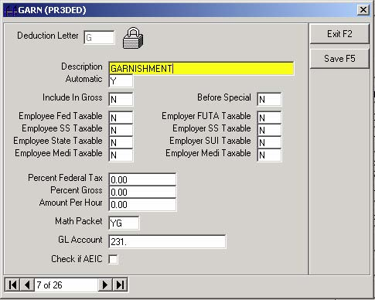

The Automatic field must be set to "Y" and reference the math packet you are going to use for the automatic calculations. The math packet in this example is a "goal" type math packet because it starts with the letter "Y".

**Setup the Math Packet**

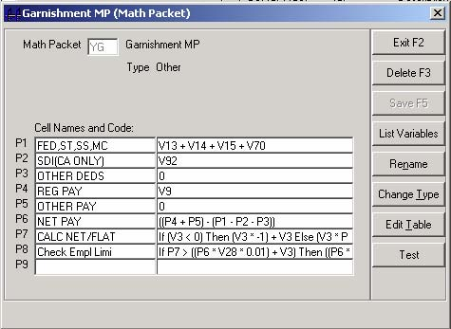

In this example, we calculate the disposable pay (cell P6) and then calculate the percentage of disposable income or flat amount to be withheld (cell P7), according to the requirements for each employee. These requirements are stored in the employee screen.

**P1**: Gets the Federal and State Withholding Amounts

**P2**: Gets the CA SDI (only applies to CA - change to "0" if you do not have CA SDI)

**P3**: Insert the variables for any deductions you wish to affect the disposable income

**P4**: Get the Reg, OT, and DT hourly pay

**P5**: Insert the variables for any additions to pay you wish to affect the disposable income

**P6**: Calculates disposable income

**P7**: Calculates the percentage or flat amount to be withheld

**If (V3 < 0) Then (V3 * -1) + V3 Else (V3 * P6 * 0.01) + V3**

**P8**: Checks for the maximum percentage from the OtherPR3MSTR screen

**If P7 > ((P6 * V28 * 0.01) + V3) Then ((P6 * V28 * 0.01) + V3) Else P7**

*In this example, V28 is the 2nd field in the Employee Info Screen - you should change this to the appropriate variable for the field you are using to track the maximum percentage in the Info Screen.*

**The Employee Screen**

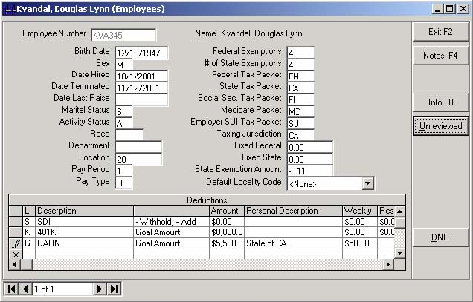

The deduction letter for the garnishment must be added to the list of automatic deductions at the bottom of the employee screen as shown.

Since we referenced a goal math packet with deduction G, the description of "GOAL AMOUNT" automatically appears.

You must enter information into the following fields:

**Amount** - The goal amount, that when reached, will stop withholding. If there is not a goal specified by the garnishing entity, enter a large amount. If you do not have an amount here, nothing will be withheld.

**Personal Description** - Enter anything descriptive you wish about the garnishing entity, including an acct number, if you wish. This field is only for your company's own information, and will not affect the calculation.

**Weekly**

**Entering positive amount** here (like $10.00), **will withhold a percentage** of the disposable income (10%).

**Entering a negative amount** (like -$10.00) **will withhold a flat amount** ($10.00).

**The OtherPR3MSTR Screen**

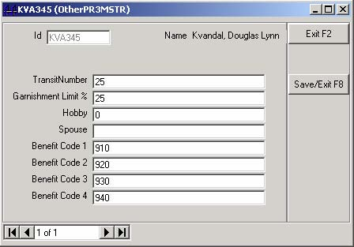

You must setup a field (like "Garn Limit" in this example) in the OtherPR3MSTR screen and refer to it in the math packet cell P8. In this example, it is the second field, which would be variable V28 for use in the math packet. This field must contain a number that represents the maximum percentage of disposable income to be withheld under any circumstances. It is used primarily for withholding a fixed amount with a percentage cap on the amount to be withheld.

 Please note, as implemented in this example, you must input a figure here (just put 100 for 100% if you wish), or nothing will be withheld.

### **Garnishments (Temps Plus JKM v3.1.x method)**

You may setup and use an unlimited number of garnishments with varying parameters to meet a diverse set of requirements. You may still use any method used in previous versions of Temps Plus, but this new dedicated feature (in Temps Plus JKM version 3.1.x) provides an improved way calculate and track garnishments.

In preparation for garnishing wages for any employees, there are some prerequisites:

1. First a table of “garnishment types” must be configured.

2. Next, a table of “remit to” information must be configured.

*Both “Types” and “Remit To” tables are tables that will be shared for use with all employees*

3. A deduction that will be used for garnishments must be setup in the “Maintain, Company Setup, Deductions” screen

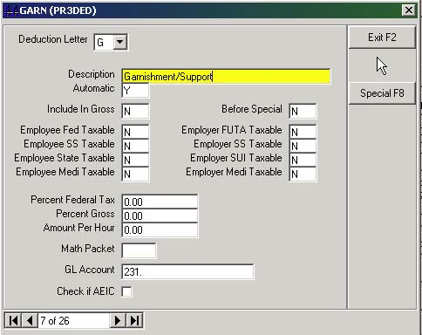

4. This deduction must also be noted in the “Maintain, Company Setup, Features” screen.

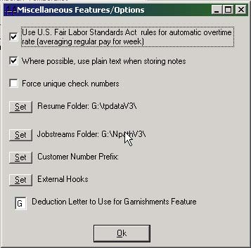

5. You **DO NOT** need to add the deduction to the automatic deductions section on the employee screen)

6. You **DO** need to set the deduction to “Y” for Automatic

At this point, you are ready to set and use garnishments for employees.

**Note:** You may setup and use just one “garnishment type” for use with all employees as long as the rules for the type are the same for all employees (same percentage of disposable income, etc.). It is preferable to setup your “types” as broadly as possible, so that you may use the same type for many employees, and to take advantage of the “equitable distribution” feature.

**Preparing the Garnishments - Overview**

1. Go to the Employee Screen for the appropriate employee by choosing Maintain, Employees or pressing the

 button at the applicant screen.

2. Next, press the

 button.

If this is your first time using the garnishments feature, you will be presented with the “Maintain Garnishment Types” screen, where you will setup the library of garnishment types you will have available to use for any employee(s).

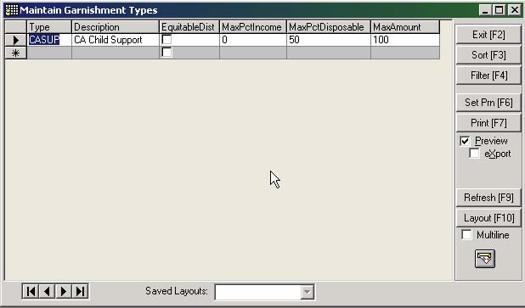

3. Next, you must setup a library of “remit to” addressed on the “Maintain Garnishment Remit To Information” screen.

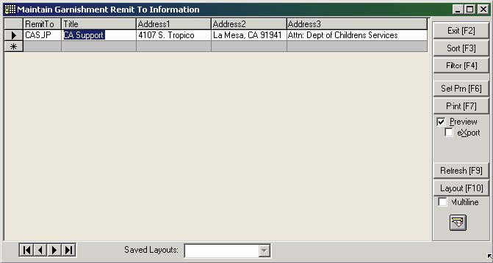

4. Now, using the garnishment “types” and “remit to” information, you may setup specific garnishments for each employee.

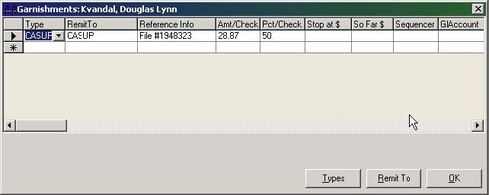

Note: For employees with a pay frequency of “daily”, the “Amt/Check” heading in the grid will change to read “Amt/Week”. This will withhold the amount allowed on each check during the entire pay period until the amount in this column is satisfied.

**Configuring the “Types” and “Remit To” Information Screens**

**Garnishment Types**

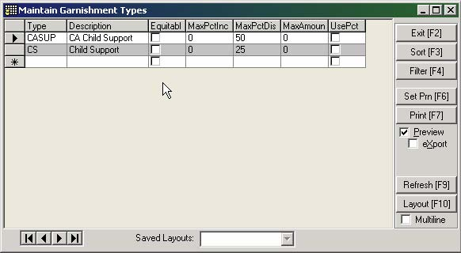

**Type** – Enter a code that will represent a garnishment type

**Description** – Enter the description for the garnishment type

**EquitableDist** – If more than one garnishment is used for the same employee, each garnishment type may be distributed equally over the garnishments. Check this if you wish this type to interact with other types that are also checked

**MaxPctIncome** – Enter the maximum percentage of gross income that should be considered for this garnishment. (normally set to “0”)

**MaxPctDisposabl**e – Enter the maximum percentage of disposable income that should be considered for this garnishment

**Max Amount** – Enter the maximum amount to withhold for this garnishment type, regardless of the maximum percentages used in the previous two fields

**Remit To Addresses**



**RemitTo** – Enter a code that will represent a garnishment remit to address

**Title** – Enter the name for the garnishment entity

Address1, Address2, and Address3 – Enter from 1 to 3 lines for the address

**Examples:**

Example 1: You have employees with Child Support Garnishments. The rule for all these employees is that you withhold a fixed amount (that may be different for each employee) checking to see that a percentage of the employee’s disposable income does not exceed a percentage that will be the same for all employees.

You are to withhold $27.38 as long as it does not exceed 50% of the employee’s disposable income.

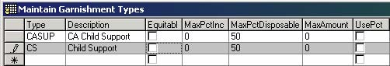

For this Garnishment Type, we’ll assume we’ve setup a Type code of “CS” and given it a description of “Child Support”. The only other thing we need to enter here is the MaxPctDisposible, which we will set to 50 (for 50%).

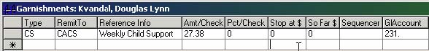

Now on the employee screen (using the

 button), we use the garnishment “Type” we previously setup (“CS”), choose a “RemitTo” address (“CACS” in this example, reference info, and the amount to withhold per week (27.38).

Example 2: You have employees with garnishments that require a percentage of the disposable income be withheld (no fixed amount).

You are to withhold 25% of the employee’s disposable income.

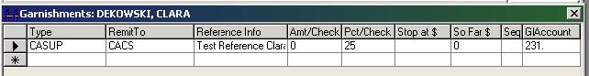

We’ll use an existing garnishment “Type” of CASUP for this one. Since the type already exists, all we need to do is enter “25” in the “Pct/Check” field.

Example 3: You have an employee that has more than one garnishment. In this example, you may use the “sequence” field to prioritize which deduction is calculated before the other.

For garnishment 1, you are to withhold $27.56 as long as it does not exceed 50% of the employee’s disposable income.

For garnishment 2, you are to withhold $50.00 as long as it does not exceed 25% of the employee’s disposable income.

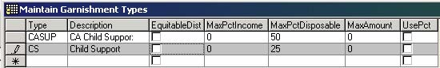

For this situation, you’d need two “Types” – one with 50 % and one with 25%.

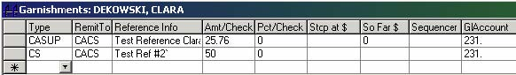

Then use these two types – each with the appropriate “Amt/Check” to be withheld.

### **Prioritizing Garnishments**

In example 3 above, the two deductions would calculate in the order in which they appear on the screen. To change the priority of which one should calculate first, you can enter a number in the “Sequencer” field for each garnishment to change the order in which the garnishment gets processed.

For instance, if you wished the second garnishment to be processed first, then number the garnishments accordingly as shown below.

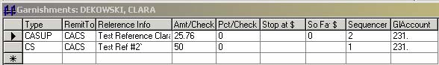

The order of the garnishments on the employee screen will then change (after exiting the garnishment screen and reentering the screen again) to the order of the sequence you entered.

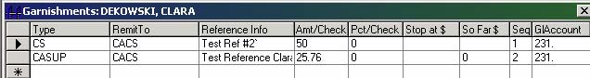

**Pro-Rating Garnishments**

If you wish multiple garnishments to be equally proportioned between the number of garnishments, check the “EquitableDist” box for each garnishment type to be treated in this way.

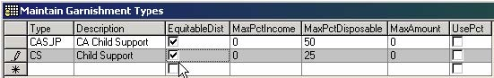

Now, for each garnishment of the same type (where there are multiple garnishments using the same type), they amount garnished will be equitably distributed between the two garnishments.

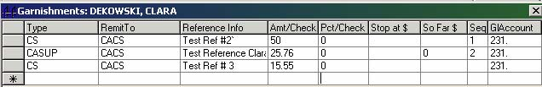

It is important to note that only garnishments of the same type can use this feature. In the example screen above the two “CS” type garnishments will be equitably distributed because the Garnishment Type has the “Equitable Distrib” box checked. All three garnishments will NOT be equitably distributed because not all three are of the same type.

### **401K Deduction Example**

One method of setting up an automatic deduction for 401K involves setting up a math packet that is referenced by an automatic deduction. Either a flat amount or percentage amount may be calculated for each employee having the 401K deduction.

For purposes of this example, we will use Deduction K and Math Packet YK with the following parameters:

• The deduction cannot exceed 15% of gross wages per pay period

• The deduction cannot exceed $8000.00 annually.

• The deduction amount calculated reduces the federal and state withholding tax basis.

• The deduction amount calculated does not reduce the Social Security or Medicare withholding tax basis.

*Make the appropriate adjustments to the example to match your requirements.*

**1. Setup the Math Packet**

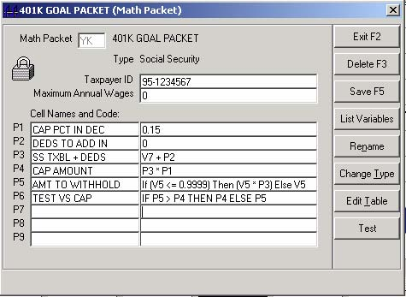

In this example, the math packet will calculate using all items that are SS taxable.

**P1**: sets the maximum percentage allowed per pay period - 15% (0.15) in this example

**P2**: see the other Math Packet example at the end of this section for an alternate version that uses this cell

**P3**: SS taxable amount

**P4**: calculates the cap - SS taxable (cell 3) times the percentage (cell 1)

**P5**: calculates the withholding amount - looks at the employee state exemption amount field, determines if it should be a flat amount (enter a positive amount) or a percentage (enter a negative fractional amount) and does the appropriate math

**P6**: tests to see if the amount in cell 6 exceeds the limit

**2. Setup the Deduction**

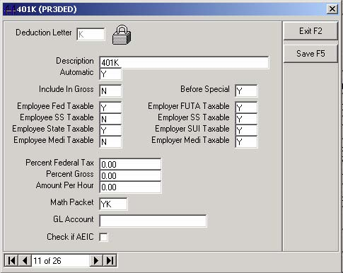

Setup your deduction as shown. Make sure it references the correct Math Packet you wish to use.

**3. Setup Each Employee**

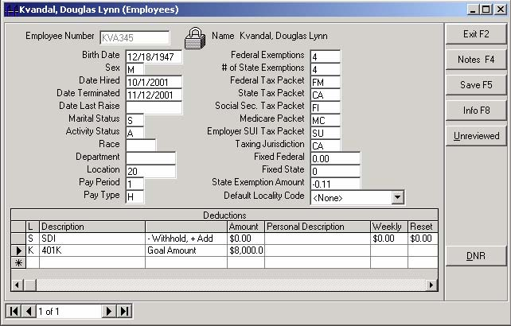

1. Enter the deduction you have previously setup to use as the 401K deduction and include the maximum annual deduction limit allowed as a goal amount.

2. Enter the **desired percentage** (as a positive decimal amount between 0 and 1) **or the flat amount** (positive amount greater or equal to 1) to be withheld in the **State Exemption Amount** field of each employee.

• Entering a number between 0 and 1 will withhold a percentage. For example, entering .05 would withhold 5%.

• Entering a positive number will withhold a flat amount. For example, entering 51 would withhold $51.00.

The example shown here will withhold 11 percent.

 After the employee has reached the goal amount, you must either remove the automatic deduction from the employee screen, or zero out the amount in the State Exemption Amount field. Otherwise, any taxable amounts that the 401K is set to affect may not calculate properly (they may continue to affect the taxable amounts).

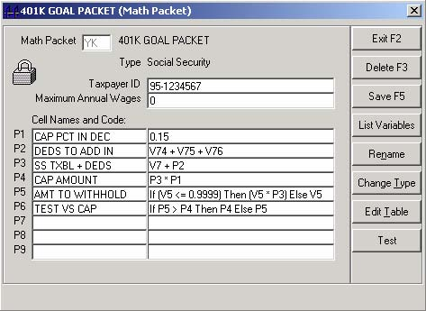

**Alternate Math Packet Example**

This Math Packet example is identical to the first example above, but shows how to include (or exclude by using a negative) specific deductions in cell P2.

### **Time Card Entry Adjustments**

If, after making time card entries, you find that you need to make corrections to entries, consider the following options:

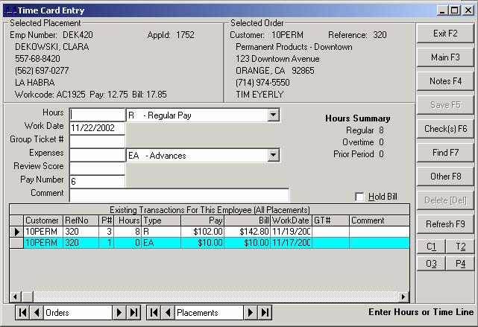

 If the entry has not yet been moved from the current to the period batch, make the correction directly to the original entry on the screen.

Making corrections to an entry included on a printed check (the entry will display as "yellow" if a check has been printed), will "void" the previously printed check, and set as "unprinted" all the entries for the same pay number.

If the entry has already been moved from the current to the period batch, you will be required to make new adjusting entries, since you cannot change an original time card entry once is has been moved to the period batch.

• Calculations for checks are performed at the time the check is printed, not when it is sent to the queue.

• All entries for the same pay number will be used in the calculations for a check when it is printed, regardless of when any of the entries were sent to the check queue. In other words, if you make additional entries with the same pay number to a time card entry that was already sent to the check queue, but not yet printed, all the entries will be used in the check calculations when it is printed.

### **Reprinting a check**

From the Time Card Entry Main Screen, pressing the [Shift-Check(s) F6] command bar will send all selected entries for the default pay number currently on the screen to the check queue.

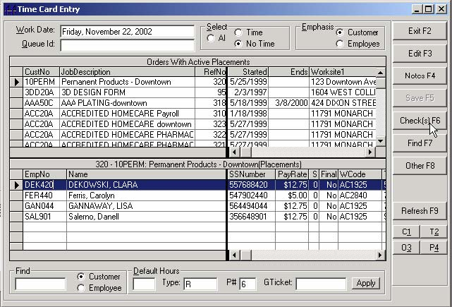

If a check for that pay number already exists in the check queue, you will get a message that you cannot send it to the queue since a check for that pay number is already pending, and your request doesn't make sense. If you are trying to reprint the check because you have made new entries since sending it to the queue, the new entries will automatically be used when the check is printed.

### **Special Check and Invoice Formats**

**Form "255" Invoices**

Configuring an invoice format to form = 255 suppresses the printing of invoices for that invoice format. The calculations will take place, but nothing is printed. Invoice Format Parameters is found Maintain, Company Setup, [Inv Format].

**"Bogus" Checks**

Configuring the check queue printer setup to send checks to any printer with the name "BOGUS" in the printer name suppresses the printing of both checks and advices. The calculations will take place, but nothing is printed. It is effectively the same as setting an invoice format form number = 255.

### **Printing Checks as Reports**

Temps Plus allows users to print their checks and advices as reports instead of individual print jobs for each check and advice. This can speed the printing process dramatically, especially in wide area network environments or in environments where the printer driver forces delays between jobs.

To print checks and advices as reports requires some minor modifications to the check and advice formats to ensure that each check starts on a fresh form.

Most Temps Plus check and advice formats are formatted with all data in the "Page Header" section of the form. Check formats(reports) with sort criteria other than the CurrentChecks.Id may require a check format with the check data in a section other than the Page Header.

A quick way to change the check and advice formats can be done as follows:

• Add 1 group at the bottom of the heading:

• Add Group 1 using CurrentCheckInfo.Id

• Suppress the following sections: Group Header #1, Details.

• Do NOT suppress Group Footer #1 -- instead, check the "New Page After" box.

• Also, It is usually necessary to leave just a bit of white space in the Group Footer #1 section so that it does take up some form real estate.

Also, a new table has been added to 3.1 Temps Plus, specifically for printing checks and advices as reports. CurrentCheckInfo has fields for rate lines 1,2 and 3 and QueueId that were previously set as formulas during the calculation/print process. Likewise, CurrentCheckInfo has a field for CardBalance if an iPay deposit was made. You should incorporate this new table into check and advice formats. Following is a diagram of the suggested linking:

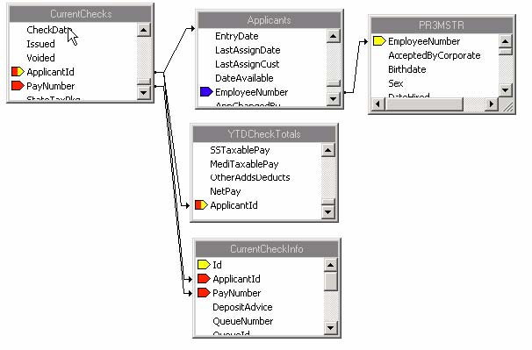

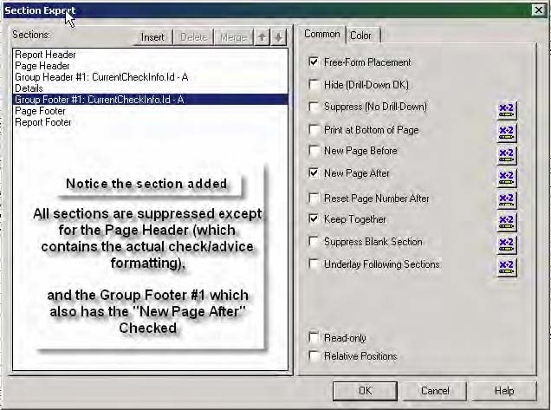

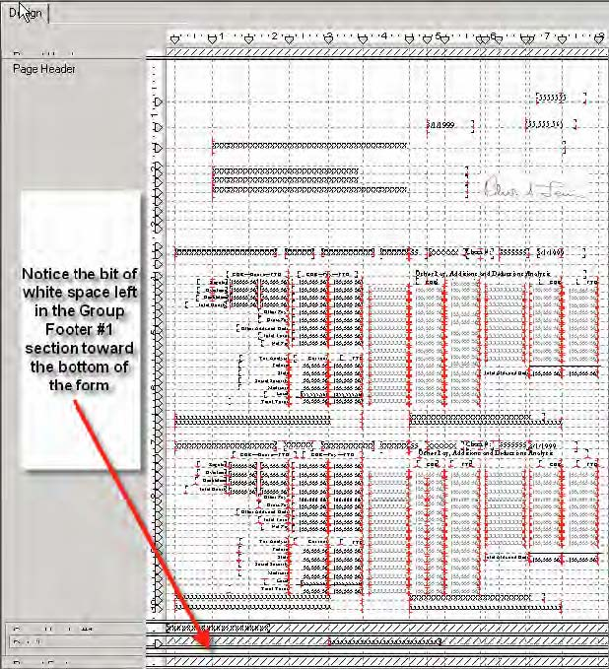

### **Local Taxes**

Many cities/villages/towns/counties/etc. are implementing local income taxes and requiring withholdings for any and all time worked in their community. Temps Plus helps minimize the administrative nightmare these local governments have created by implementing a local tax scheme that allows job orders to carry tax information for assessing local income tax withholdings for all time entered on the job. To take advantage of this system, 2 steps need to be taken: 1. Setup your table of localities under Maintain, Company Setup, Maintain, Tax Localities. This is a straightforward table, consisting of an 8- character (alpha numeric) locality code, a 40-character description of the locality, a tax rate,and the GL Account Number to use when creating entries for local taxes in this locality. The Gl Account specified must exist in your Temps Plus Chart Of Accounts.

Optionally, you can also assign a Math Packet to do a calculation, or do “head taxes” using the fields “HTF – Head Tax Frequency”, “HT Wages – Head Tax Wages” and “HT Amount – Head Tax Amount” fields. 2. Assign locality codes to all job orders for which you want to assess local taxes. You will find the locality field on the 1 Invoicing Tab of the Job Order screen. The locality codes are presented in a sorted drop down list. You can also assign a default locality to an employee. If implemented, the code specified on the employee record would take effect only if there was no code specified on the job order(s) where the employee is working (or for pay not associated with any particular job.) To setup a default locality code for an employee, go to either Maintain, Applicants, [F10 Employee screen], or simply, Maintain, Employees. The same drop down list of locality codes as described in job orders will be presented.

Note: There is an option in Maintain Company Setup, Active Company Code, Tax Localities which will allow you to have the locality code found in an employee screen “trump” any locality code found in an associated order screen (see the help section on “Localities” in the SuperJKM help. When local taxes are assessed, the total tax for a given check is set in a field named "LocalTaxes" in the CurrentChecks table. You will probably want to modify your check format to display this field. Similarly, there is a "LocalTaxes" field in the CheckHistory table. The details of which localities made up these totals are stored in the CurrentAutomatics table for current checks and in HistoryAutomatics for the check history. All local taxes have a "4" stored in the "Deduction" field. The locality code is the first 8 characters of the "Description" field, followed by a space and then the total wages for which the tax was assessed. The "Amount" field stores the amount of the tax (and, of course, the GlAccount field stores the Gl Account number.) With this data, creating reports for the individual localities is a snap.

### **Shift Differentials**

Shift Differentials (also known as Shift Premiums) can be easily applied when making time card entries.

1) On any work codes you will use for Shift Premiums, enter the premium amount or percentage to apply to the base rate for time entered for the work code.

2) Make sure you have a pay and expense type setup for use when you enter time card hours.

3) Enter the percentage you wish to markup the pay differential by on the job order.

4) When entering the time card information, use the pay code that refers to the differential you setup for this use.

The following example demonstrates how to pay a differential of $.50/hour, and mark up the $.50/hour on the associated billing by 40%.

**1) Setup the work code**

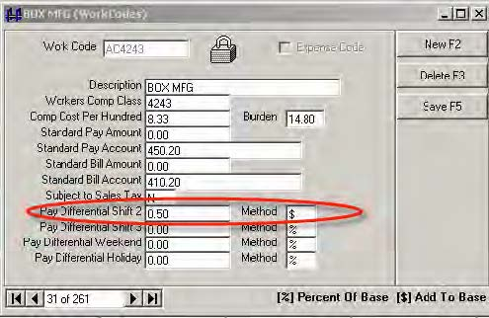

In this example, we will be paying a differential of 50 cents per hour, so we enter .50 in the “Pay Differential Shift2” field, and “$” in the Method field (to show it’s a fixed amount as opposed to a percentage, which would require a”%” sign.

**2) Setup the pay and expense type**

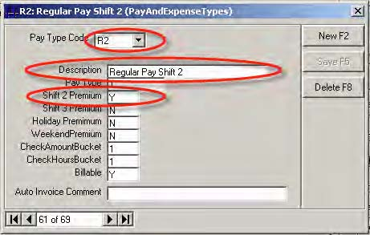

We’ll use a Pay Type Code of “R2”, and set the Shift 2 Premium = “Y”.

**3) Setup the job order**

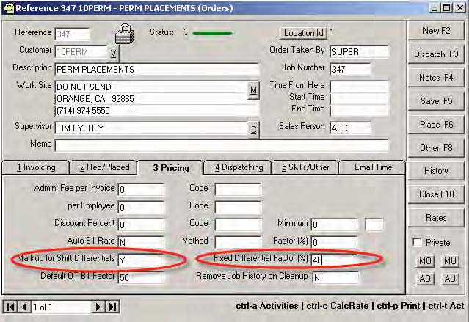

On the Job Order, we set the Markup for Shift Differentials = “Y”and the Fixed Differential Factor (%) to “40” (to markup the $.50/hour we’ll be paying by 40% when billing.

**4) Enter the time**

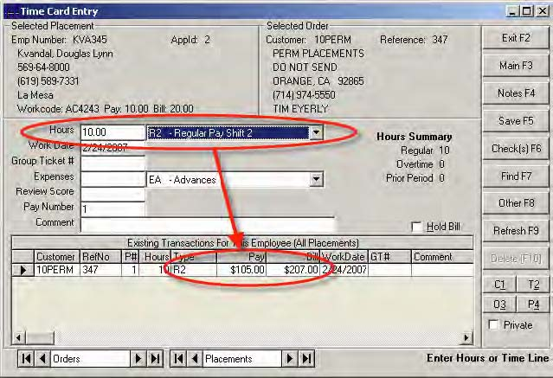

Now, entering 10 hours, and using the Pay Code “R2” (as we setup above), results in a pay and bill that includes the pay differential we setup.

### **Doing Staff Payroll with Temps Plus**

Temps Plus makes handling staff payroll a breeze. It can be done in the same database (company code) as your temp payroll, or, for security reasons, you may want to have your staff payroll handled in a separate database. The following example will take you step by step through setting up a staff payroll in a separate company code.

1) After creating the new company code for your staff, either create the chart of accounts you will need for your staff payroll or go to your temp company code and clone the chart of accounts for your temp company code to your staff company code.

2) Set up a deduction (for our example we will use deduction S) for Staff Salaries. This deduction should have the following options set to Y (Yes): Automatic, Include in Gross, Before Special, Employee Fed Taxable, Employee SS Taxable, Employee State Taxable, Employee Medi Taxable, Employer FUTA Taxable, Employer SS Taxable, Employer SUI Taxable and Employer Medi Taxable.

3) Edit “P&E Types” and set the “Billable” flag to N (No). This can also be done very quickly by executing the following query in the Temps Plus Query window: Update PayAndExpenseTypes Set Billable=False

4) Set up the necessary work codes to differentiate the type of work your staff performs so that the proper workers compensation reporting is available.

5) Now add your staff employees and create employee records for them via applicant maintenance. If the staff member is salaried assign deduction S to their employee record and specify the amount of their salary in the amount field.

6) Create a customer record called “STAFF” and create 2 job orders for that “customer.” In the Job Description for one of the orders indicate “Salaried Staff” and on the other order indicate “Hourly Staff”

7) Assign the salaried staff to the appropriate order using the appropriate work code for the type of work they are doing and leave the pay rates and bill rates at 0 for these assignments.

8) Assign the hourly staff to the hourly job order as above but specify the appropriate hourly pay rate for each employee assigned. The bill rate can be left at 0.

Your staff payroll is now set up. New employees can be added, salaries can be changed, and hourly rates can be modified using standard Temps Plus maintenance features. To enter time each week (or biweekly, etc) use the following technique:

1) Using the Enter Time Cards (grid) option highlight the “Salaried” order and under “Default Hours” enter 40 (or whatever hours are appropriate for the time period covered) and then press the Apply button.

2) Enter the hours for the hourly employees in the most efficient way possible – just as you do for your temp payroll.

3) Enter any miscellaneous adds or deducts just as you do for your temp payroll.

4) Queue all unpaid entries and print checks.

5) Print your payroll reports and update payroll. There will be no billing to process because the “Billable” flag on the Pay And Expense Types was set to false.

### **Posting to General Ledger Configuration**

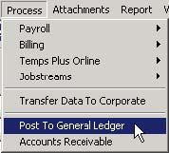

Before you can use the Post to the General Ledger selection, you must configure your posting selections by running one of the posting applications directly from your Temps Plus program folder. This will not only determine your setting, but place the application on your Temps Plus application screen, if it does not already appear.

From the Temps Plus program folder, choose a posting application. If you wish to post to the CYMA accounting program, choose “V2GLCYWI.exe”. Otherwise choose “V2CLNOCY.exe”.

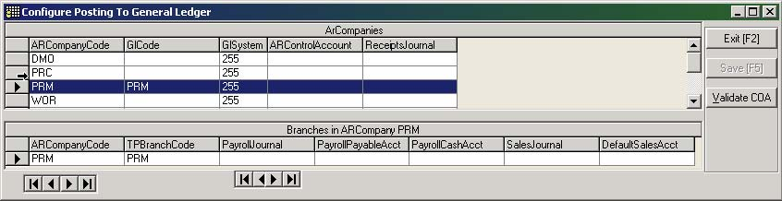

The configuration screen allows you to configure as many company codes as you wish. An AR company code must be setup before you can use this option.

**ArCompanies Section**

ARCompanyCode – the accounts receivable company code that includes the branch you wish to post from

GlCode – the general ledger code (if posting to CYMA) to post to

GlSystem – there are four choices here:

0 – Post to CYMA Windows software (CYMAIV)

1 – Post to CYMA DOS software (PASIII)

254 – Reports only, no actual posting

255 – Unconfigured

ARControlAccount – the general ledger chart of accounts number for Accounts Receivable Payable

ReceiptsJournal – the general ledger journal which will receive AR payments from Temps Plus

**Branches in ARCompany Section**

ARCompanyCode – the same as the ARCompanyCode in the ARCompanies section

TPBranchCode – the company code to post from (you may have more than one TPBranchCode for each ArCompany

PayrollJournal – the general ledger journal which will receive the payroll entries

PayrollPayablesAcct - the general ledger chart of accounts number for Payroll Payable

PayrollCashAcct - the general ledger chart of accounts number for the Payroll Cash

Sales Journal - the general ledger journal which will receive the Payroll Sales entries

DefaultSalesAcct – a default general ledger chart of accounts number for the Payroll Sales



If you are interfacing with CYMA accounting, you may have the system test your configuration to make sure that corresponding accounts for Temps Plus exist in the CYMA application.

For more complete information, please refer to the Post To General Ledger documentation in the Bridgeware University library at <http://www.bridgewaregold.com/BSIU/BsiLibrary.asp>.

### **Email TimeCard Spreadsheets**

Beginning in Temps Plus version 4.0.147 you can now opt to email Excel spreadsheets of active placements on a given job or jobs to employees and/or customers for the purpose of entering time. When the files are returned, a Temps Plus Timecard Processor program can validate and create entries from these spreadsheets directly into the current payroll activity of Temps Plus.

Installing the necessary files

A new program called “TPTime.exe” belongs in the application path with the rest of your Temps Plus programs. There are 2 new reports, “ETimecard.rpt” and “ETimecardR.rpt” which must be placed in the Npath(you can find these new reports on the FTP site).

Run dbValidator and validate all Temps Plus databases to implement the required data structure modifications. Additional security information will also be created so that you can control access to the new features.

Where to look for the changes:

In Maintain>>Company Setup on the Features screen a new tab, “E Timecards” is presented.

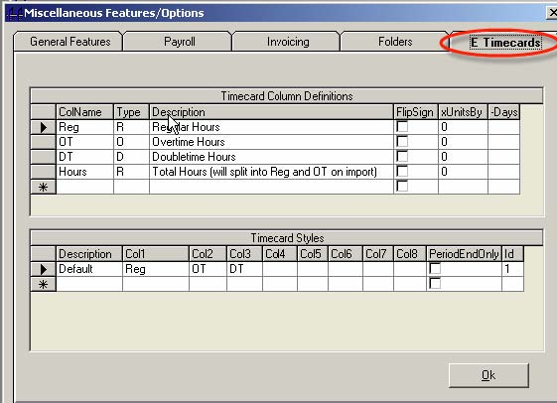

In this area you can define the columns you want to use within the spreadsheets for entering time and/or expenses. And you can define sets of up to 8 columns to use in spreadsheets. These sets of columns are referred to as Layouts and different layouts can be assigned to different customers.

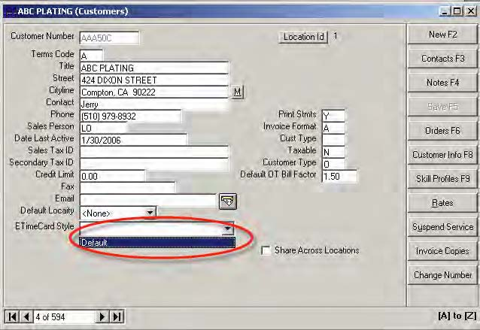

In Customer Maintenance, a new dropdown is available to assign a timecard spreadsheet layout to a given customer.

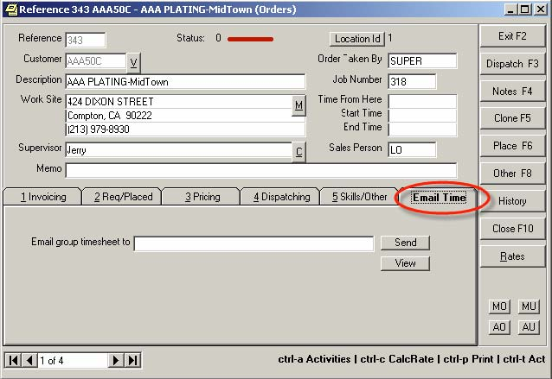

In Job Order Maintenance”, a new tab, “Email Time” is available to designate a mailing address to email timecard spreadsheets (when all time entry for a given job or jobs is to be handled by the same person.) There are also 2 command buttons in this tab to Send a timecard spreadsheet interactively and to View a summary of timecard files previously issued.

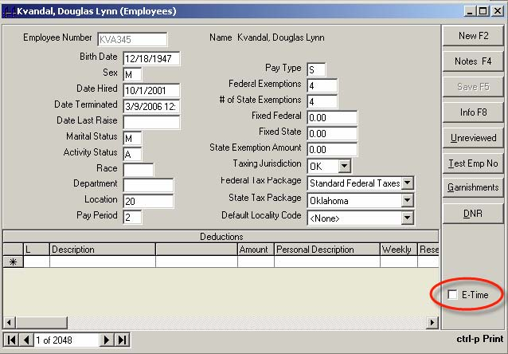

In Employee Maintenance”, a new checkbox, “E-Time” is available to designate that timecards should be mailed to the email address for the employee for all active placements for the employee which were not being mailed to an address specified on a job order.

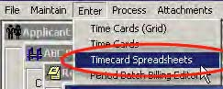

A new entry appears under the Enter>> menu, “Timecard Spreadsheets”, which launches the Timecard Processor program, which captures the information from returned spreadsheets.

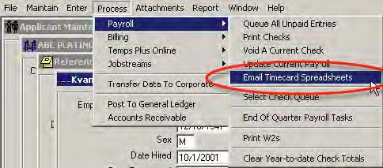

A new entry appears under the Process>>Payroll>> menu, “Email Timecard Spreadsheets” for sending timecard spreadsheets in batch.

You are presented with a dialog box requesting the work date/period end date. This must be coordinated with the starting and ending dates on job orders and placements. Only orders and placements that start before and end after (or with no ending date) the requested work/period end date will be considered when creating spreadsheets.

The basics of how things work

When you set up timecard columns in the features tab, you define various elements of time and/or expenses that you want to be brought into Temps Plus through the Timecard Spreadsheets feature. You give these columns short names like “Hours” which become column headings in the spreadsheet to be mailed. You then assign the column to a given Temps Plus pay type. This tells the Temps Plus Timecard Processor how to handle amounts that are entered in the column just as if the value was entered via Timecard Entry in Temps Plus. Additional rules can be created for a column by specifying “FlipSign” or by entering a value in “xUnitsBy”. The FlipSign option tells the Processor to reverse the sign of any value in the column so that positives become negatives and negatives become positives. The xUnitsBy is only used for non-hourly pay types and tells the Processor to multiply the value in the column by a given amount. This provides for handling things like Miles to Mileage. When the Timecard Processor creates an entry for a column that has a xUnitsBy value, it creates a parenthetic comment for the transaction that shows the calculation, for example “(300 * .42)”

You group columns to be used in a given style of spreadsheet using the Layouts grid which is presented immediately underneath the column definition grid. If your needs are the same regardless of customer, then you will only need the default layout. You don’t need to have different columns defined for overtime versus regular time although you certainly can do it that way. You could simply have a column called Hours and Temps Plus will automatically do the splitting between Regular and OT when appropriate.

You assign spreadsheet layouts at the customer level, in the Customer Maintenance routine. Initially all customers are assigned the default layout.

You assign email addresses for spreadsheets at the job order level in Job Order Maintenance or, if the spreadsheet is being sent to the employee, the email address assigned on the applicant record is used (a checkbox on the employee record indicates that you want to mail a timecard spreadsheet to the employee if it is not being emailed to the job.)

Spreadsheets are always for a given work date or period end date. The system keeps track of the spreadsheets sent and received and validates the legitimacy of the basic data when processing spreadsheets for entry into Temps Plus.

When spreadsheets are sent by pressing the “Send” button on a job order form, only a single spreadsheet is sent for the single order and it uses the style assigned to the customer the order is for. The work date is prompted for, and if this work date had not been previously issued, the spreadsheet is built, the email prepared and then the user is presented with the email for any customization of the email content. If the work date had been previously issued, the user can opt to send a supplemental spreadsheet for new placement activity or the user can opt to void any and all previous timecard spreadsheets sent for that job on that work date and issue a new spreadsheet based on current placement data.

When timecards are sent in batch through the Process>>Email Timecard Spreadsheets option, the user is first prompted for a work date and then, if the user can access all locations, they are prompted for the Location Ids to issue for. Supplementals and Voids are handled as previously mentioned with the exception that the system differentiates between what was sent via pressing the “Send” button on an order versus what was done in batch. So you could send a job a spreadsheet early without interfering with sending via batch, for the same work date, later on. In batch, each location is handled separately. Within location, the grouping of the spreadsheets is based on the destination email address and the Layout of the spreadsheet. For example, if you had an email address of [myemployee@xyzcompany.com](mailto:myemployee@xyzcompany.com) as the email address for 10 different jobs at 10 different customers and all those customers used the same Layout, then a single spreadsheet would be built for those 10 jobs and it would be sent to [myemployee@xyzcompany.com](mailto:myemployee@xyzcompany.com). If 1 of those 10 customers used a different Layout, then [myemployee@xyzcompany.com](mailto:myemployee@xyzcompany.com) would receive 2 spreadsheets: 1 for the 9 jobs in the same style and 1 for the job in the different style.

Similarly, if an employee set to receive timecard spreadsheets worked on 10 different jobs over the course of the day/week and the email timecard address on those job orders was blank, and all the customers used the same Layout, the employee would receive a single timecard spreadsheet that contained rows for timecard entry for each of the jobs. If the customers had different Layouts, the employee would receive spreadsheets grouped by Layout.

When spreadsheets are generated a Crystal Report is used with an export option of Excel. The column headings are handled via formulas in the report so a single report format can handle multiple Layouts by simply setting the formulas according to the specified layout.

Report Formats

The Crystal Report used, in most cases, is a file in the Npath named “ETimecard.rpt.” If all the timecards within a group being emailed are for the same customer, the system will look for a custom timecard report file in the npath named “ETimecardCUSTNO.rpt” where CUSTNO is the customer number. You can customize the spreadsheet reports to change the basic appearance, add or remove information, etc, but take care. Creating good layouts for export to Excel can by tricky. When in doubt, work with Bridgeware to develop custom layouts. Always test a modified timecard report for use with the Timecard Processor in a test company code. Issue spreadsheets, enter some time into them and then process them to insure they are properly aligned.

TPTIME.EXE

When completed spreadsheets are returned, the time and expense data is brought into Temps Plus by using the Timecard Processor program, TPTime.exe. You can access this through the Temps Plus “Enter>>Timecard Spreadsheets” menu item. The program allows you to view spreadsheets prior to processing and to view a report of the entries created from a spreadsheet after you process a file. Once processed, the file is renamed from an XLS file extension to a TPT (Temps Plus Time) file extension to let you know the file was processed and to filter it out of browsing for any remaining unprocessed spreadsheets.

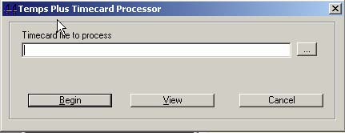

You may import or view the timecard spreadsheets by entering the path and filename of the spreadsheet you wish to import or view.

Action Column

ACTIONS allow you to close placements and optionally set DNRs. You can set “Action” columns with the following values:

**“Close” or “C” or “3”** – (closes placement with a close status of 3 – “normal”)

**“NoShow” or “No Show” or “N” or “1”** – (closes placement with a close status of 1)

**“Injury” or “Injured” or “I” or “2”** – (closes placement with a close status of 2)

**“Quit” or “Q” or “4”** – (closes placement with a close status of 4))

**“DNR”** can be added to any of the above to designate a “Do Not Return” to the customer. So "DNRNOSHOW" or "dnr no show" would set a customer DNR for the employee and close the placement with a status 1. It does not matter if DNR comes before or after the other action.

If “DNR” is used in the Action column without specifying a close status, the current placement will be closed with a status 3 and the DNR will be set. Case is ignored when evaluating the Action column.

Offset Column

The “Offset” column adds support for day by day hours entry. Column definitionscarry an offset days value of from 0 to 6 to tell the system how many days to subtract from the period end date for values entered in the column.

Advanced Features

Under version 4.0.155 or higher, the system will attempt to massage the layout of the Excel files to add some additional functionality if Excel is installed on the client machine. The additional functionality is as follows:

• any columns where the heading matches a timecard column definition, Temps Plus will create a formula to sum the totals of that column.

• Temps Plus will write protect any column that is not recognized as an input column.

• column headings and the summary total row are write protected.

• Temps Plus checks for any column headings of "tot-#" where # is a number from 2 to 9. When found, Temps Plus replaces the column heading with "Total" and the subsequent rows in that column with formulas to sum the immediately preceding # of columns for the respective rows. This allows for horizontal and vertical totals. For example, you could have column headings with the days of the week followed by a column captioned "tot-7" to total the preceding 7 columns of daily hours. Or you could have columns of Reg, OT, DT and then Tot-3 to total the sum the Regular, overtime and double-time hours.

• Temps Plus password protects the write protected columns with a password of 'only???' where ??? is the lower case company code.

• Temps Plus adds gridlines to the spreadsheet.

### **Document Based Time Card Entry**

Under version 4.0.244 or higher, you can now have a traceable (numbered) document created when you print a time ticket from the placement screen. This is quite similar to the Email Timecard Spreadsheets feature implemented in an earlier release of Temps Plus. In fact, the new time entry routine used with the timecard documents can be used for both emailed spreadsheets and standard timecard documents. And all the features supported in Email Timecard Spreadsheets are supported with this new feature (you can close placements, set DNRs etc.)

• • A special work ticket format named “PLPRD.rpt” must be created and loaded into the npath folder. You can simply take your PLPRG.rpt (Group Time Ticket) format and use that as the starting point. The big difference is that you’ll want to include the Timecard Document number on the ticket, and add links to additional tables in your database(TimeCardsExpectedBase, TimeCardsExpectedDetails, TimeCardsIssuedSource).

• • A new Timecard Processor program, TPTimeInput.exe must be loaded into the Temps Plus program folder for processing timecard documents. The program is available in your updates folder on the Bridgeware ftp site (ftp.bridgeware.net).

• • If you are not using the standard TPTime.exe Timecard Processor already, any existing customers you will be printing work tickets for must have the “ EtimeCardStyle” field filled in on the customer maintenance screen. You may wish to run a query to fill the field for all customer records that do not have a CardStyle set instead of pulling up each customer and filling the field manually. If you are not familiar with styles, check the help for Email Timecard Spreadsheets. The bottom line is that you may want a day by day hours entry or lump sum hours entry, etc. This is the reason for different styles controlled at the customer level.

• • The ProcessOptions table in the database must have the “GenDocument” option of the “PrintGroupTicket” process set to TRUE. This process option record is created automatically the first time you print a time ticket from the placement screen using Temps Plus version 2.0.244 or higher, but by default it is set to FALSE.

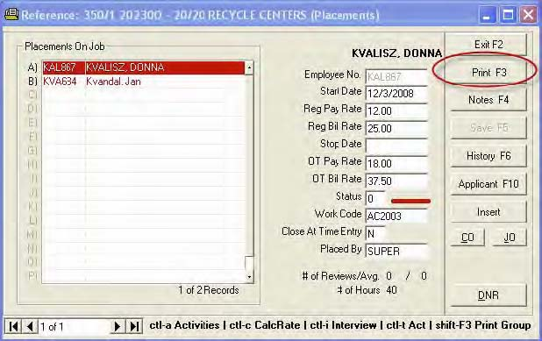

Once the prerequisites have been implemented, when you print a work ticket (there is no more “single” or “group” tickets, just a single work ticket that handles everything), the process is started, including the issuing and printing of a ticket number on the work ticket. This ticket number is referenced in the system when entering and processing the time card entries. Before the ticket is printed, you are prompted for a work date that the ticket is being issued for. This may be the current date if you are dispatching for a daily job or it may be the period end date for a weekly job.

If you attempt to print another ticket for the same job using the same work date, the system will ask if you want to void the previous document. If you respond affirmatively the system will void the previous document and ask if you want to reissue a new time ticket. This can be useful when you add someone to a job and nothing has happened yet with the previous document. But what if you add someone and there is already an existing ticket in the field that you do not want to void? Simply respond “No” to voiding the previous document and you will be asked “Do you want to issue a supplement with active placements that have not had a time ticket created for this work date?” Responding “Yes” will create a document with just the new placement(s).

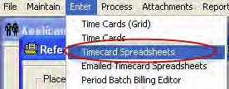

After the work tickets are printed, choosing Timecard Spreadsheets from the Temps Plus menu brings up the Time Ticket Entry grid.

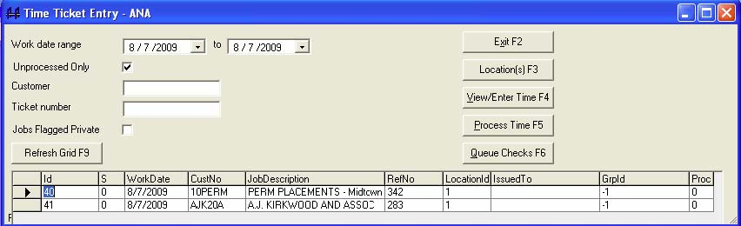

All tickets that were printed will appear in the grid (for the displayed criteria). You may change the criteria to display more or less printed tickets with the following options:

**Work date range** – shows the tickets for the date range shown

**Unprocessed Only** – when checked, shows only tickets that have not been processed using the [Process Time F5] button

**Customer** – entering a specific customer number will show only tickets for that customer

**Ticket number** – entering a specific ticket number will show only tickets for that ticket

**Jobs Flagged Private** – when checked, includes only tickets for any job orders that are flagged as private. When unchecked, jobs flagged as private are not included in the grid - so internal staff payroll can also be handled with timecard documents. Users need special security privileges to view records flagged as private so this option will not even appear if the user does not have access to private records.

The buttons on the screen perform the following operations:

**[Refresh Grid F9]** – refreshes the grid section after making any changes to the criteria

**[Exit F2] –** exits the grid

**[Location(s) F3]** – pressing this button allows you to choose the location(s) for which to show tickets

**[View/Enter Time F4]** – highlighting a grid entry and pressing this button brings up the spreadsheet associated with the ticket where you can make your time card entries.

**[Process Time F5]** – pressing this button makes entries for highlighted grid items into the current batch from the spreadsheets where time was entered using the [View/Enter Time F4] button

**[Queue Checks F6]** – sends highlighted grid items to the check queue

**Color Codes for the Grid**

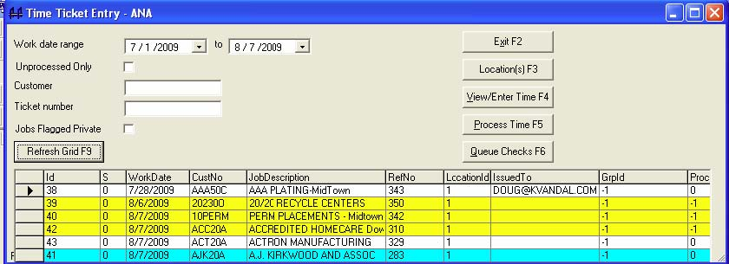

If entries have been processed and are showing on your screen (check the Unprocessed Only box to include processed items), the following colors are used:

**White** – unprocessed/missing

**Cyan** – document is ready to be processed (may or may not have time entered on it, but the document is there and it has not yet been processed.

**Yellow** – time for this document has been processed.

Note: Any tickets with an email address in the “IssuedTo” column were spreadsheets created not by printing work tickets, but using the email timecards feature. These tickets can be edited and processed along with the printed work ticket items by saving or placing the spreadsheets when received back from the party who made the time card entries into the proper folder on your computer system. This folder is specified by your setting in Company Setup > Features > Folders Tab > Attachments.

Tickets that already have time entered on them(color = cyan) may be edited by highlighting the ticket and making any changes or additions.

### **Printing Checks as Reports**

Temps Plus allows users to print their checks and advices as reports instead of individual print jobs for each check and advice. This can speed the printing process dramatically, especially in wide area network environments or in environments where the printer driver forces delays between jobs.

To print checks and advices as reports requires some minor modifications to the check and advice formats to ensure that each check starts on a fresh form.

Most Temps Plus check and advice formats are formatted with all data in the "Page Header" section of the form. Check formats(reports) with sort criteria other than the CurrentChecks.Id may require a check format with the check data in a section other than the Page Header.

A quick way to change the check and advice formats can be done as follows:

• Add 1 group at the bottom of the heading:

• Add Group 1 using CurrentCheckInfo.Id

• Suppress the following sections: Group Header #1, Details.

• Do NOT suppress Group Footer #1 -- instead, check the "New Page After" box.

• Also, It is usually necessary to leave just a bit of white space in the Group Footer #1 section so that it does take up some form real estate.

Also, a new table has been added toTemps Plus version 3.1 and above, specifically for printing checks and advices as reports. CurrentCheckInfo has fields for rate lines 1,2 and 3 and QueueId that were previously set as formulas during the calculation/print process. Likewise, CurrentCheckInfo has a field for CardBalance if an iPay deposit was made. You should incorporate this new table into check and advice formats. Following is a diagram of the suggested linking:





